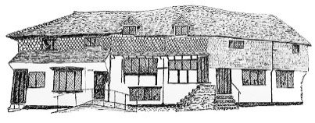

Midhurst Town Council

**Recruiting for**

**A Gardener and Amenity Officer**

**Monday to Thursday, 24 hours per week worked flexibly (including very occasional Friday and Saturday work)**

**Salary – Pro Rata between £35k and £37k per annum dependent on qualifications and experience**

**Closing Date 1st September 2025**

Midhurst is a Town in Chichester District with a rich history and is a busy ambitious council currently embarking upon a number of diverse projects and improvements to its services and assets. We are seeking a skilled and highly motivated person to be part of a small committed and flexible team with a ‘no job too big or too small attitude’.

The position is focused upon maintenance and improvement of the Council’s assets at various locations around Midhurst (a van is provided), with a base at the Council Offices, at the Old Library, Knockhundred Row, Midhurst, West Sussex GU29 9DQ

This is an interesting and varied role which requires well developed gardening knowledge and DIY skills with an ability to instruct and work with the Town Council’s contractors and undertake associated administrative tasks.

An information pack and application form can be downloaded from Midhurst Town Council website: [www.midhurst-tc.gov.uk](http://www.midhurst-tc.gov.uk)

You may also contact the Clerk on 01730 816953 for information or a discussion about the extent and requirements of the role.

Please either complete our application form or send your CV and a brief covering letter to [clerk@midhurst-tc.gov.uk](mailto:clerk@midhurst-tc.gov.uk) or post to The Clerk, Midhurst Town Council, The Old Library, Knockhundred Row, Midhurst, GU29 9DQ.