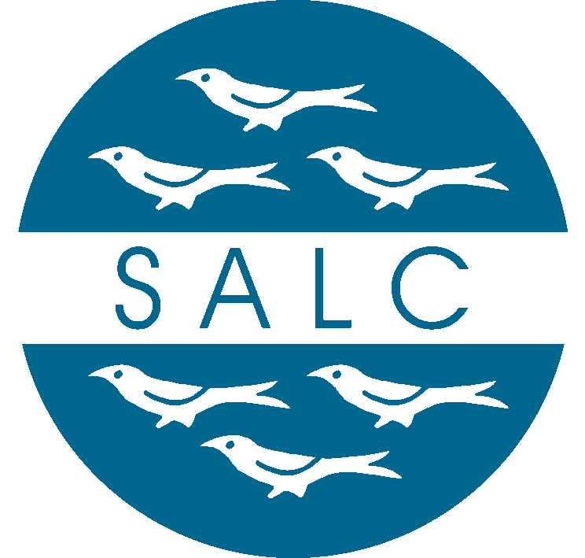
WEST SUSSEX ASSOCIATION OF LOCAL
COUNCILS LIMITED
Sackville House, Brooks Close, Lewes, East Sussex, BN7 2FZ

Minutes of Annual General Meeting
Held on 17th October 2016 at the Lodge Hill Centre, Watersfield, Nr Pulborough, West Sussex, RH20 1LZ

Present: There were 52 representatives and 36 member councils/appointed representatives present

1a. Election of President – Cllr Terry Oliver WSALC Chairman proposed that Michael Chater OBE be recommended to continue to be the West Sussex President.
Michael Chater OBE was elected unanimously.
1b. Welcome by the President – The President welcomed everyone to the meeting.

2. Apologies - Apologies were reported from 4 member councils/appointed representatives

3. Minutes of the Annual General Meeting held on 19 November 2015 - There being no comments the minutes were agreed as a correct record and signed.

4. Report from the Chairman of West Sussex ALC Limited on the Annual Report for 2015/16 – The Chairman presented the Annual Report to members.

5. To Adopt the Accounts for the year ended 31 March 2016 – The Company Secretary advised that the year-end had been as expected. There were no questions.
The adoption of the report and accounts was duly proposed and seconded, and carried unanimously.

6. Appointment of the Directors – The President received approval to take nominations for consideration en bloc.
It was duly proposed and seconded that the Directors listed below be appointed and it was carried unanimously.

Tony Gardiner | Arun District Association
Derek Hulmes | Arun District Association
Vacancy | Arun District Association
Mike Beal | Chichester District Association
Laurie Pocock | Chichester District Association
Valerie Court | Horsham District Association
Terry Oliver | Horsham District Association
Rodney Jackson | Mid Sussex District Association
Rex Whittaker | Mid Sussex District Association
Mark Mulberry | Company Secretary
Roger Taylor | Company Solicitor
7. Election of Vice Presidents –
The President received approval to take the proposal Lord Lytton DL, Alan Grant and Dr John Godfrey be invited to continue as Vice Presidents en bloc.
It was duly proposed, seconded and agreed that the Vice Presidents continue in office.

8. Election of Representatives to the National Association 2016/17 – The President received approval to take nominations for consideration en bloc.
It was duly proposed, seconded and carried unanimously that:
(i) Cllr R Jackson as representative on NALC Council
(ii) Cllr T Oliver, Cllr M Beal & Mr T Leggo as voting representatives at the Annual General Meeting of NALC

9. Any Other Matters – No matters had been received in advance of the meeting.

