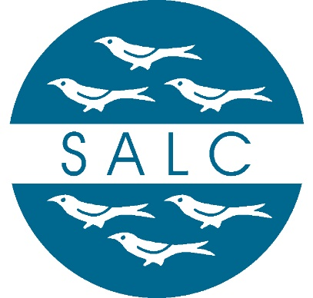
WEST SUSSEX ASSOCIATION OF LOCAL COUNCILS LIMITED
Agenda for a Board meeting to be held remotely by Zoom on Friday 31st January 2025 at 10.30am

Item | Item Description | Action(s) | Who
 | Welcome by Chair | Welcome by Chair | Chair
 | Appointment of Vice Chair | To appoint a new Vice Chair | Chair
 | Apologies for absence | To receive apologies for absence | Chair
 | Minutes of the previous meeting | To approve the minutes of the meeting held on 31st October 2024 | The Board
 | Financial update | To receive an overview of WSALC finances | Company Secretary
 | Devolution | Update on devolution bid | CEO
 | CEO update | CEO to report | CEO
 | District Associations | Report from recent meetings | DALC Chairs
 | Any other matters raised by Board members |  | All
 | Date of next meeting | To be arranged | The Board

