**Stepping Stones Learning Center LLC**

COVID Policies as of November 3, 2020

One of the toughest decisions we have had to make is whether to require masks. There is so much uncertainty either way we go, but we are requiring masks be worn for all children in our 3yr old room, our 4-5yr old room, school-agers, and staff.

If your child has an underlying health issue that prevents them from wearing a mask, please reach out to Director so we can make accommodations. Stepping Stones will be providing masks for each child.

Masks are washed every evening. A new mask is supplied everyday for the children and staff. Each child will also be provided with a breakaway lanyard so the mask can easily be removed and tucked in their shirts for eating and drinking.

Each child will also be provided with a plastic box to place their mask and lanyard in during nap time, so it is easily accessible and kept clean as they are not being worn while napping. These boxes will be washed and sanitized after nap time every day, and a clean face mask will then be placed in the box, so it is ready for the next day!

When your child enters the entryway, they will get their temp checked by a masked staff, get their hands sanitized. and then they will grab their mask box put their mask on and take their box to their cubby then they will enter their classroom.

When your child leaves for the day they will be placing their mask they wore that day in a hamper by the exit door

Here is how drop off will go for your child if you are coming between the hours of 7a.m-8:30a.m there is no need to call as a staff will be in the entryway waiting. If you are before or after those hours, please make sure that you are calling as a staff might not be up there. Once you arrive please pull up in the turnaround one car at a time, at the Stop Sign. Watch for the green light to come on, once the green light is on you can get out of your car and a masked staff member will open the building door and get your child(ren) from you. We are only allowing one family in the entryway at a time.

No parents will be allowed to enter the building still at this time. We ask for you to wait outside the door to get the ok that your child does not have a fever before you leave as temps will be taken inside in the entryway. We are asking parents to also wear masks at drop off to help with the spread of COVID-19. Please be considerate and allow more time at drop off as this process is going to take more time.

Here is how pick up will go for your child please call when you arrive (unless there is other cars there) as we will not be allowing more than one child(ren) in the entry way at a time. Once you arrive please pull up in the turnaround one car at a time, at the Stop Sign. Watch for the green light to come on, once the green light is on you can get out of your car and a masked staff member will open the building door and bring your child(ren) to you. We ask for you to wait in your car until your child(ren) are brought out by a masked staff. We are again asking parents to also wear masks at pick up to help with the spread of COVID-19. Please be considerate and allow more time at pick up as this process is going to take more time.

This will hopefully cut down on an issue of the whole center having to go into quarantine shut down, if a positive COVID-19 case should happen again.

Please read the following sheet below on quarantine guidelines. If you have strong feelings about your child NOT wearing a mask, please understand they will be quarantined every time if there are any positive cases of COVID-19 in the center at all. Please know that I am trying my hardest to not have this happen, but I am only responsible for what happens inside the center.

**Staff and masks**

All Staff members will be required to wear masks, unless they have an underlying health issue that prohibits them from doing so. They will have the same procedure as the children do each day they come in and each day they leave.

Please know that I understand what a controversial issue masks are and we did not make this decision lightly.

If you have any questions please do not hesitate to contact me, if I do not have an answer, I will get you one from someone that does!!

Individual is considered a close contact because they have been within 6 feet of the COVID-19 positive individual for more than 15 minutes.

**Front & Back Infant Rooms:**

1. If an unmasked infant room child test positive, all infants and infant room employees will be required to isolate for at least 14 days.
2. If a masked infant room employee test positive, all infants and infant room employees will be required to isolate for at least 14 days.

**Younger & Older Toddler Rooms:**

1. If an unmasked toddler room child test positive, all toddlers and the employees that work directly in their classroom will be required to isolate for at least 14 days.
2. If a masked employee that works directly in the toddler rooms test positive, all children in the toddler room and toddler room employees will be required to isolate for at least 14 days.

**3 yr old Room & 4-5 yr old Room:**

1. If a masked child in the 3yr old room or 4-5yr old room test positive, said child must isolate for at least 14 days. All other staff and children should be self-monitored for symptoms such as fever, cough, or respiratory difficulties.
2. If a masked employee that works in the 3yr old room or 4-5yr old room test positive, said employee must isolate for at least 14 days. All other staff and children should be self-monitored for symptoms such as fever, cough, or respiratory difficulties.

This response guide also explains the procedure for potential exposure from positive household members. Please follow the 14-day quarantine period for yourself and your child if someone in your household tests positive. Our previous fever policy will remain the same. If your child has a fever of 100.4 degrees or higher, they may not return until 72-hour period has passed from the time they are picked up. Your children are not required to get tested to return to daycare.

[[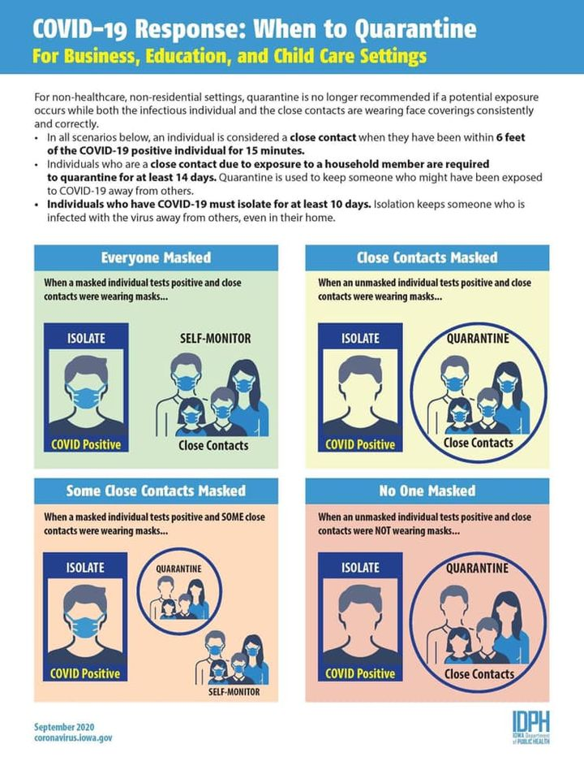](https://www.facebook.com/bridgetobeginnings/photos/pcb.225615762413538/225615592413555/?__cft__%5b0%5d=AZUvkkNBFaeDIpbAj79sFmUeBVlE3Wn3EgpN3tevNL3heaMlxoZcxn4d0YKuCBWviWPSD1Jjdi_4eu0yPOfvjPIgXuOR0zn1vGlM1ANQEhkuFTr8BaUOeBjYzYqs6OU6TpH_aLxuosti5QM1rH7Tt3ok&__tn__=*bH-R)](https://www.facebook.com/bridgetobeginnings/photos/pcb.225615762413538/225615592413555/?__cft__%5b0%5d=AZUvkkNBFaeDIpbAj79sFmUeBVlE3Wn3EgpN3tevNL3heaMlxoZcxn4d0YKuCBWviWPSD1Jjdi_4eu0yPOfvjPIgXuOR0zn1vGlM1ANQEhkuFTr8BaUOeBjYzYqs6OU6TpH_aLxuosti5QM1rH7Tt3ok&__tn__=*bH-R)