RHK Pup Go home Checklist

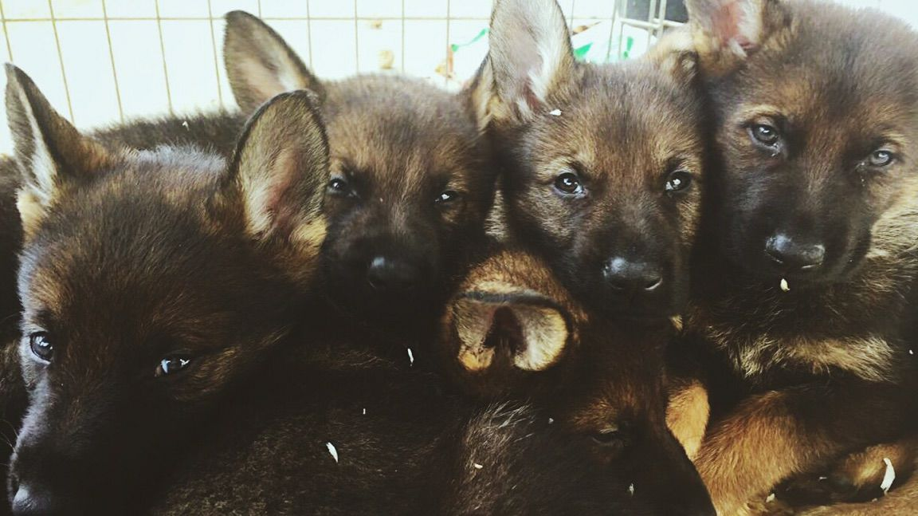

equipment
☐ | Crates. They ether need to be adjustable or small enough that pup has room to turn around and just lay down. No mansions. You need at least two crates, one for the house and one for traveling in your vehicle.
☐ | Food. We feed a RAW diet, if you prefer to feed a kibble then we recommend Dr. Gary’s Best Breed, Nutrisource or Instinct Grain Free. Grain free is a must, dogs are not designed to eat grains.
☐ | Flat, adjustable collar and a 6’ light lead. Flexi leads are only good for taking your pup to the bathroom.
☐ | Training Treats. Zuke’s Minis are the ones that we use. A treat pouch, apron or vest is a good idea.
☐ | Chews and Toys. Absolutely no Tennis Ball type of material even if it says it is made for dogs. The felt ruins the dog’s teeth. Hard rubber, indestructible type of toys, natural bone or elk antler, Kongs. Absolutely no rawhide!
☐ | Play pens and baby gates will make your life easier. When pup is out of crate they need to be either attached to you with a lead or within easy grab distance. So, gate areas or have a play pen or use a drag chain.
☐ | Large Flake Pine Shavings.

schedule
☐ | Pups need lots of sleep and down time. 18 hours in a 30-hour period. 18 hours broke up over a 30-hour period of different lengths. Not 18 hours straight. Please do not over stimulate your pup. They are babies and like babies they need their naps.
☐ | Anytime they come out of crate or pen take them to potty area.  *They are litter box trained to large flake pine shavings. Put some in the area you want them to potty in.
☐ | No more than twice a day feedings. I don’t care what your vet says, if you feed more than twice a day plus you are training with treats you will have a fat pup and you must love cleaning up poop. We will not guarantee hips if you have a fat puppy.
☐ | After eating and drinking, after exercise, after sleeping, they need a potty break. Until they hit about 4 to 5 months of age they are pee and poop machines without diapers. Sometimes they won’t even know they have to go and pee will be flying out of them while they are playing.
☐ | Establish a routine with the little guy and stick to it. If you break the routine they will voice their opinion.  *This includes establishing clear designated areas for designated activities. Play are for play area, training area, potty area, low key area and sleep area. Living room is chill out unless you want a broken TV. Bedroom is for sleeping. So no playing in the chill out area or sleeping area unless you are a masochist. No playing in the potty area either or you will be standing outside in the wind and rain for hours.  *Your lead is your umbilical cord. Always have treats on you.
☐ | My Sample Pup Schedule:  - I have pup kennel runs with litter boxes to make my life easier  - 5:30am, get up and water pups, no breakfast for them on work days. Or their breakfast is short training sessions for food.  - 7am we all load up to go to training, this is crate training for pups.  - 730am, arrive and potty break pups. I carry shavings with me and sprinkle them in potty areas. That’s why you guys see the shavings at the park next to tree line.  - 8am they hang in exercise pen until their turn to train.  - Each pup is trained with nutritious treats/food and that is how they get their breakfast.  - After training session pup is given a potty break again.  - Nap time will adults train.  - Lunch time, group potty break, water, play time and general run around like idiots for pups.  - After lunch, nap time.  - Adult training.  - Around 4pm, long walk time and potty break time in prep for ride home.  - Get home everyone goes back into their kennel run until dinner time.  - Dinner time and each pup gets quiet socialization with family  - Back in kennel run (Read Kennel Run as potty break for you guys. I have litter boxes full of pine shavings in back area of kennel runs.) for bedtime.

Extra Stuff
☐ | Do not squeeze, pet or smoosh pups ears. The ear cartilage is still forming. If I catch you doing that and your pup’s ears do not stand, I will scold you; several times, probably in front of others.
☐ | Do not socialize your pup. Environmental neutralize your pup. That means your pup should ignore everything in their environment and pay attention to you. They should seek your affection not strangers. The whole world is NOT their pack, only you and your family. No letting strangers give your pup treats or petting your dog. So, take pup everywhere and show them the cool stuff. Keep the strangers off of him. If they get their feelings hurt that you won’t let them feed or pet your puppy give them my number to come buy a dog for themselves then. As soon as you try to sell them a puppy they will leave you alone.
☐ | Keep your pup lean. Overweight in pups is as bad for them as people. I am fat and look how much pain I am in at the end of a busy day.
☐ | Train your pup. It is good bonding for the both of you. Aaron always says you get the dog you deserve. So, work with your little one. Make things black and white to establish trust. Keep things consistent, be fair. Watch and learn your dog’s language. He is definitely watching you. Love your dog by establishing consistent rules, boundaries and limitations. Be a good leader that is what he craves.
☐ | Regular vet care is a must. Teach your pup that the vet’s is a fun place. Take him in there and make it a training session. *This includes getting your dog license from your county.
☐ | Teach your pup that grooming is fun. Accustom him to the bath and water. Play with his feet and keep his nails short. Really short. The shorter the better. Use a gauze pad and wipe out the inside of his ears. Brush him. Do all of this as training exercise and make it fun, lots of treats.
☐ | Practice the restrained recall with all the family members. Have someone restrain the pup while you encourage him to run to you. Then, when you say the magic word “Heir!” that person lets go and you take off running. When pup catches you, jack pot him with treats.
☐ | Stay away from dog parks. They are bad news.
☐ | Remember, any questions you know how to get a hold of me. I am now “Grandma”. My number 614.330.4071 should be saved to your phone and if you are on FB friend request me. Feel free to list me as emergency contact for you pup.
Notes & Questions

