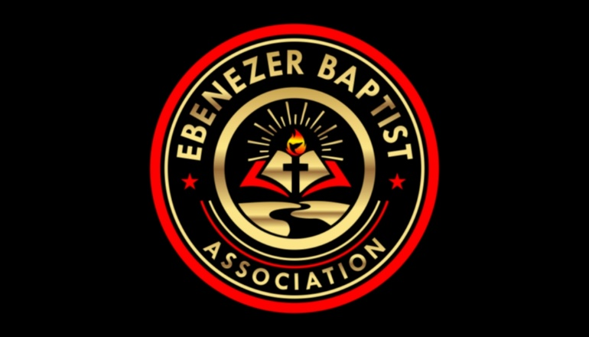

***Ebenezer Baptist Association***

***Rev. Ray Smith, Moderator***

**18206 Bonneville Lane**

**Dinwiddie, Virginia 23841**

**(Cell) 804-405-2101**

***From the Desk of the Moderator***

*For well over 100 years, God has shown this Ebenezer Baptist Association that He is*

*indeed God. From the time of Reverend James Harrison Bagley (our first Moderator)*

*until now, God has helped us and He has given us the tools as an Association of Baptist*

*Churches to navigate through good and difficult times.*

*He has given us the Spiritual Tools to study His Word, to pour into the lives of His*

*people, to meet, greet and gather together for fellowship and edification. As your newly*

*appointed Moderator, I am honored to lead and to serve God’s people as did, those great*

*Moderators and Pulpiteers that came before me.*

*It is my desire that together we will intentionally lead as many persons as possible*

*Into a Dynamic, Appealing and Loving Relationship with Jesus Christ.*

*I Love You Ebenezer*

*Moderator, Ray A. Smith*