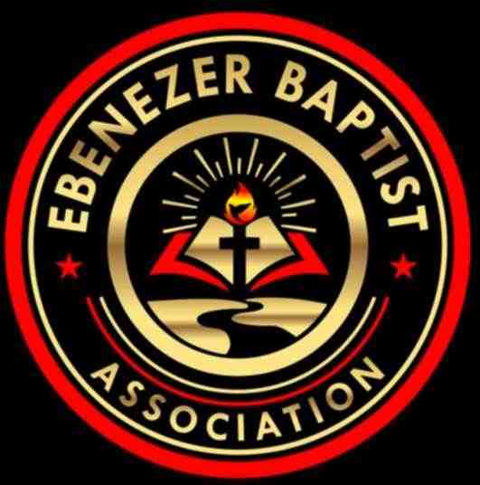
2026 Calendar
 | Event | Date | Time | Place | Pastor Name
January | Finance Meeting –  Executive/Planning Meeting | Jan. 10, 2026 | 9:00 AM | TBA | Moderator  Rev. Ray A. Smith
 | Missionary Ministry Meeting | Jan. 17, 2026 | 9:00AM | TBA | POC: President  Diaconate Beatrice Head
February | Founders Day | Feb. 5 2026 |  | Virginia Union University  Richmond, VA | President: Dr. John Guns
 | Website Meeting | EMAIL | EMAIL |  | Chairperson:  Sis. Barbara Crawley
March | EBA Training  Youth Training | Mar 21, 2026 | 9:00 AM – 11:00 AM | TBA | POC: Dean Rev. Dr. James Kelly  CE Pres. Rev. Jennifer Smith
April | King & Queen Pageant | April 25, 2026 | 2:30 PM | Mount. Level Baptist Church, Amelia, Va. | Contact Person: TBA
May | 159th Annual Session  The VA Baptist State Conv.  -----------------------------------------  Youth Banquet | May 10-14, 2026  ----------------------TBA | Daily  -------------------------- | TBA  ----------------------------------- | President:  Rev. Dr. Waddell Jones Jr.  ---------------------------------------  POC: Deacon Cecil Shell
June | Planning Meeting | June 6, 2026 | 9:00AM | TBA | Moderator  Rev. Ray A. Smith
 | Hampton Ministers Conference | June 7-11, 2026 | Daily | Hampton University  Hampton, VA | President: Dr. Harold A. Carter Jr.
 | Event | Date | Time | Place | Pastor Name
July | Founder’s Day (Children Home) | July 11, 2026 | 11:00 AM | Baptist Children Home of Virginia  Ettrick, VA | Director: Mrs. Erna Robinson
 | EBA Annual Session | July 13-16, 2026 | 8:30 AM-2:00 PM | Friendship Baptist Church  Kenbridge, Va 23841 | Host Pastor: 1st Vice Moderator  Rev. Elmus Morgan
 | Virginia Baptist Congress | July 20-24, 2026 | Daily | TBA | President: Dr. Geoffrey Guns
August | Finance Meeting –  Executive Board Meeting | Aug 22, 2026 | 9:00 AM | TBA | Moderator  Rev. Ray A. Smith
September
October | Missionary Prayer Breakfast | Oct. 24, 2026 | 9:00 AM | Oak Grove Baptist Church  Kenbridge, Virginia 23944 | Host Pastor: Rev. Boris Bullock
November | EBA Training  Youth Training  VBSC Mid Session | Nov. 14, 2026  Nov 9-10, 2026 | 9:00 AM – 11:00 AM  Daily | TBA  TBA | POC: Dean Rev. Dr. James Kelly  CE Pres. Rev. Jennifer Smith  President:  Dr. Waddell Jones Jr.
December | Hayes Allen Day Activities | December 2, 2026 | 8:00 AM – 4:00 PM | VUL  Lynchburg, VA | President: Dr. James Coleman

