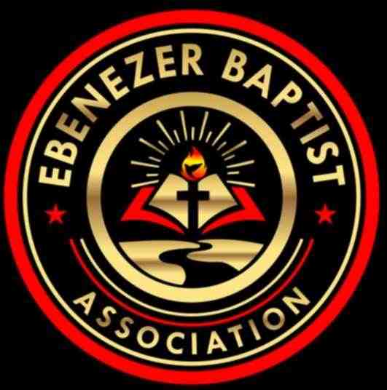

2025 Calendar

|  |  |  |  |  |  |
| --- | --- | --- | --- | --- | --- |
|  | **Event** | **Date** | **Time** | **Place** | **Pastor Name** |
| **January** | Finance Meeting –  Executive/Planning Meeting | Jan. 11, 2025 | 9:00 AM | ZOOM / Tele-Conference | Host Pastor: Moderator  Rev. Ray A. Smith |
|  | Missionary Ministry Meeting | Jan. 18, 2025 | 9:00AM | ZOOM / Tele-Conference | POC: President  Diaconate Beatrice Head |
| **February** | Founders Day | Feb. 1, 2025 |  | Virginia Union University  Richmond, VA | President: Dr. John Guns |
|  | Website Meeting | EMAIL | EMAIL |  | Chairperson:  Sis. Barbara Crawley |
| **March** | EBA Training  Youth Training | Mar 15, 2025 | 9:00 AM – 11:00 AM | ZOOM / Tele-Conference or  TBA at January Meeting | POC: Dean Rev. Damion Batts  CE Pres. Rev. Jennifer Smith |
| **April** | King & Queen Pageant | April 26, 2025 | 2:30 PM | Friendship Baptist Church, Kenbridge, Va  4956 South Hill Road.  Kenbridge, Va 23944 | Host Pastor: 1st Vice Moderator  Rev. Elmus Morgan |
| **May** | 158th  Annual Session  The VA Baptist State Conv.  -----------------------------------------  Youth Banquet | May 12-15, 2025  ----------------------TBA | Daily  -------------------------- | TBA  ----------------------------------- | President:  Rev. Dr. Waddell Jones Jr.  ---------------------------------------  POC: Deacon Cecil Shell |
| **June** | Planning Meeting | June 7, 2025 | 9:00AM | ZOOM/Tele-Conference | Host Pastor: Moderator  Rev. Ray A. Smith |
|  | Hampton Ministers Conference | TBA | Daily | Hampton University  Hampton, VA | President: Dr. Cynthia L. Hale |
|  | **Event** | **Date** | **Time** | **Place** | **Pastor Name** |
| **July** | Founder’s Day (Children Home) | July 12, 2025 | 11:00 AM | Baptist Children Home of Virginia  Ettrick, VA | Director: Mrs. Erna Robinson |
|  | EBA Annual Session | July 15-17, 2025 | 8:30 AM-2:00 PM | Center Star Baptist Church  11627 Wheelers Pond Road  Dinwiddie, Va 23841 | Host Pastor: 2nd Vice Moderator  Rev. Dr. Larry Cooper |
|  | Virginia Baptist Congress | July 21-25, 2025 | Daily | TBA (Tentative Virtual) | President: Dr. Geoffrey Guns |
| **August** | Finance Meeting –  Executive Board Meeting | Aug 23, 2025 | 9:00 AM | ZOOM / Tele-Conference | Host Pastor: Moderator  Rev. Ray A. Smith |
| **September** | Fellowship Luncheon | TBA |  |  | POC: Fellowship Committee |
| **October** | Missionary Prayer Breakfast | Oct. 25, 2025 | 9:00 AM | Unity Baptist Church  542 Unity Road  Kenbridge, Virginia 23944 | Host Pastor: Moderator  Rev. Ray A. Smith |
| **November** | EBA Training  Youth Training  VBSC Mid Session | Nov. 8, 2025  Nov 10 – 11, 2025 | 9:00 AM – 11:00 AM  Daily | ZOOM / Tele-Conference or  TBA at August Meeting  TBA | POC: Dean Rev. Damion Batts  CE Pres. Rev. Jennifer Smith  President:  Dr. Waddell Jones Jr. |
| **December** | Hayes Allen Day Activities | December 3, 2025 | 8:00 AM – 4:00 PM | VUL  Lynchburg, VA | President: Dr. James Coleman |