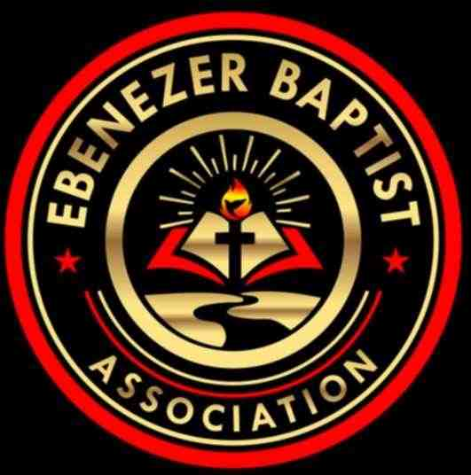

Ebenezer Baptist Association 116th Annual Session Schedule
Host Church: Center Star Baptist Church, Dinwiddie, VA

"KEEPING THE MAIN THING, THE MAIN THING"
Therefore, go and make disciples of all nations, baptizing them in the name of the Father and of the Son and of the Holy Spirit, and teaching them to obey everything I have commanded you. And surely, I am with you always, to the very end of the age.” Matthew 28:19-20.
"GO" - EVANGELIZE | "TEACH - EQUIP" - EDUCATE | "BAPTIZE" - ENROLL

Tuesday, July 15, 2025
9:00 AM – 9:30 AM The 116th Convening of EBA Annual Session
Reverend Ray Smith, Moderator
Devotions — Center Star Baptist Church
Welcome — Reverend Dr. Larry Cooper, Host Pastor

Presiding – Youth Director – Deaconess Hope Nelson
9:30 AM – 10:00 AM Youth Ministry President Address
Vernon Jones II, President
10:00 AM – 11:00 AM Youth Talent Hour Featuring Youth from each EBA Church
Youth Trophy Presentation
11:00 AM – 12:00 AM Youth Workshop —“Faith Lift: ABCD”
Reverend Jessica Jones , Pastor, Author
Tabernacle of Zion Church, Lawrenceville, VA

11:00 AM – 11:30 AM The Baptist Center of Virginia, Inc.
11:30 AM –12:00 PM Baptist General State Convention
Reverend Dr. Ricardo L. Brown
12:00 PM – 1:00 PM Lunch

Presiding – Reverend Dr. Larry Cooper, 2nd Vice Moderator
1:00 PM – 1:30 PM Christian Education President Address
Reverend Jennifer Queen-Smith
1:30 PM – 2:30 PM Adult Workshop —“All About the Deacons”
Deacon Marvin Jones, President of Deacons & Deaconess Auxiliary, Virginia Baptist State Convention
Youth Workshop — “Getting Back To Basics”
Deaconess Hope Nelson, Rosebud Baptist, Dundas, VA
2:30 PM – 3:00 PM Inspirational Sermon
Reverend Dr. Kevin Robinson, Pastor
St. Matthew’s Baptist Church, Kenbridge VA

Offertory Prayer & Offering Association Ushers Ministry, Brother Carl Morgan, President
Benediction

Wednesday, July 16, 2025
Presiding -– Deaconess Joyce Hawkes, Missionary Ministry 2nd Vice President

9:00 AM – 9:30 AM Devotions
Welcome — Reverend Dr. Larry Cooper, Host Pastor

9:30 AM – 10:00 AM Missionary Ministry President Address
Deaconess Mary Irby, Missionary Ministry
1st Vice President
10:00 AM – 11:00 AM Adult Workshop — “Leadership in the Church”
Reverend Joseph Charlton, Senior Pastor
First Baptist Church, Franklin, Virginia
10:00 AM – 11:30 AM Youth Workshop —“The Power of Your Word”
Sister Rozanne Logan
Rosebud Baptist Church, Dundas, VA

11:00 AM – 11:30 AM Virginia Baptist State Convention
Dr. Waddell Jones, President
11:30 AM – 12:00 PM Committee Meetings Breakout

12:00 PM – 1:00 PM Lunch
Presiding – Reverend Elmus Morgan, 1st Vice Moderator
1:00 PM – 1:30 PM Award Scholarships
EBA Queen Recognition
1:30 PM – 2:30 PM “Getting Back to Basic “Family & Home”
Deacon Cecil E. Shell, Regional Emmy Award Winning Episode —“Memories of A Tobacco Farmer”
Rosebud Baptist Church, Dundas, VA
1:30 PM – 2:30 PM Youth Workshop —“Eyes on the Mission”
Minister Daniel P.Y. Smith, Assistant Pastor,
Springhill Baptist Church, Blackstone, VA

2:30 PM – 3:00 PM Moderator’s Address
Reverend Ray Smith

Offertory Prayer & Offering Association Ushers Ministry, Brother Carl Morgan, President
Benediction

Thursday, July 17, 2025

9:00 AM – 9:30 AM Devotions
Welcome — Dr. Larry Cooper, Host Pastor

9:30 AM – 11:00 AM Business Meeting
Committee Reports: Voices from the Committee Chairpersons
Installation of Officers

11:00 AM – 11:30 AM Communion
Reverend Ray Smith, Moderator
Reverend Elmus Morgan, 1st Vice Moderator

Adjourn Session/Benediction Moderator Ray Smith

Social Media Platforms
Website: www.ebenezerbaptistassociation.org
Facebook: Ebenezer Baptist Association

