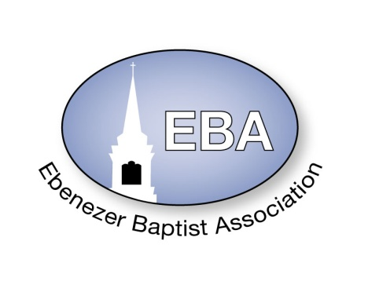
2021 Calendar
 | Event | Date | Time | Place | Pastor Name
January | Finance Meeting – 9:00 AM  Executive/Planning Meeting -10:00 AM | Jan. 9, 2021 | 9:00 AM-12:00 Noon | ZOOM | Host Pastor: Moderator
 | Missionary Ministry Meeting | Jan. 23, 2021 | 9:00AM | Mount Gazerine Baptist  3606 Kenbridge Rd  Blackstone, VA 23824 | Host Pastor:  Dr. Irene Allen
February | Founders Day | Feb. 6, 2021 |  | Virginia Union University  Richmond, VA | Moderator:  Rev. Wanda Wallace-Tucker
 | Website Meeting | EMAIL | EMAIL |  | Chairperson:  Sis. Barbara Crawley
March | EBA Training  Youth Training | Mar 20, 2021 | 9:00 AM – 11:00 AM | St Matthews Baptist Church  219 N. Board St  Kenbridge, VA 23944 | Host Pastor:  Rev. Kevin A. Robinson
April | King & Queen Pageant | April 24, 2021 | 2:30 PM | Shiloh Baptist Church-Din  4610 W. Darvills Rd  Blackstone, VA 23824 | Host Pastor:  Rev. Kelvin C. Smith
May | 154rd Annual Session  The VA Baptist State Conv.  -----------------------------------------  Youth Banquet | May 10-13, 2021  ----------------------May 15, 2021 | Daily  --------------------------  2:30 PM | Roanoke, VA  -----------------------------------  People’s Community Center  Victoria, VA | Moderator  ---------------------------------------  POC: Deacon Cecil Shell
June | Planning Meeting | June 5, 2021 | 10AM – 12:00 Noon | Mount Nebo Baptist Church  476 Mount Nebo Rd  Blackstone, VA 23824 | Host Pastor:  Rev. Damion T. Batts
 | Event | Date | Time | Place | Pastor Name
 | Hampton Ministries Conference | June 7-11 June, 2021 | Daily | Hampton University  Hampton, VA | Moderator:
July | Founder’s Day (Children Home) | July 10, 2021 | 11:00AM | Baptist Children Home of Virginia  Ettrick, VA | Moderator:  .
 | EBA Concert  EBA Annual Session | July 12, 2021  July 13-16, 2021 | 7:00 PM  8:30AM – 3:00 PM | Mount Nebo Baptist Church  476 Mount Nebo Rd  Blackstone, VA 23824 | Host Pastor:  Rev. Damion T. Batts
 | Sunday School & BTU Congress | July 19-23, 2021 | Daily | Virginia State University  Petersburg, VA
August | Finance Meeting – 9:00 AM  Executive Board – 10:00 AM | Aug 28, 2021 | 9:00 AM-12:00 Noon | Mount Zion Baptist Church  9308 Cox Rd  Ford, VA 23850 | Host Pastor:  Rev. Dr. Joseph Fields
September | Fellowship Luncheon | Sept. 25, 2021 | 2:30 PM | Nottoway Civic League  1010 Mt Nebo Rd  Blackstone, VA 23824
October | Missionary Prayer Breakfast | Oct. 23, 2021 | 9:00 AM | Little Mount Baptist Church  34330 Christanna Highway  Blackstone, VA 23824 | Host Pastor:  Rev. Wanda Wallace-Tucker
November | EBA Training  Youth Training | Nov. 13, 2021 | 9:00 AM – 11:00 AM | Sharon Baptist Church  26804 Fort Emory Rd  N. Dinwiddie, VA | Host Pastor:
December | Hayes Allen Day Activities | December 1, 2021 | 8:00AM – 4:00PM | VUL  Lynchburg, VA

