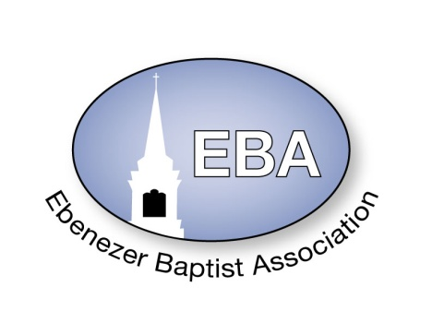

2022 Calendar

|  |  |  |  |  |  |
| --- | --- | --- | --- | --- | --- |
|  | **Event** | **Date** | **Time** | **Place** | **Pastor Name** |
| **January** | Finance Meeting – 9:00 AM  Executive/Planning Meeting -10:00 AM | Jan. 8, 2022 | 9:00 AM-12:00 Noon | ZOOM / Tele-Conference | Host Pastor: Moderator  Rev. Dr. Wanda Wallace-Tucker |
|  | Missionary Ministry Meeting | Jan. 22, 2022 | 9:00AM | ZOOM / Tele-Conference | POC: President  Diaconate Beatrice Head |
| **February** | Founders Day | Feb. 5, 2022 |  | Virginia Union University  Richmond, VA | President: Dr. John Guns |
|  | Website Meeting | EMAIL | EMAIL |  | Chairperson:  Sis. Barbara Crawley |
| **March** | EBA Training  Youth Training | Mar 19, 2022 | 9:00 AM – 11:00 AM | ZOOM / Tele-Conference or  TBA at January Meeting | POC: Dean Rev. Damion Batts  CE Pres. Rev. Jennifer Smith |
| **April** | King & Queen Pageant | April 23, 2022 | 2:30 PM | Mount Gazerine Baptist  3606 Kenbridge Road  Blackstone, VA 23824 | Host Pastor:  Rev. Dr. Irene Allen |
| **May** | 154rd Annual Session  The VA Baptist State Conv.  -----------------------------------------  Youth Banquet (Cancelled) | May 9-12, 2022  ----------------------May 14, 2022 | Daily  --------------------------  2:30 PM | Roanoke, Va  -----------------------------------  People’s Community Center  Victoria, VA | President:  Rev. Dr. D. Tyrone Brandon  ---------------------------------------  POC: Deacon Cecil Shell |
| **June** | Planning Meeting | June 4, 2022 | 10AM – 12:00 Noon | ZOOM/Tele-Conference | Host Pastor:  Rev. Dr. Wanda Wallace-Tucker |
|  | Hampton Ministers Conference | June 6-10, 2022 | Daily | Hampton University  Hampton, VA |  |
|  | **Event** | **Date** | **Time** | **Place** | **Pastor Name** |
| **July** | Founder’s Day (Children Home) | July 9, 2022 | 11:00AM | Baptist Children Home of Virginia  Ettrick, VA | Director: Mrs. Erna Robinson |
|  | EBA Concert  EBA Annual Session | July 11, 2022  July 12-15, 2022 | 7:00 PM  8:30AM – 3:00 PM | Mount Nebo Baptist Church  476 Mount Nebo Rd  Blackstone, VA 23824 | Host Pastor:  Rev. Damion T. Batts |
|  | Sunday School & BTU Congress | July 18-22, 2022 | Daily | TBA (Tentative Virtual) | President: Dr. Kevin Northam |
| **August** | Finance Meeting – 9:00 AM  Executive Board – 10:00 AM | Aug 27, 2022 | 9:00 AM-12:00 Noon | ZOOM / Tele-Conference | Host Pastor:  Rev. Dr. Wanda Wallace-Tucker |
| **September** | Fellowship Luncheon | Sept. 24, 2022 | 2:30 PM | Nottoway Civic League  1010 Mt Nebo Rd  Blackstone, VA 23824 | POC: Fellowship Committee |
| **October** | Missionary Prayer Breakfast | Oct. 22, 2022 | 9:00 AM | Little Mount Baptist Church  34330 Christanna Highway  Blackstone, VA 23824 | Host Pastor:  Rev. Dr. Wanda Wallace-Tucker |
| **November** | EBA Training  Youth Training  VBSC Mid Session | Nov. 12, 2022  Nov 14 – 15, 2022 | 9:00 AM – 11:00 AM  Daily | ZOOM / Tele-Conference or  TBA at August Meeting  TBA | POC: Dean Rev. Damion Batts  CE Pres. Rev. Jennifer Smith  President:  Dr. D. Tyrone Brandon |
| **December** | Hayes Allen Day Activities | December 7, 2022 | 8:00AM – 4:00PM | VUL  Lynchburg, VA | President: Dr. James Coleman |