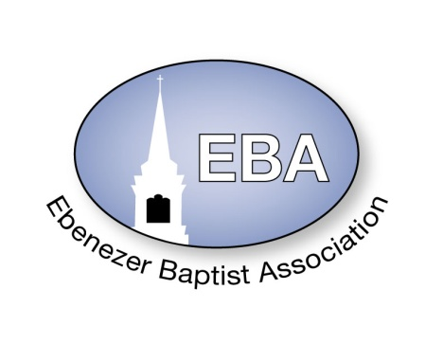

2023 Calendar

|  |  |  |  |  |  |
| --- | --- | --- | --- | --- | --- |
|  | **Event** | **Date** | **Time** | **Place** | **Pastor Name** |
| **January** | Finance Meeting –  Executive/Planning Meeting | Jan. 7, 2023 | 9:00 AM | ZOOM / Tele-Conference | Host Pastor: Moderator  Rev. Dr. Wanda Wallace-Tucker |
|  | Missionary Ministry Meeting | Jan. 21, 2023 | 9:00AM | ZOOM / Tele-Conference | POC: President  Diaconate Beatrice Head |
| **February** | Founders Day | Feb. 4, 2023 |  | Virginia Union University  Richmond, VA | President: Dr. John Guns |
|  | Website Meeting | EMAIL | EMAIL |  | Chairperson:  Sis. Barbara Crawley |
| **March** | EBA Training  Youth Training | Mar 18, 2023 | 9:00 AM – 11:00 AM | ZOOM / Tele-Conference or  TBA at January Meeting | POC: Dean Rev. Damion Batts  CE Pres. Rev. Jennifer Smith |
| **April** | King & Queen Pageant | April 22, 2023 | 2:30 PM | Little Mount Baptist Church  34330 Christanna Highway  Blackstone, Va 23824 | Host Pastor:  Rev. Dr. Wanda Wallace-Tucker |
| **May** | 156th  Annual Session  The VA Baptist State Conv.  -----------------------------------------  Youth Banquet | May 15-18, 2023  ----------------------TBA | Daily  -------------------------- | TBA  ----------------------------------- | President:  Rev. Dr. D. Tyrone Brandon  ---------------------------------------  POC: Deacon Cecil Shell |
| **June** | Planning Meeting | June 3, 2023 | 10AM – 12:00 Noon | ZOOM/Tele-Conference | Host Pastor:  Rev. Dr. Wanda Wallace-Tucker |
|  | Hampton Ministers Conference | June 5-9, 2023 | Daily | Hampton University  Hampton, VA |  |
|  | **Event** | **Date** | **Time** | **Place** | **Pastor Name** |
| **July** | Founder’s Day (Children Home) | July 8, 2023 | 11:00AM | Baptist Children Home of Virginia  Ettrick, VA | Director: Mrs. Erna Robinson |
|  | EBA Annual Session | July 11-13, 2023 | 8:30AM-2:00 PM | Mount Level Baptist Church  901 Wills Road  Court House, Va 23002 | Host Pastor:  Rev. Dr. Charles Shannon |
|  | Sunday School & BTU Congress | July 17-21, 2023 | Daily | TBA (Tentative Virtual) | President: Dr. Kevin Northam |
| **August** | Finance Meeting –  Executive Board Meeting | Aug 26, 2023 | 9:00 AM | ZOOM / Tele-Conference | Host Pastor:  Rev. Dr. Wanda Wallace-Tucker |
| **September** | Fellowship Luncheon | TBA |  |  | POC: Fellowship Committee |
| **October** | Missionary Prayer Breakfast | Oct. 21, 2023 | 9:00 AM | Rosebud Baptist Church  249 Gigg Road  Dundas, Virginia 23938 | Host Pastor:  Rev. Dr. Waverly Brown |
| **November** | EBA Training  Youth Training  VBSC Mid Session | Nov. 11, 2023  Nov 13 – 14, 2023 | 9:00 AM – 11:00 AM  Daily | ZOOM / Tele-Conference or  TBA at August Meeting  TBA | POC: Dean Rev. Damion Batts  CE Pres. Rev. Jennifer Smith  President:  Dr. D. Tyrone Brandon |
| **December** | Hayes Allen Day Activities | December 6, 2023 | 8:00AM – 4:00PM | VUL  Lynchburg, VA | President: Dr. James Coleman |