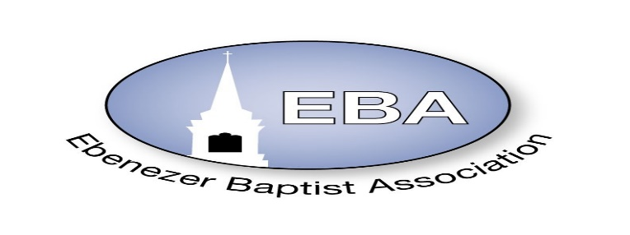
EBA SMALL BUSINESS DIRECTORY
Business Specialty

Center Star Baptist Church
Rev. Dr. Larry Cooper

Epps & Son Lawn Care
Deacon & Deaconess Charles& Tammie Epps
12037 Wheeler Pond Rd
Dewitt, Va. 23840
(804) 731-6663
Fashion Forward
Deacon & Deaconess Charles& Tammie Epps
804) 731-6662

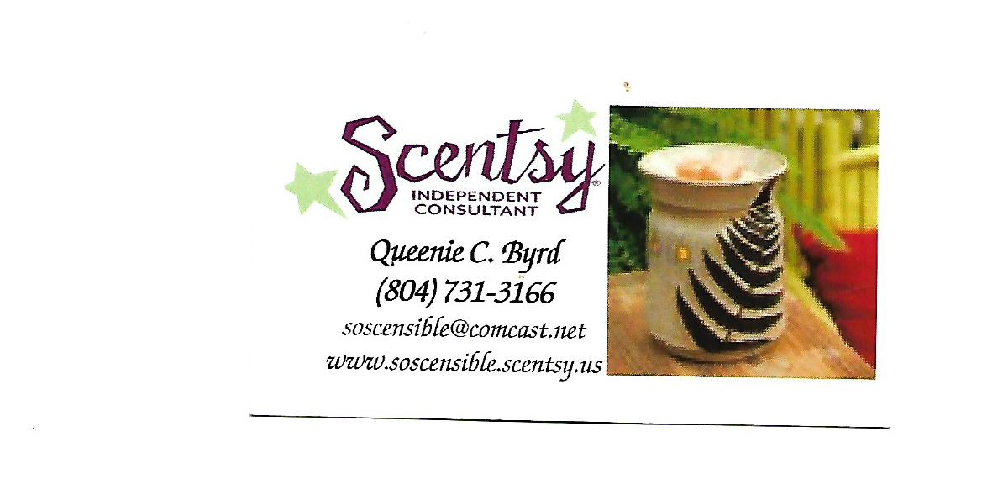
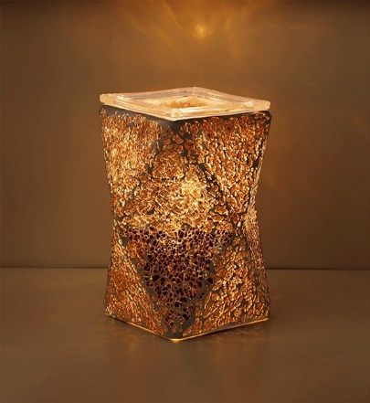
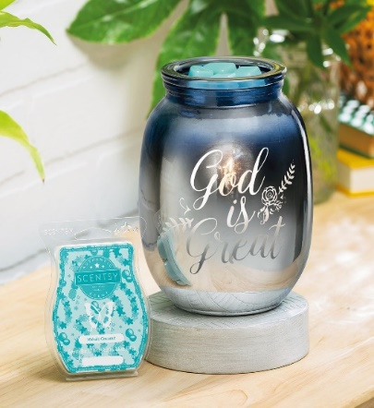
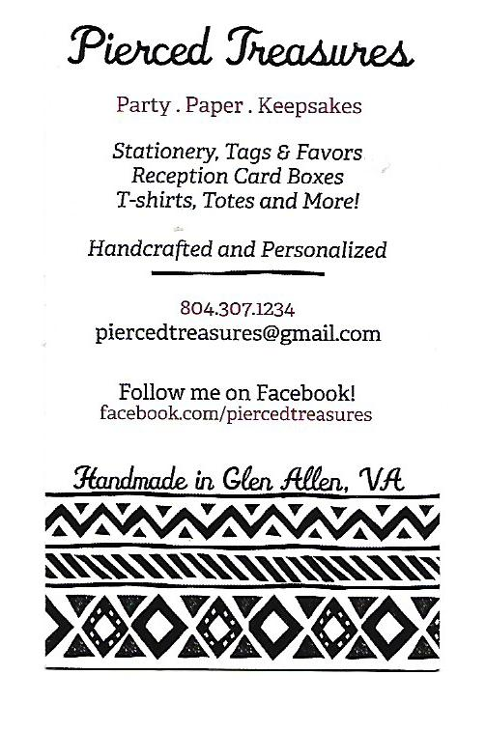

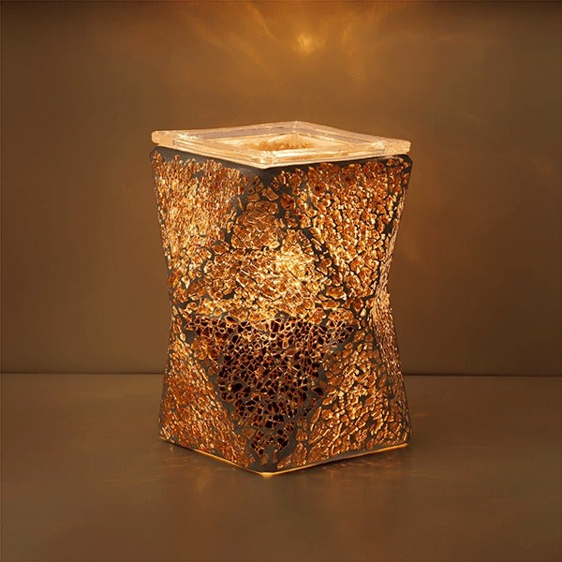
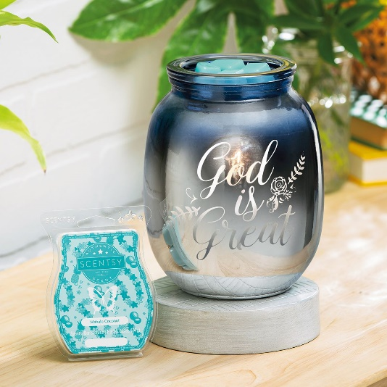

Little Mt. Baptist Church
Rev. Dr. Wanda Wallace-Tucker

Mahogany Designs
Custom Apparel & More
@info@mahoganydesignsco.com or
Mahoganydesigns20@gmail.com
Customize T-Shirts, face masks and
Party favors (chip bags, candy bars, etc.)
Owner: Shandrelle Fisher
(757) 379-5225

Mt. Level Baptist Church
Rev. Charles L. Shannon, III, D. Min

Always Sharper Knives • “We give you an Edge”
R. Williams a.k.a. Uncle Bubba
C: 804-704-0704
Email: asharperknives@gmail.com

B&M Heavenly Hands Home Care, Inc. • Where our Focus is providing the proper care
3250 Holland Drive | Petersburg, VA 23803 for your loved ones in the comfort of their own
Myeshia Rose, Owner home.
Phone number: 434-294-3807

Booker Realty Group, LLC • We Buy Houses
James Booker II, Owner |Real Estate Investor
C: 434-294-3505
Email: rekoob@icloud.com

Your Cruise and Land Specialist • Specializing in cruises, land and tour
Independently Owned & Operated by Joyce Worsham, ACC vacations, Destination Weddings,
Associate of Gloria Thomas Honeymoons, Individual & Group Travel,
Email: joyce.worsham@cruiseplanners.com Family or High School Reunion, Meetings &
Website: www.familynfriendstravel.com Corporate Incentive Travel, Non-profit
H: 804-321-4690; C: 804-334-6579; B: 804-251-0349 Organization

KIPICS • Available for parties/birthday parties,
Kiara Johnson, Photographer weddings, baby showers and photo
Photography sites: Facebook- KiPics; Instagram- kipics shoot sessions
Contact number: 434-294-4690

Personal Favors by Sandra • Creating something PERSONAL for YOU!!
Sandra Johnson, Crafter Personalized T-Shirts, Invitations, Party Deco
C: 804-677-2499 & More
Email: PersonalfavorsbyShandra@gmail.com

Worsham Adventures, LLC • Weddings & Honeymoons
Independently Owned & Operated • Wedding Anniversaries
Joyce B. Worsham • Milestone Birthday Celebrations
H: 804-321-4690
C: 804-334-6579
B: 804-251-0349
Email: jbworsham@comcast.net; jbworsham6@gmail.com; jworshadven@gmail.com

