May 2022  S M T W T F S  1 2 3 4 5 6 7  8 9 10 11 12 13 14  15 16 17 18 19 20 21  22 23 24 25 26 27 28  29 30 31 |  |  | JUNE 2022 |  |  | July 2022  S M T W T F S  1 2  3 4 5 6 7 8 9  10 11 12 13 14 15 16  17 18 19 20 21 22 23  24 25 26 27 28 29 30  31
Sunday |  | Monday | Tuesday | Wednesday | Thursday | Friday | Saturday
 | 29 | 30 | 31 | 1 | 2 | 3 | 4
 |  |  |  |  |  | National Donut Day
 | 5 | 6 | 7 | 8 | 9 | 10 | 11
 | 12 | 13 | 14 | 15 | 16 | 17 | 18
 | 19 | 20 | 21 | 22 | 23 | 24 | 25
Father's Day |  |  | 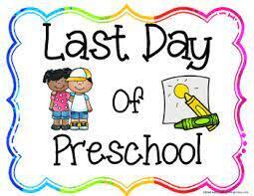 | Toddler, Wrap Around, School Age can attend | Toddler, Wrap Around, School Age can attend | Toddler, Wrap Around, School Age can attend
 | 26 | 27 | 28 | 29 | 30 | 1 | 2

June 2022  S M T W T F S  1 2 3 4  5 6 7 8 9 10 11  12 13 14 15 16 17 18  19 20 21 22 23 24 25  26 27 28 29 30 |  |  | JUNE / JULY 2022 |  |  | August 2022  S M T W T F S  1 2 3 4 5 6  7 8 9 10 11 12 13  14 15 16 17 18 19 20  21 22 23 24 25 26 27  28 29 30 31
Sunday |  | Monday | Tuesday | Wednesday | Thursday | Friday | Saturday
 | 26 | 27 | 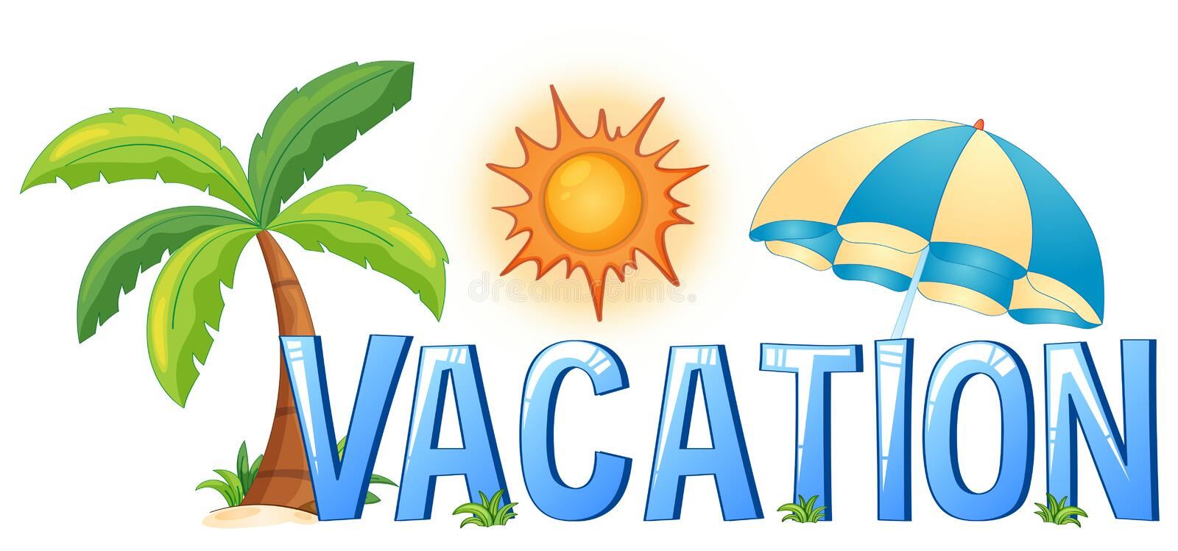  28 | 29 | 30 | 1 | 2
 |  | Toddler, Wrap Around, School Age can attend | No School for all students  – Summer Vacation  – Summer Vacation | No School for all students  – Summer Vacation | No School for all students  – Summer Vacation | No School for all students  – Summer Vacation
 | 3 | 4 | 5 | 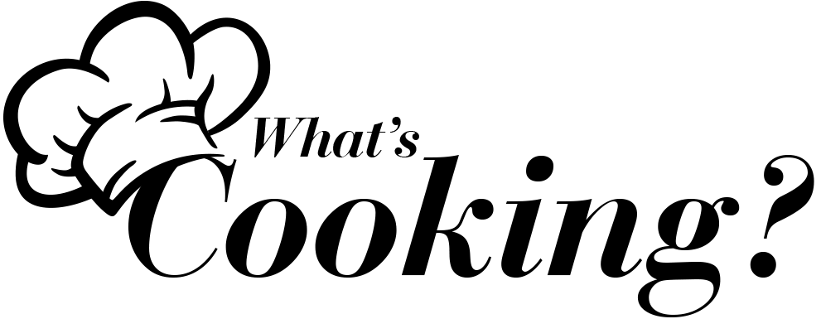  6 | 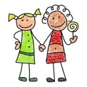  7 | 8 | 9
ALL ABOUT ME WEEK |  | No School for all students  – Summer Vacation | 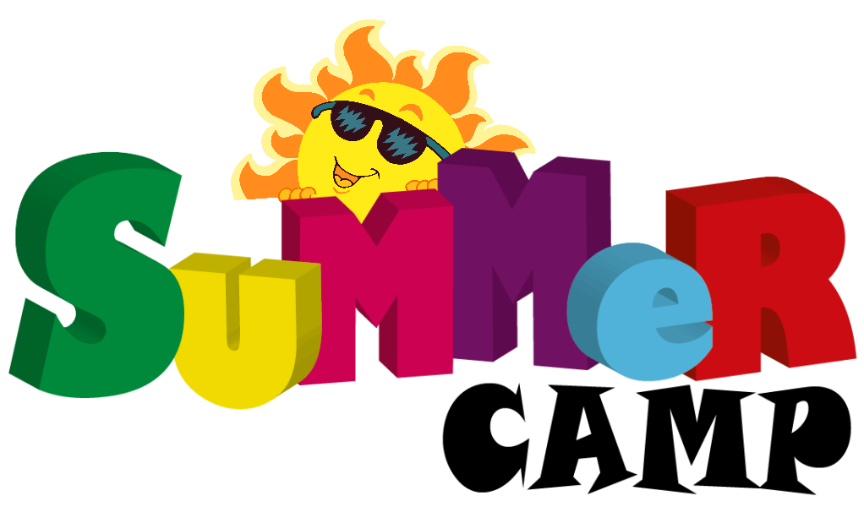  1st Day | Create how you feel Pizza | Pick a little buddy day | 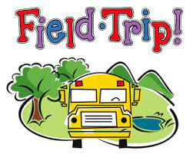  Bowling
 | 10 | 11 | 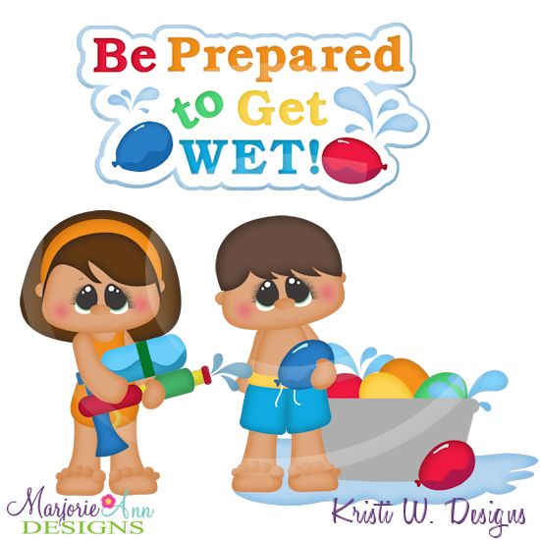  12 | 13 | 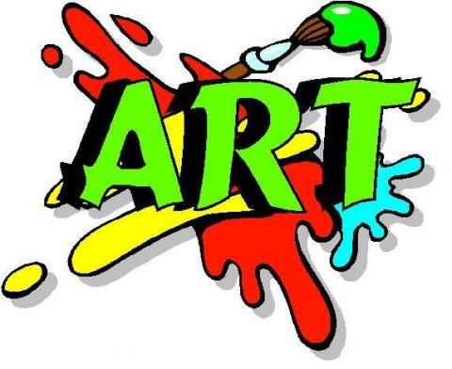  14 | 15 | 16
OUTDOORS |  | 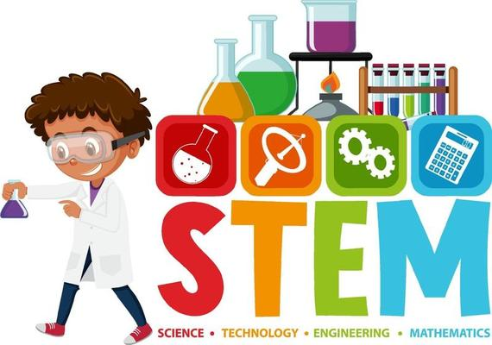  Liquid Chalk | Water Wars | Dirt Cake | Bird Feeder | Smith Memorial Playground
 | 17 | 18 | 19 | 20 | 21 | 22 | 23
ALL ABOUT ANIMALS |  | Animal Puppets | Making food for our favorite animal | Elmwood Park Zoo | Animal Collage | 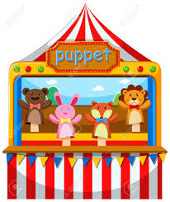  Animal Puppet Show
 | 24 | 25 | 26 | 27 | 28 | 29 | 30
UNDER THE SEA |  | Aquarium - Sponge Paint | 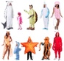  Dress like your favorite Sea Creature | Edible Fish Bowls | Water Wars | Adventure Aquarium
 | 31

July 2022  S M T W T F S  1 2  3 4 5 6 7 8 9  10 11 12 13 14 15 16  17 18 19 20 21 22 23  24 25 26 27 28 29 30  31 |  |  | AUGUST 2022 |  |  | September 2022  S M T W T F S  1 2 3  4 5 6 7 8 9 10  11 12 13 14 15 16 17  18 19 20 21 22 23 24  25 26 27 28 29 30
Sunday |  | Monday | Tuesday | Wednesday | Thursday | Friday | Saturday
 | 31 | 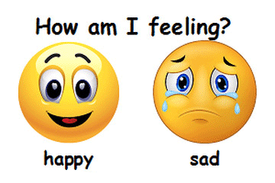  1 | 2 | 3 | 4 | 5 | 6
EXPRESSIONS WEEK 1 |  | Create a Word Wall of feelings & expressions | 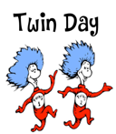 | Sky Zone | 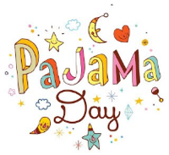 | Water Wars
 | 7 | 8 | 9 | 20 | 11 | 12 | 13
EXPRESSIONS WEEK 2 |  | 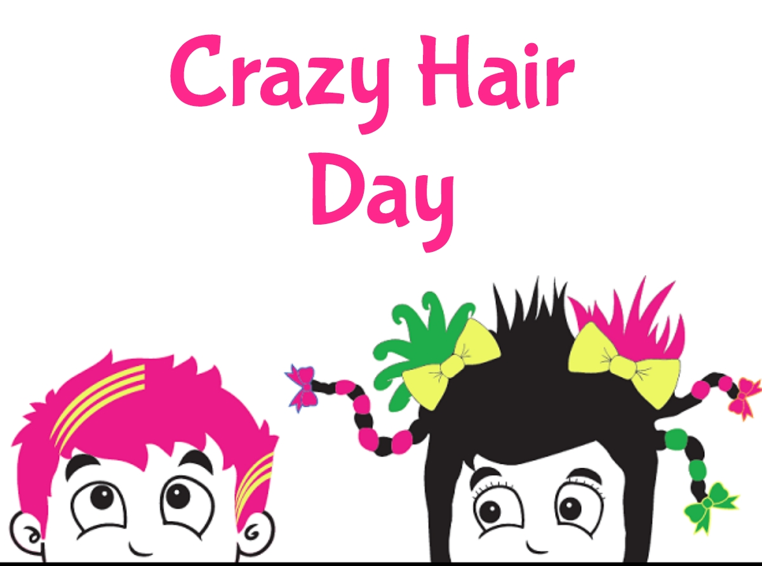 | 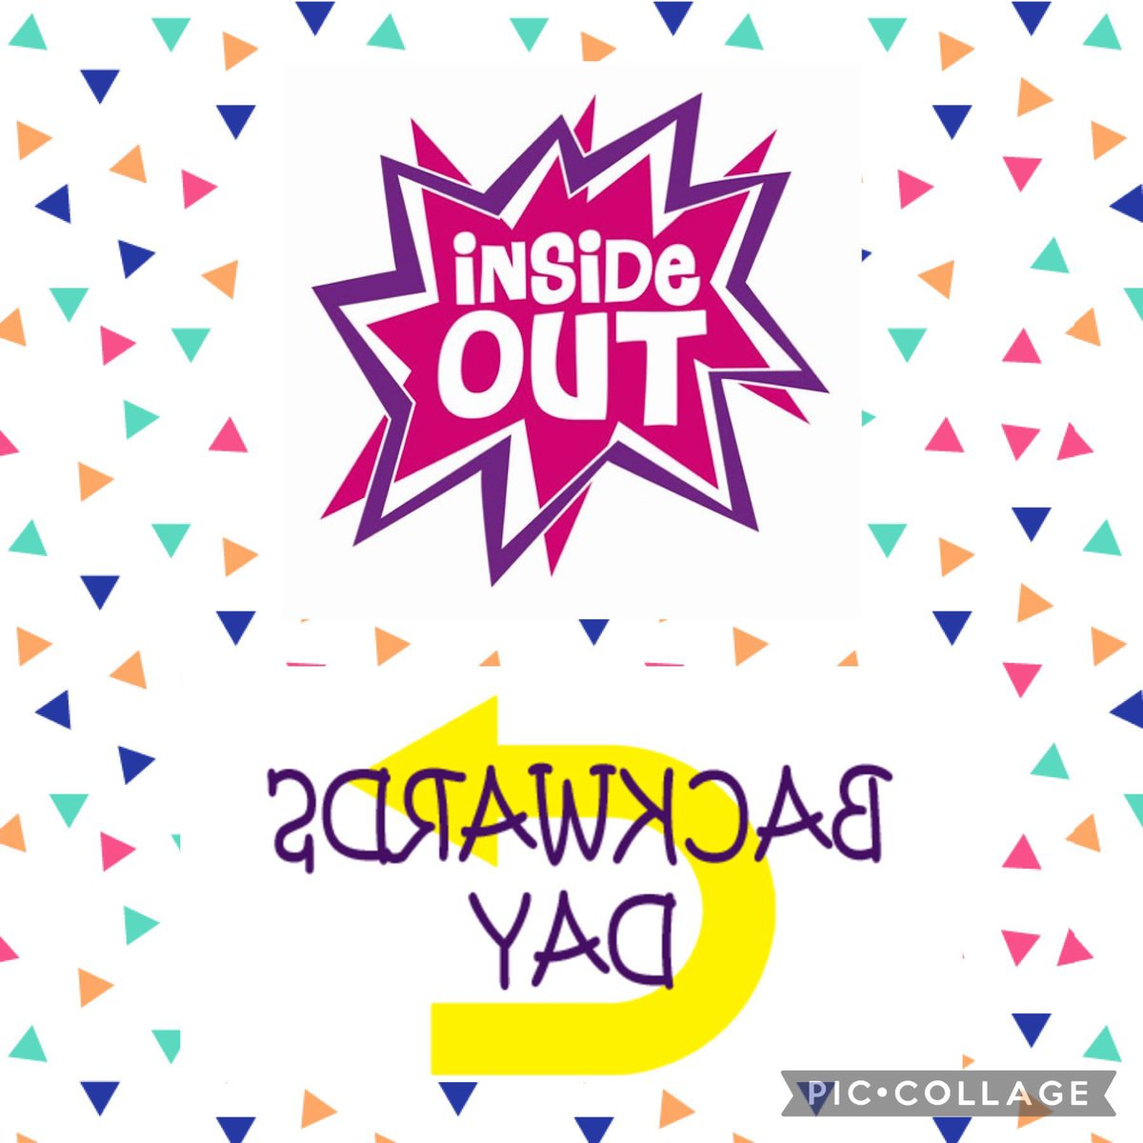 | Please Touch Museum | Water Wars | Talent Show
 | 14 | 15 | 16 | 17 | 18 | 19 | 20
SCIENCE WEEK |  | Franklin Institute | Frozen Hands 1 | Frozen Hands 2 | Solar Oven | Creating Volcano
 | 21 | 22 | 23 | 24 | 25 | 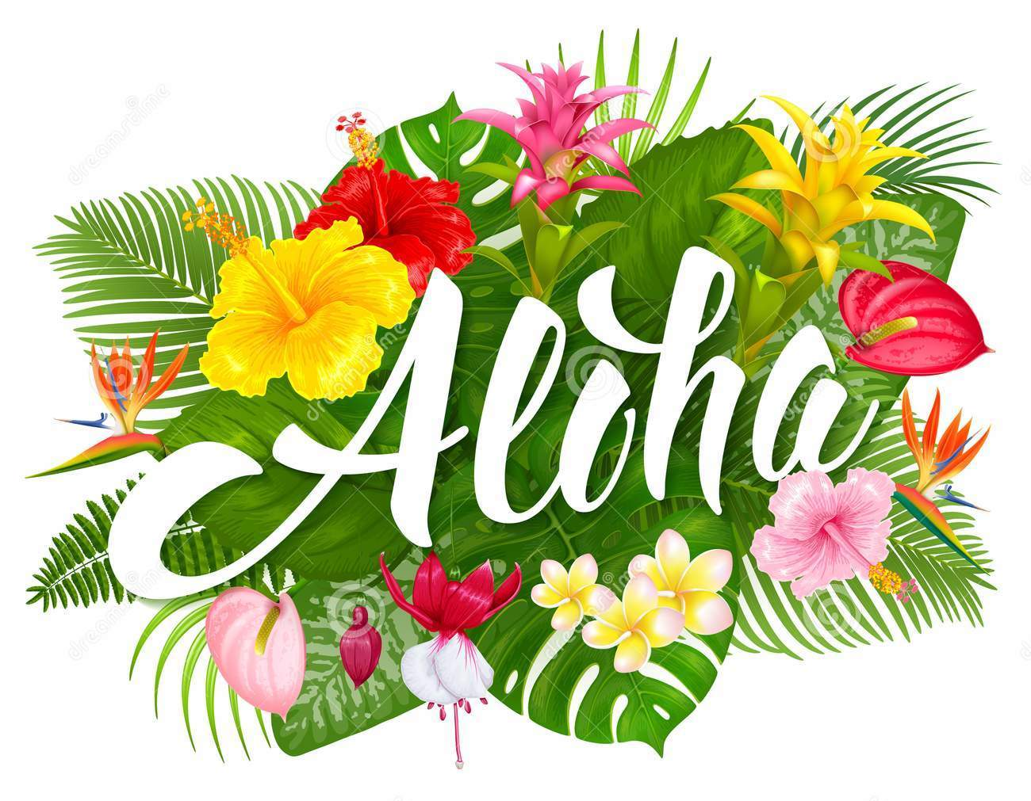  26 | 27
ALOHA WEEK |  | 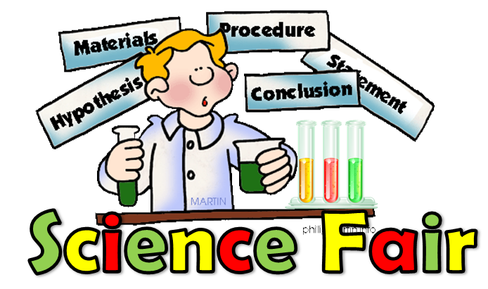 | Make a Lei | Make food that is common in Hawaii | Make a Hula Skirt
 | 28 | 29 | 30 | 31
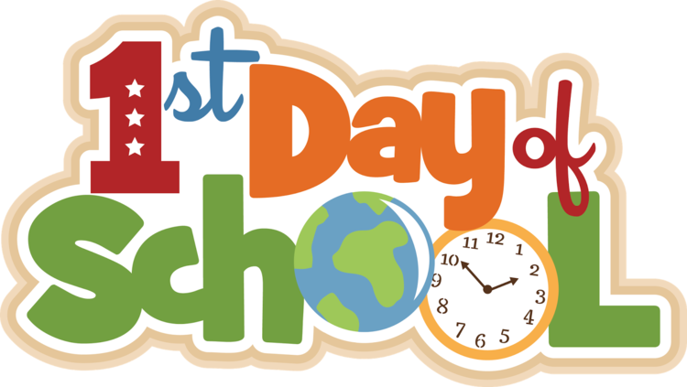
Phila. School District District

