North Platte Walleyes Unlimited, Inc.
2026

PO Box 1363, Casper WY 82602



Club meetings are suspended until October, so our board members can take time camping, fishing, and enjoying summer.

THANK YOU, THANK YOU to everyone who supported our club at this year's banquet.
We are so grateful to our table sponsors for all your help.

Next year's “ALL YOU CAN EAT WALLEYE BANQUET” will have a small change. Banquet date will be February 27th , 2027. Still at the same location and the same great food.
Mark your calendars.

The 2026 Toughman Tournament was a success. We hope you all enjoyed your day on the water.

Walleye:
1st: Team 6, KUHN, SCHULER, HERDER
2nd: Team 23, JENSEN, SOJOURNER, BITZAN
3rd: Team 3, BLEHM, WRAY, DAVIS
4th: Team 23, JENSEN, SOJOURNER, BITZAN.
Trout: 1st: Team 3, BLEHM, WRAY, DAVIS
2nd: Team 34, LENSERT, LENSERT, ALSABER
3rd: Team 18, DORNBIER, MEUISSEN, PLUMMER

We had a mix-up in the trout division and 2nd place actually was team #34. We did get it corrected and $$ paid out and plaques.

1st Place Walleye 2nd Place Walleye
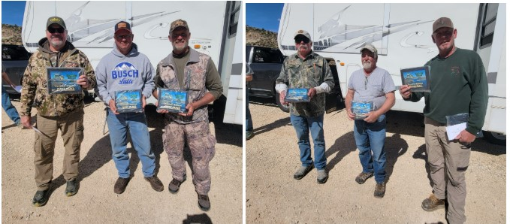

3rd Place Walleye 4th Place Walleye
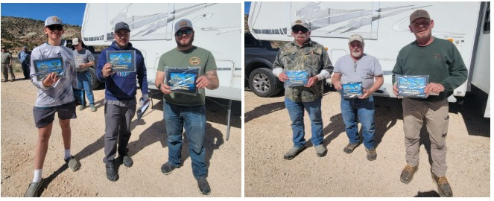

1st Place Trout 2nd Place Trout 3rd Place Trout
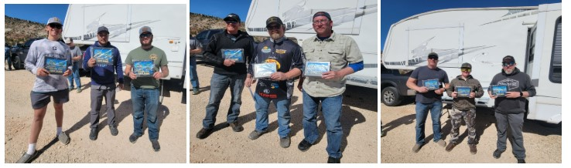

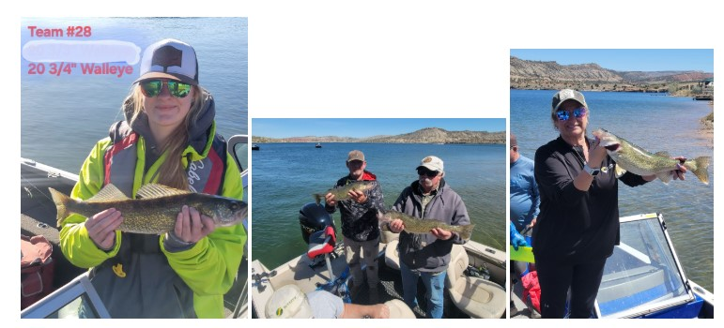
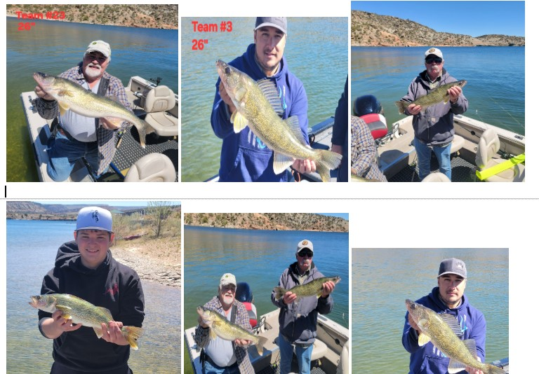

Please follow this link for the Casper Game and Fish Fishing Forecast:
Casper Region Fishing Forecast: Strong populations meet challenging water levels | Wyoming Game & Fish Department

Upcoming Events:
June 6th – Kids Free Fishing @ Harry Yesness Pond from 9am to 1pm
August 23rd – Family Outing @ Pathfinder Reservoir Diabase Shelter @ 3PM
October 7th- Next Club Meeting @ Air Innovations @ 6pm

Current Water Levels:
Glendo: https:www.usbr.gov/gp-bin/arcweb_patr.pl
Pathfinder: https:www.usbr.gov/gp-bin/arcweb_gler.pl
Seminoe: https:www.usbr.gov/gp-bin/arcweb_semr.pl
Alcova: https:www.usbr.gov/gp-bin/arcweb_alcr.pl
Boysen: www.usbr.gov/gp-bin/arcweb_boyr.pl
Grey Reef: https:www.usbr.gov/gp-bin/arcweb_grar.pl
Guernsey: https:www.usbr.gov/gp-bin/arcweb_guer.pl

Board of Directors
President: George Overman (797-0417)
Vice Pres: Brian Woodward (258-8898)
Secretary: Cheryl Juarez (267-0984)
Treasurer: Willie Forbes (797-3449)

Directors:
Jay Zastrow (267-0287)
Tom Juarez (267-9266)
Woody Giles (247-0695)
Ted Thompson (259-0266)
LaCinda Tilton (267-2171)

