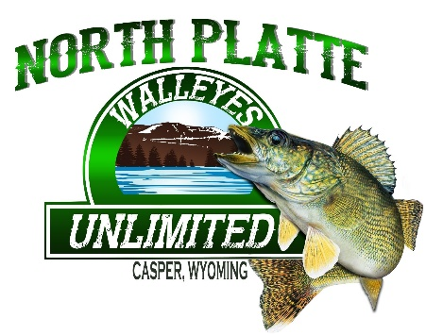
2020 SPRING / SUMMER WALLEYE LEAGUE
PRESENTED BY: ROCKY MOUNTAIN DISCOUNT SPORTS

PROMOTING A NO FEE EVENT… OPEN TO ALL NPWU MEMBERS… CAN SIGN UP EACH NIGHT OF THE EVENT IF NOT A MEMBER (ONE TIME $20 MEMBERSHIP DUES APPLY)
WHO: ANYONE THAT LOVES WALLEYE FISHING!
WHAT: NPWU WALLEYE LEAGUE
WHERE: PATHFINDER RESERVOIR (MARINA)
TIME: 5PM TO 9PM (TEAMS MUST CHECK IN BETEWEEN 4PM AND 5:30PM AT THE MARINA)
DATES: MAY 21ST THROUGH JULY 30TH (CHAMPIONSHIP TO BE HELD AUGUST 22ND @ PATHFINDER)

FORMAT: CATCH, PHOTO, RELEASE (CPR)
- 2-3 ANGLERS PER TEAM (MAKE SURE TO BRING KIDS BECAUSE THEY WILL HAVE THEIR OWN CATEGORY!)
- 9 WEEKS LONG – BEST 5 WEEKS TOTAL WEIGHT WILL BE COUNTED TOWARD END OF SEASON AWARDS
- BOAT WEIGHT WILL FOLLOW ANGLERS EVERY WEEK
- 15” MINIMUM… HAWG TROUGH AND TOKEN GIVEN EACH NIGHT FOR PHOTOS (HAWG TROUGH AND TOKEN MUST BE RETURNED @ END OF EVENING)
- ALL FISH OVER 22” MUST HAVE A TROPHY PICTURE TAKEN!!!
- ALL LIVEWELLS WILL BE CHECKED BEFORE LAUNCH!
- 5 BEST FISH RECORDED EVERY NIGHT
- EACH NIGHT THERE WILL BE AN OPTIONAL BIG FISH POT $20 PER TEAM
- GAME AND FISH RULES AND REGULATIONS WILL BE FOLLOWED
GOAL:
- TO ENCOURAGE NEW MEMBERSHIP
- TO ENCOURAGE FAMILY AND YOUTH PARTICIPATION
- TO ENCOURAGE WALLEYE FISHING PARTICIPATION WITH A CONSERVATION GOAL IN MIND
PRIZES:
- WEEKLY PLAQUES FOR HEAVIEST WEIGHT
- PLAQUES AWARDED TO TOP 3 TEAMS OF THE SEASON (BEST 5 WEEKS OUT OF 9 WEEKS)
- TOP YOUTH ANGLER AWARDED PLAQUE AND FISHING ROD AND TACKLE BOXES

