North Platte Walleyes Unlimited, Inc.
FEBRUARY 2026

PO Box 1363, Casper WY 82602

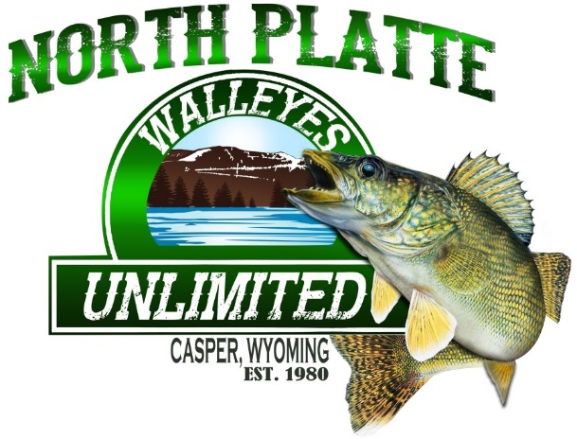

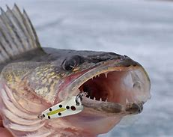

NEXT CLUB MEETING MARCH 4TH
7:00 @ AIR INNOVATIONS

*******SAVE THE DATE*******
******2026 WALLEYE ALL-YOU-CAN-EAT BANQUET********

Exciting news, that our 2026 All You Can Eat Walleye Banquet will be held on April 18th at Fairgrounds Industrial Building. Tickets are now available. See Brian Woodward at RM Discount Sports or any board member.
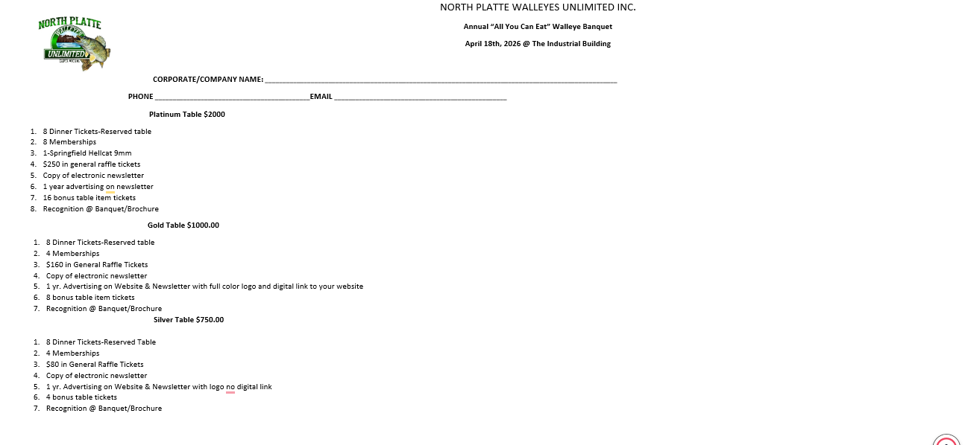

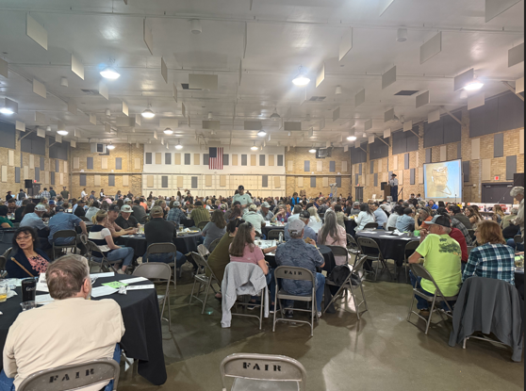
NPWU made the following donations for our community in 2025. $2,000 was donated to the Natrona County School District to help pay for student meals so they don’t go without.
$3000 was donated to Wyoming Food Bank to help nourish Wyoming families. This money was matched 100% by the John P. Ellbogen Foundation.
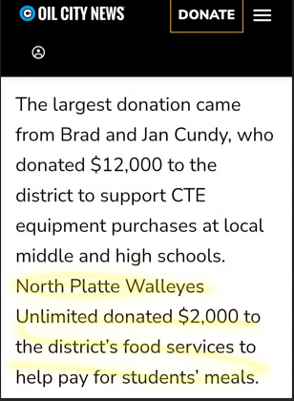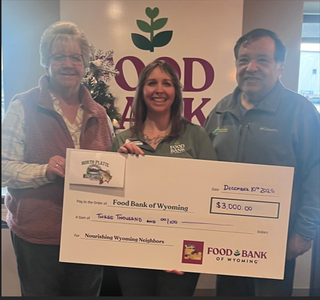

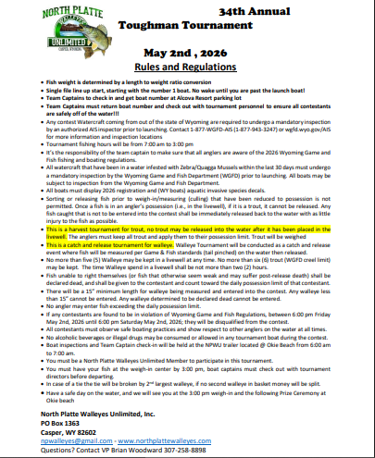

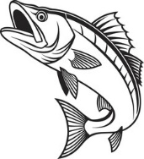2026 TOUGHMAN TOURNAMENT IS SET FOR MAY 2ND 2026* 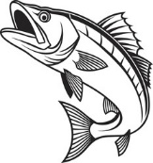
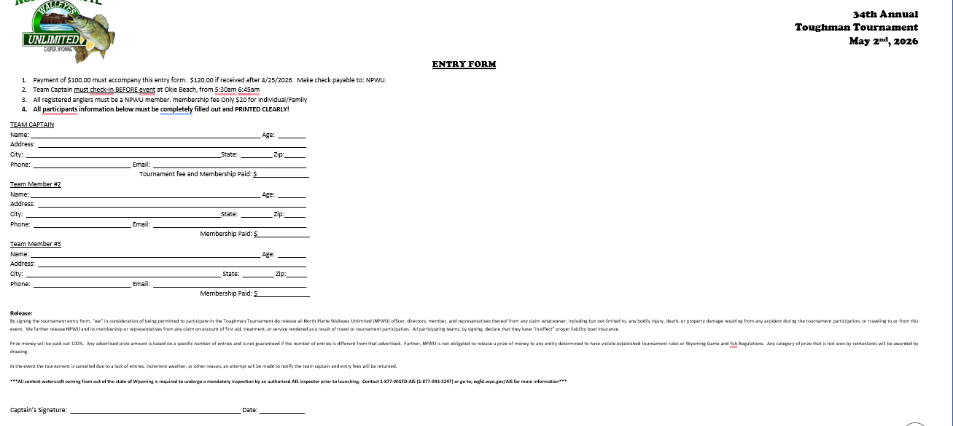

At our last club meeting, there was a discussion on the Seminoe Pump Project. Brian Woodward gave the following information on that project.

Below are some links to the Seminoe Pump Project. This is a project where water will be pumped into a storage reservoir, held, then discharged and sold back into the reservoir when energy demands are high. Water rights are owned by the Q Creek Ranch from my understanding. I think we need to get the word out about this. I will have more info and bullet points on the negative impact this project will have on Seminoe, the recreation, and the wildlife int the area soon.
Some of the key takeaways are:
1. Impact on wildlife such as Sheep and Deer migration.
2. Changing temperatures of water discharged from new reservoir back into Seminoe and downstream.
3. Impact of sediment discharged back into Seminoe
4. Closure of road from the Miracle Mile to Seminoe for anticipated time frame of 5 years.
5. Impact from building new reservoir and impact to existing dam. Quite a bit of blasting in the area will be required in the building phase.
6. Estimated 24,000 fish killed per year due to being sucked up thru pump system.
7. Mortality of Raptors and higher predation of sage grouse.
8. New 600+ acre reservoir will no be open to the public. (Proposed on BLM land)(Possible land swap is in consideration)

Please read thru some of the links to get a better idea of the size and impact of this project. There are instructions on how to voice concern to the Federal Energy Regulatory Commission during the current open public comment period. (See attached)

Here is the info about the Seminoe Pump Project website, which has the links to make public comments, and we are posting more and more articles every day. .

Website link: https://www.friendsofthenorthplatte.com/

I am looking for companies and organizations to oppose this project and allow me to list them on the website. If you have an idea, let me know, all I need is their permission, and I can steal logos from online.

Links to the Ferc Permit paperwork: https://elibrary.ferc.gov/eLibrary/filelist?accession_number=20250926-3003

Link to developers website: https://www.seminoepumpedstorage.com/media

UPCOMING EVENTS

***Monthly Club Meeting March 4th, Air Innovations @ 7:00. ***

***All You Can Eat Walleye Banquet, April 18^{th,} 2026 ***

***Toughman Tournament May 2^{nd,} 2026***

GET YOUR BANQUET TICKETS & TABLES. Evening will include dinner, (ALL YOU CAN EAT), raffles, and auctions.

Current Water Levels:
Glendo: https:www.usbr.gov/gp-bin/arcweb_patr.pl
Pathfinder: https:www.usbr.gov/gp-bin/arcweb_gler.pl
Seminoe: https:www.usbr.gov/gp-bin/arcweb_semr.pl
Alcova: https:www.usbr.gov/gp-bin/arcweb_alcr.pl
Boysen: www.usbr.gov/gp-bin/arcweb_boyr.pl
Grey Reef: https:www.usbr.gov/gp-bin/arcweb_grar.pl
Guernsey: https:www.usbr.gov/gp-bin/arcweb_guer.pl

Board of Directors
President: George Overman (797-0417)
Vice Pres: Brian Woodward (258-8898)
Secretary: Cheryl Juarez (267-0984)
Treasurer: Willie Forbes (797-3449)

Directors:
Jay Zastrow (267-0287)
Tom Juarez (267-9266)
Woody Giles (247-0695)
Ted Thompson (259-0266)
LaCinda Tilton (267-2171)

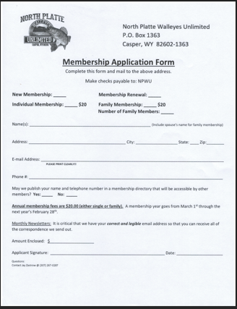
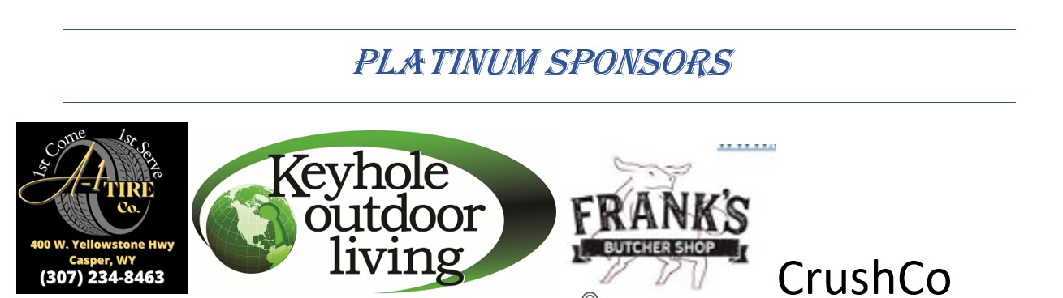


Gold Sponsors

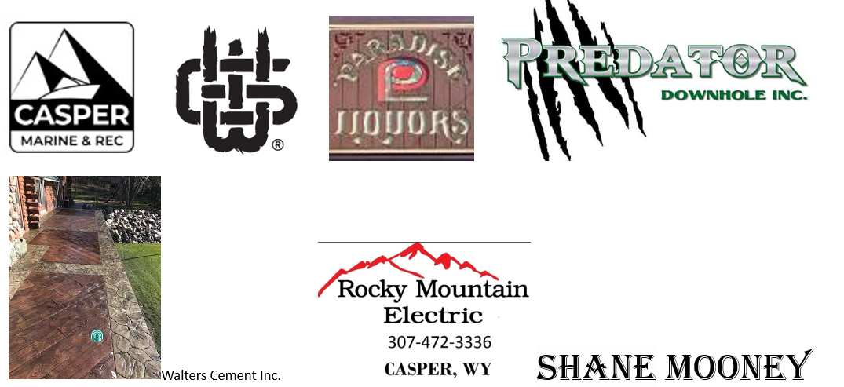

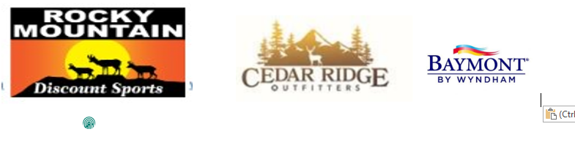
Silver Sponsors



WALLEYE RECIPE

The Ultimate Crispy Air Fryer Walleye Recipe

Ingredients
- 1 lb walleye (2 fillets)
- ¼ cup panko breadcrumbs
- ¼ cup parmesan (finely grated)
- 1 egg
- ¼ teaspoon garlic powder
- ¼ teaspoon onion powder
- ¼ teaspoon paprika
- ¼ teaspoon salt
- ¼ teaspoon pepper
- 1 lemon (for squeezing juice on after)

Instructions
- Thaw the 1 lb walleye as needed. Cut the skin off your walleye fillets if needed and slice them in half.
Pat the fillets dry with a paper towel on both sides so that they're dry (this is super important!).
- Crack 1 egg into a shallow bowl and whisk it. Then, grate ¼ cup parmesan into a separate bowl and stir in the ¼ cup panko breadcrumbs, ¼ teaspoon garlic powder, ¼ teaspoon onion powder, ¼ teaspoon paprika, ¼ teaspoon salt, and ¼ teaspoon pepper.
- Dip one fillet into the egg wash to completely coat it with egg. Then, dip it into the bowl with the dry ingredients to coat it with the dry ingredients.
Next, place the fillet in the air fryer basket. Repeat with other fillets. Space each piece out evenly about 1" or more apart. Work in batches as needed.
- Air fryer at 400 degrees for 6 minutes. Remove and top with a squeeze of fresh lemon juice!

