North Platte Walleyes Unlimited, Inc.
MARCH 2026

PO Box 1363, Casper WY 82602

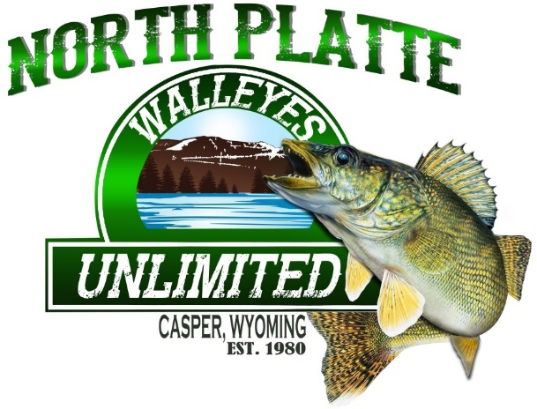

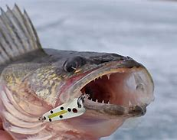

NEXT CLUB MEETING APRIL 1, 2026
7:00 @ AIR INNOVATIONS

ONLY 1 MONTH AWAY FROM OUR WALLEYE BANQUET.
GET YOUR TICKETS BEFORE WE SELL OUT. SPONSOR TABLE TICKETS PLATINUM, GOLD & SILVER ALSO.

“ALL YOU CAN EAT WALLEYE DINNER”, LIVE AUCTION, AND MANY BUCKET RAFFLES

*******SAVE THE DATE*******
******2026 WALLEYE ALL-YOU-CAN-EAT BANQUET********

Exciting news, that our 2026 All You Can Eat Walleye Banquet will be held on April 18th at Fairgrounds Industrial Building. Tickets are now available. See Brian Woodward at RM Discount Sports or any board member.

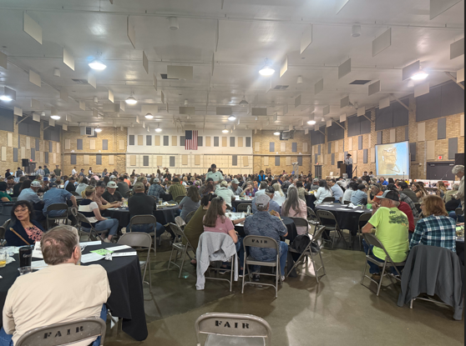

2026 TOUGHMAN TOURNAMENT

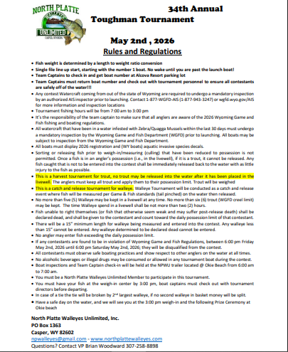

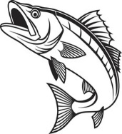2026 TOUGHMAN TOURNAMENT IS SET FOR MAY 2ND 2026* 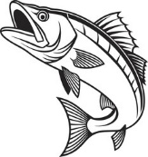
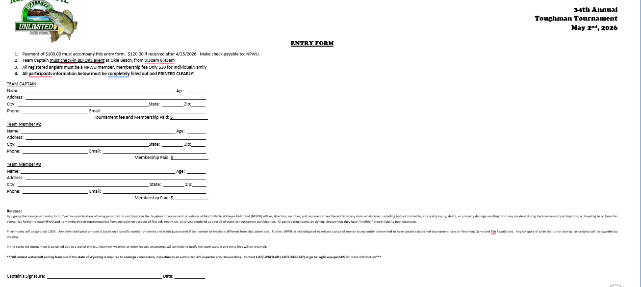

We want to give a huge thank you to our table sponsors for your generous support. Your contribution helped make past and present banquets possible, and we truly appreciate your commitment to our event.

UPCOMING EVENTS

***Monthly Club Meeting April 1st, Air Innovations @ 7:00.***

Current Water Levels:
Glendo: https:www.usbr.gov/gp-bin/arcweb_patr.pl
Pathfinder: https:www.usbr.gov/gp-bin/arcweb_gler.pl
Seminoe: https:www.usbr.gov/gp-bin/arcweb_semr.pl
Alcova: https:www.usbr.gov/gp-bin/arcweb_alcr.pl
Boysen: www.usbr.gov/gp-bin/arcweb_boyr.pl
Grey Reef: https:www.usbr.gov/gp-bin/arcweb_grar.pl
Guernsey: https:www.usbr.gov/gp-bin/arcweb_guer.pl

Board of Directors
President: George Overman (797-0417)
Vice Pres: Brian Woodward (258-8898)
Secretary: Cheryl Juarez (267-0984)
Treasurer: Willie Forbes (797-3449)

Directors:
Jay Zastrow (267-0287)
Tom Juarez (267-9266)
Woody Giles (247-0695)
Ted Thompson (259-0266)
LaCinda Tilton (267-2171)

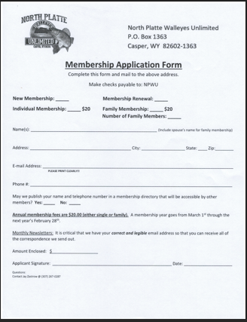



Gold Sponsors

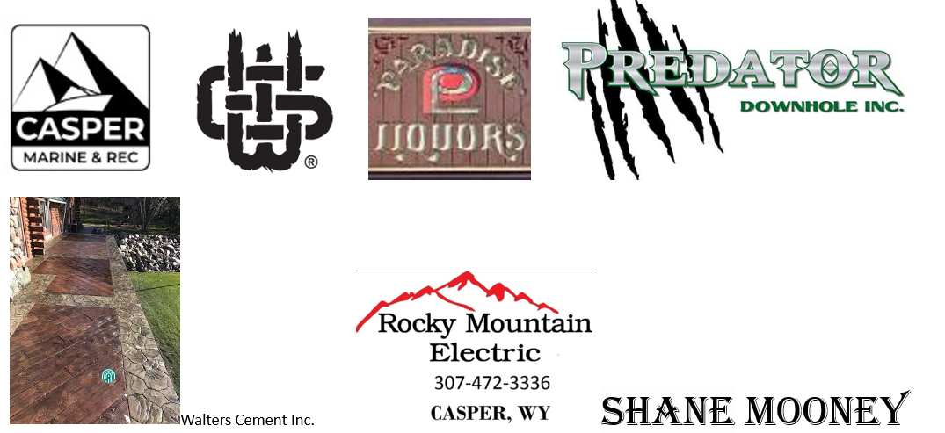

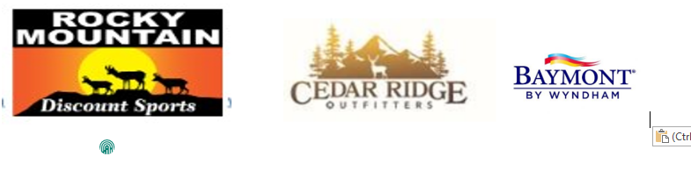
Silver Sponsors



WALLEYE RECIPE

The Ultimate Crispy Air Fryer Walleye Recipe

Why this air fryer walleye will make you do the happy food dance
- Ready in 10 minutes thanks to the air fryer that cooks the filets perfectly in 6 minutes.
- Super flaky and crispy because the air fryer sends hot air all around but doesn't dry out the fish. We also dredge it in eggs which helps retain that moisture.
- Not oily like typical fried fish because it requires no oil, olive oil, or other! This leads to a healthier and lighter breaded walleye fillet.

Ingredients
- 1 lb walleye (2 fillets)
- ¼ cup panko breadcrumbs
- ¼ cup parmesan (finely grated)
- 1 egg
- ¼ teaspoon garlic powder
- ¼ teaspoon onion powder
- ¼ teaspoon paprika
- ¼ teaspoon salt
- ¼ teaspoon pepper
- 1 lemon (for squeezing juice on after)

Before you start!
If you make this recipe, please take a moment to leave us a review. We love to hear from you!

Instructions
- Thaw the 1 lb walleye as needed. Cut the skin off your walleye fillets if needed and slice them in half.
Pat the fillets dry with a paper towel on both sides so that they're dry (this is super important!).
- Crack 1 egg into a shallow bowl and whisk it. Then, grate ¼ cup parmesan into a separate bowl and stir in the ¼ cup panko breadcrumbs, ¼ teaspoon garlic powder, ¼ teaspoon onion powder, ¼ teaspoon paprika, ¼ teaspoon salt, and ¼ teaspoon pepper.
- Dip one fillet into the egg wash to completely coat it with egg. Then, dip it into the bowl with the dry ingredients to coat it with the dry ingredients.
Next, place the fillet in the air fryer basket. Repeat with other fillets. Space each piece out evenly about 1" or more apart. Work in batches as needed.
- Air fryer at 400 degrees for 6 minutes. Remove and top with a squeeze of fresh lemon juice!

