North Platte Walleyes Unlimited, Inc.
OCTOBER 2026

PO Box 1363, Casper WY 82602

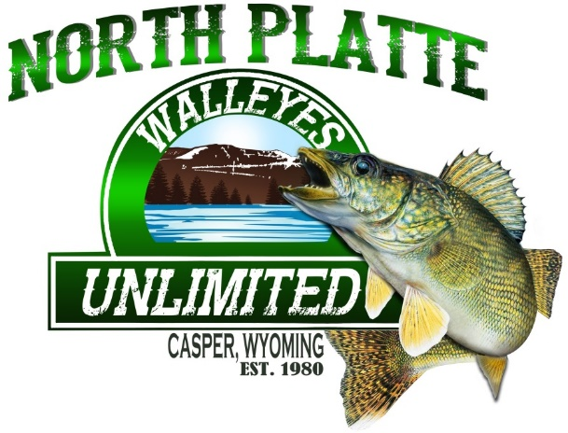

Club meetings are resuming in October, so our fall meetings will start October 7th 2026, and every 1st Wednesday of the month from then on. Club meetings are held at Air Innovations on CY Ave starting @ 6:00 pm. We invite all members to attend and give any input to help the club. If you are interested in becoming a board member or officer, please feel free to let one of our officers know.

Next year's “ALL YOU CAN EAT WALLEYE BANQUET” will have a small change. Banquet date will be February 27th , 2027. Still at the same location and the same great food.
SAVE THE DATE
Mark your calendars.
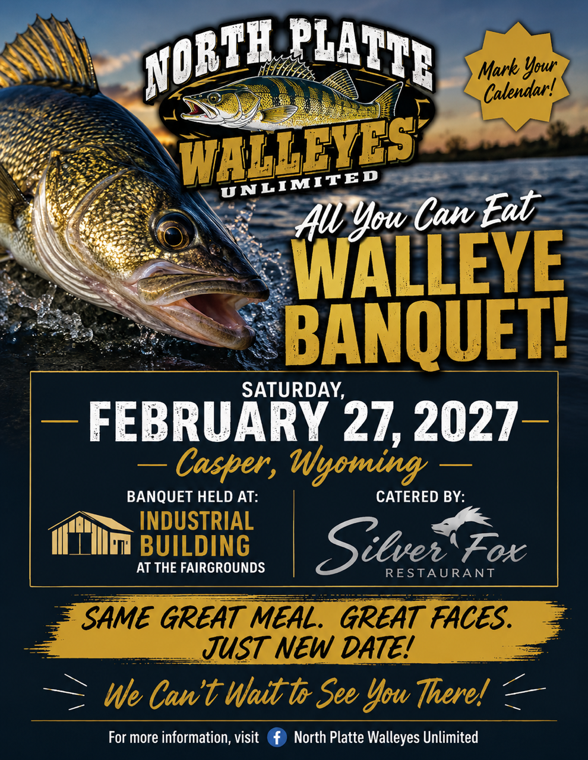

Current Water Levels:
Glendo: https:www.usbr.gov/gp-bin/arcweb_patr.pl
Pathfinder: https:www.usbr.gov/gp-bin/arcweb_gler.pl
Seminoe: https:www.usbr.gov/gp-bin/arcweb_semr.pl
Alcova: https:www.usbr.gov/gp-bin/arcweb_alcr.pl
Boysen: www.usbr.gov/gp-bin/arcweb_boyr.pl
Grey Reef: https:www.usbr.gov/gp-bin/arcweb_grar.pl
Guernsey: https:www.usbr.gov/gp-bin/arcweb_guer.pl

Board of Directors
President: George Overman (797-0417)
Vice Pres: Brian Woodward (258-8898)
Secretary: Cheryl Juarez (267-0984)
Treasurer: OPEN POSITION

Directors:
Jay Zastrow (267-0287)
Tom Juarez (267-9266)
Woody Giles (247-0695)
Ted Thompson (259-0266)
LaCinda Tilton (267-2171)

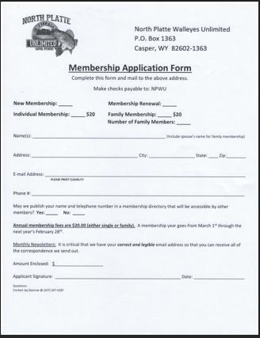







How To Make Fish Florentine
