**Sacred Decisions**

*Consensus in Faith Communities*

**Marcia J. Patton & Nora J. Percival**

When you use consensus to make group decisions, you invite God more deeply into the life of your faith community. We can help you learn how to effectively use this more inclusive, collaborative, and creative process for making decisions in your congregation or faith-based organization.

**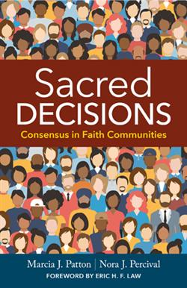*We offer these services:***

**Introduction to Faith-Based Consensus** – a 2 or 3-hour seminar for all members of your group, covering the basics of using consensus in a faith community. Offered in person and online.

**Advanced Facilitator Training** – a 3-day intensive for “consensus champions” in your group who will lead meetings and mentor others. Offered in person only.

**Meeting Facilitation** – an impartial facilitator to lead group meetings when everyone within your community has a stake in an important decision you are facing and no one within your group can be impartial (a necessity for effective facilitation).

**Process Mentoring** – real-time support for facilitators as they lead their first meetings of groups new to consensus.

*For more information, contact us at:*

sacred.decisions@yahoo.com

206-458-2089