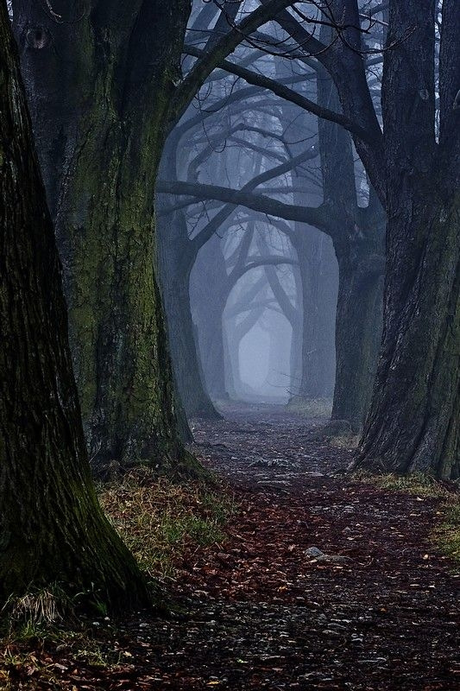
Walnut Lake, 14 August 2025: AT A CROSSROAD: THE FUTURE AHEAD

A WATER QUALITY SURVEY

OF WALNUT LAKE, 2025:

COMPARISONS WITH PRIOR DATA, HISTORICAL CHANGES,

CURRENT CONCERNS, AND A PATH FORWARD

Study performed: 14 August 2025
Report submitted: 14 December 2025

Prepared by: David J. Jude, Ph.D.,
Limnologist, Fishery Biologist

FRESHWATER PHYSICIANS, INC
5293 DANIEL, BRIGHTON MI 48114 P: 810-227-6623

Introduction
We visited Walnut Lake on 14 August 2025 and with the assistance of Dr. David Davis and Mike Surnow surveyed the lake with an interest in examining the current state of the macrophytes, the abundance of fishes, and we sampled the deep basin. We were limited to 100 ft of depth even though the lake is much deeper since we were limited by the length of cable on the YSI dissolved oxygen meter. As one can see from the graph and table below, since there were no changes in dissolved oxygen or water temperature below 23 m, we can safely assume that these variables would be the same in the bottom waters not sampled. The visit was prompted by a desire to monitor the water quality of Walnut Lake and to investigate concerns expressed by fishers on the lake that fishing was not as good as it was in the recent past. Prior to this happening, we were brought in to investigate the proliferation of macrophytes in the lake, that we documented by our earlier studies as well as doing a fish study to ascertain the current state of the fish community (Freshwater Physicians, 2019, 202).
Results

Dissolved Oxygen – 119 Years of Temperature-Dissolved Oxygen Profiles: 1906-2025
The long history of Walnut Lake and its changes in water quality and fish community diversity are startling. This compilation would not have been possible without the attention given to this lake by prior limnologists and the data available are probably without precedent in Michigan. People early on recognized the importance of gathering data on this lake so that future limnologists like me could monitor changes and warn the riparians who live within its influence what it was like in the early days of the 1900s and those who come later can sadly document what it is now and what was lost. It is also symptomatic of what is happening with many of our other lakes in Michigan that have experienced degradation, but do not have to background information to document it.
One of the most important water quality parameters in a lake is the dissolved oxygen profile and whether it has dissolved oxygen all the way to the bottom, a prime characteristic of oligotrophic lakes. Hence, I chose to include the dissolved oxygen profiles from 1906 through the present time – 2025 and show how the patterns have changed over the 119 years. The graphs shown (Figs. 1-8) are taken from an earlier report (Freshwater Physicians 2021) and I added in the data from our most recent study in 2025 (Fig. 9). In addition, I tried to summarize succinctly, what the major changes were over time (Table 1). Additional data were also gathered by Paul Hausler of ProgressiveCompanies during latter summer 2025 (ProgressiveCompanies, 2025).
In 1904 there was dissolved oxygen all the way to the bottom in Walnut Lake, which created an environment that was ideal for the lake whitefish to flourish. The lake whitefish is/was only found in one Michigan inland lake not connected to a Great Lake and is a creature of pristine waters and oligotrophic conditions. They were abundant in the early years with reports of farmers catching large fish in great numbers. However, in our fish study in 2019 (Freshwater Physicians, 2020), none were caught, but in 2021 two washed up dead in the lake, so some did survive until that year and there still may be a few hanging on, but the dissolved oxygen decline and probable warmer waters in their preferred cold water zone may have led to their extirpation. Time will tell. In addition, Walnut Lake also contained an amazing diversity of fish species – 39. That number of species has declined over the 113 years since from 39 species in 1906 to 16 species in 2019 (Freshwater Physicians, 2020) a loss of 23 species.
So, to summarize the dissolved oxygen pattern over the prior time period, we compiled whether there was dissolved on the bottom, and if not, how much of the bottom waters were anoxic (Table 1). In 1906, dissolved oxygen was 1 mg/L on the bottom so there was at least some dissolved oxygen throughout the water column during summer. There was adequate dissolved oxygen in the optimal depths (5-10 m) of 4.5-7.6 mg/L. Lake whitefish feed on zooplankton in the water column and chironomids and probably the large mayfly Hexagenia, which live in the sediments so they would have optimal water quality conditions at this time to forage and grow well. From 1943 to 1985, conditions were similar to the 1906 findings with some dissolved oxygen on the bottom (0.2 to 3.8 mg/L). Conditions changed drastically in 2004 when anoxia first appeared and it extended from 17 m to the bottom, a distance of 14 m. This was the tipping point when conditions went from oligotrophic to mesotrophic and probably stressed lake whitefish and pushed them upwards into the optimal zone where there was cold temperatures and adequate dissolved oxygen. In addition, with anoxia comes another detrimental effect- initiation of the phosphorus pump, which only happens when the bottom waters are anoxic and large amounts of ammonia and phosphorus can be released from the accumulated sediments in the deep basins of the lake. This phenomenon did not happen to our knowledge in the past and it represents another source of nutrients when the lake mixes in the fall and spring folding all those nutrients from the bottom into the lake resulting in more productivity in the expansion of macrophytes and algae in the lake. Interestingly, in our 2019 and 2021 studies there was some dissolved oxygen in low concentrations (0.2-0.3 mg/L) on the bottom, but those studies were done early in the summer and the lake probably went anoxic later on in the year continuing the anoxia seen in 2004. The latest data confirmed our conclusions, since the lake was anoxic on 14 August 2025 in mid-summer without dissolved oxygen from 23 m to the bottom a distance of 7 m. Again, we would expect this condition to increase until fall turnover and become much worse.

Figure 1. Temperature-dissolved oxygen curve for station A in Walnut Lake, 26 August 1906. Note the presence of a small, deep chlorophyll layer at around 6 - 8 m.

Figure 2. Temperature-dissolved oxygen curve for station A in Walnut Lake, 8 September 1943. Note the presence of a small deep chlorophyll layer at around 12 - 15 m.

Figure 3. Temperature-dissolved oxygen curve for station A in Walnut Lake, 12 August 1972. Note the presence of a possible deep chlorophyll layer at around 8 - 10 m.

Figure 4. Temperature-dissolved oxygen curve for station A in Walnut Lake, 24 August 1979.

Figure 5. Temperature-dissolved oxygen curve for station A in Walnut Lake, 16 September 1985.

Figure 6. Temperature-dissolved oxygen curve for station A in Walnut Lake, 18 August 2004. Note the presence of a possible deep chlorophyll layer at around 12 - 15 m.

Figure 7. Temperature-dissolved oxygen curve for station A in Walnut Lake, 13 August 2019.

Figure 8. Temperature-dissolved oxygen curve for station A in Walnut Lake, 28 August 2021.

Figure 9. Temperature-dissolved oxygen curve for station A in Walnut Lake, 14 August 2025. Note the presence of a small deep chlorophyll layer at around 9 m.

Table 1. Compilation of the dissolved oxygen presence on the bottom
of Walnut Lake over the 119 years of data availability, showing whether there was dissolved oxygen present on the bottom and if not, how high off the
bottom the anoxia extended. See graphs of dissolved oxygen profiles in
the report (Figs. 1-9)
___________________________________________________________________________
Year | Amount of DO (mg/L) on the bottom and extent of anoxia
___________________________________________________________________________
1904 | 1 no anoxia
1943 | 0.2 no anoxia
1974 | 2.3 no anoxia
1979 | 3.8 no anoxia
1985 | 0.3 no anoxia
2004 | 0 from 17 m to bottom- 14 m
2019 | 0.3 no anoxia
2021 | 0.2 no anoxia
2025 | 0 from 23 m to bottom - 7 m
___________________________________________________________________________

Water Chemistry, August 2025
We collected a water sample from the surface, at 15 m, and 1 m off bottom at 29 m. The values for pH were mostly as expected although usually the surface waters have higher pH than the waters below due to photosynthesis removing carbon di oxide (acidic) and increasing pH (Table 2). Conductivity, the ability of water to conduct electricity, was also higher than expected in surface water at 891 uS, while it was lower at mid depth and the bottom (789-794 uS). Usually, the bottom water, due to decomposition processes, generates more negative ions increasing conductivity. However, sometimes during summer stratification, surface runoff during rain events are high in contaminants, which can result in elevated conductivies accumulating in surface waters, since density layers prevent it from sinking deeper. Chlorides were similar ranging from 136 to 138 mg/L from surface to bottom. These are elevated concentrations reflective of the road salting that goes on during winter. Note that other contaminants will be entering Walnut Lake with these chlorides so they act as bellwethers of lake degradation. Nitrates were low in surface and mid depth waters (0.3-0.5 mg/L) as expected, but elevated on the bottom (0.27 mg/L), a natural response to the anoxia on the bottom which accelerates decomposition and generates nitrates and ammonia. We expected to see high concentrations of ammonia, a common occurrence in eutrophic lakes, but ammonia was low in surface waters and on the bottom (trace- 0.07 mg/L). The soluble reactive phosphorus was at trace concentrations throughout the water column. We expect it to be taken up by algae and macrophytes in the surface and mid depth waters, but to be somewhat elevated due to anoxic conditions on the bottom. This is a good sign for Walnut Lake, since it reduces the input of nutrients in the spring and fall overturn. The total phosphorus concentrations were both low and according to the classification (oligotrophic - <0.010 mg/L, mesotrophic -0.011-0.020 mg/L), and eutrophic – >0.020 mg/L), the lake is now mesotrophic. Despite this designation, Walnut Lake has a low phosphorus concentration, another good sign for the lake.
Table 2. Conductivity (COND -uSiemens), pH, chlorides, nitrates (NO³), ammonia (NH³), total phosphorus (TP), and soluble reactive phosphorus (SRP) for station A in Walnut Lake, 14 August 2025. All concentrations are in mg/L.
_________________________________________________________________
Depth | pH | Cond | Chlorides | Nitrates | Ammonia | SRP | TP
_________________________________________________________________
Surf | 7.61 | 891 | 138 | 0.03 | 0.03 | <0.005 | 0.012
15 M | 7.84 | 789 | 138 | 0.05 | <0.01 | <0.005
29 M | 7.58 | 794 | 136 | 0.27 | 0.07 | <0.005 | 0.019
_________________________________________________________________

Water Clarity
The water clarity in Walnut Lake on 14 August 2025 was 4.2 m or 13.8 ft. Lakes are classified thusly: oligotrophic - <7.5 ft, mesotrophic 7.5-15 ft, and eutrophic >15 ft; hence Walnut Lake would be considered mesotrophic. One can also see that the 2025 reading is similar to August to October secchi disk data from 2004 (Fig. 10 – from Freshwater Physicians 2020).

Figure 10. Mean Secchi disk readings (ft) for Walnut Lake station A during spring and summer, 2004. A lake is oligotrophic if the Secchi disk reading is >15 ft, mesotrophic is 7.5-15 ft, while eutrophic is <7.5 ft. Extrapolated from Fusilier (2005).
Macrophytes
The former discussion sets the stage for our consideration of the current macrophyte and fisheries concerns in Walnut Lake. The dissolved oxygen declines in the deep basin are related to the many drastic modifications of the surrounding land that impinges on the quality of the lake. Residents have cut down trees, destroyed wetlands, fertilized and treated lawns with toxic herbicides, reduced the permeable land surfaces with houses, driveways, tennis courts, swimming pools, and garages, do not have green belts at the lake margin, and have a massive web of roads and highways intersected with drains that run directly into Walnut Lake. It is no wonder that suddenly there is a recent proliferation of aquatic plants in the lake, which serve a useful function in the lake as fish and fish-food habitat and a barrier to wind and wave boat – generated currents, despite their sometime infestations of non-indigenous species like Eurasian milfoil and starry stonewort. During our 2019 study it was obvious that in our efforts to collect water, benthos, zooplankton, algae, and fish we covered the entire lake by boat and by foot seining and it was obvious at the time that aquatic plants were very dense in several large areas and that there were several prominent beds of Eurasian milfoil in many sections of the lake. Starry stonewort was also detected later. It was also noted that there was a modest abundance of fish of various species in the areas that we sampled and among the macrophytes we evaluated.
Among the recommendations we made at that time was to bring in a competent contractor that could treat the Eurasian milfoil and starry stonewort as well as any other exotic species in the lake, but to leave the native species to flourish and replace the non-indigenous species that were exterminated. This text is based on my recollections and some of the pictures I took at the time of sampling in 2019 (Figs. 12-13). I did not do extensive aquatic plant surveys on which to base my comments, but recommended that others with more expertise should do it to provide a template for plant control action. It was clear that there were extensive beds of macrophytes and some of those beds were Eurasian milfoil which can be very detrimental to a lake, by clogging access to the lake for moored boats, causing stunting of panfish by providing too dense habitat, and eliminating competing native macrophytes.
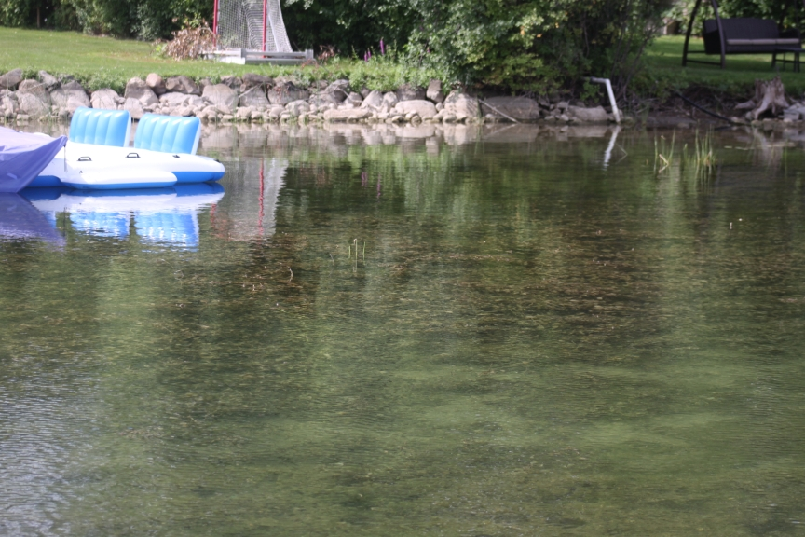
Figure 12. Macrophytes present during 2019.
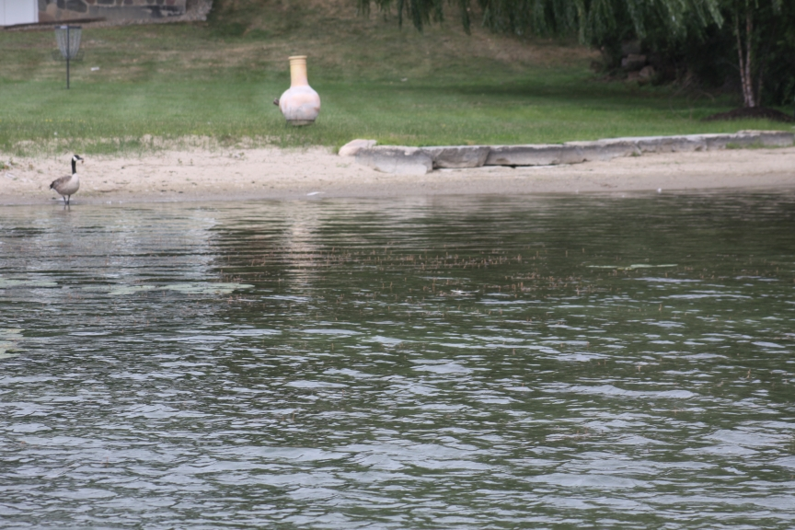
Figure 13. Macrophytes present during 2019.

During 2025, I was asked to visit the lake, collect water samples to determine if there was anoxia on the bottom and how much, tour the lake with the purpose of getting an idea of how the 2025 macrophyte treatments affected plant abundance, density, and diversity, and because fishers had complained about the fishing. We paid close attention to the abundance of fishes in the nearshore zone compared with my earlier observations and the surveys of 2019 and 2021 and we were to draw some conclusions about these two subjects. Note that we discussed the dissolved oxygen and the other parameters of the water quality study above.
As noted above our baseline for our evaluation of the macrophyte community was our studies on the lake during 2019 and 2021, when we collected water samples, set gill nets offshore and seined at several sites nearshore where we got close with the macrophytes while wading through them. There was a high diversity of macrophytes but the Eurasian milfoil was dense in several areas of the lake and some native plants were abundant in others and dominated the nearshore zone. We contrast that with our visit during summer 2025 when we did the water quality work then cruised the lake to view how the macrophyte treatment affected the abundance of aquatic plants. It was clear that most of the Eurasian milfoil was extirpated but some of the places where native species were formally abundant (and we saw many fishes swimming around among them) were severely diminished and we did not see any fishes, when before they were common. We were pleased with the elimination of the non-indigenous species, but concerned that diminishment of native species may do harm to the fishes, since they act as cover for small fishes, provide a food source for fish-food organisms like chironomids and dragonflies, and they act to cool the water in these climate-induced high water temperature days in summer. Although riparians may still complain about too much vegetation, there must be some recognition that exotic species were removed but that they are hoped to be replaced by native species that may still cause problems with boat access and swimming activity.
It should also be noted that Paul Hausler was hired to do a vegetation and limnological survey on Walnut Lake during 2025 so those data (ProgressiveCompanies, 2025) can also be consulted to gain more understanding of my comments and a more accurate assessment of the state of aquatic plants in Walnut Lake.
The Fish Community Concerns
I have been informed that fishers on Walnut Lake, who mostly practice catch and release, have complained that the fishing success has declined in 2025. I read over my report (Freshwater Physicians, 2020) and note here some of the pertinent findings. We found 16 species during 2019, which is quite reduced from much higher numbers found in past studies as noted above. The sport fish we are interested in include: bluegill (44 caught in 2019 study, size range: 1.1-6.3 in), pumpkinseed (20 caught: 2.7-6.5 in), yellow perch (31 caught: 1.9-7.7 in), black crappie (1 caught: 12.7 in), rock bass (16 caught: 1.3-8.8 in). Top predators included: largemouth bass (9 caught: 1.4-6.3 in), smallmouth bass (21 caught: 1.7-13.7 in), northern pike (7 caught: 19.2-29.3 in). This is a fairly, well balanced fish community, but the bluegills and pumpkinseed, although having acceptable sizes up to 6.3 and 7.7 in, could have been more numerous and of a larger size. The yellow perch were small with a maximum size we caught of 7.7 in; we believe northern pike predation is probably responsible for the small sizes of yellow perch as perch are favorite prey of northern pike. The presence of a large black crappie is a great sign of some large sizes of black crappies in the lake, but they appear to be rare. Rock bass were also present and some large ones (up to 8.8 in) were collected. So, a fair assessment of the fish community and its acceptability to fishers of Walnut Lake, is that there was a range of sizes of sunfish present and they were growing at mostly state averages. Merna (past study – see Freshwater Physicians, 2020) found that black crappie and largemouth bass were growing at state averages, while smallmouth bass, northern pike and walleye were growing above state averages. In addition, there were a large number of northern pike based on our catches and other predators (largemouth bass and smallmouth bass) that should be a good fishery for the sports folks. However, this study was done 6 years ago and, in the meantime, some dramatic changes to the macrophyte populations have occurred. However, it seems to me that reduction in aquatic plants in 2025 could not affect the abundance of larger harvestable fish in 2025. The only way that could happen is if the habitat for larger fish (aquatic plants) was reduced so severely that they became more susceptible to fishers, However, as we noted, most fishers practice catch and release fishing, so this seems like an unlikely prospect. There definitely could be an effect on the smaller fishes, which did appear to be reduced, based on our observations on the 2025 tour when we saw few if any fishes swimming around in the nearshore zone, while they were common nearshore when did studies in 2019 and 2021. Since the lake has a good population of top predators, removal of substantial numbers of aquatic plants would allow them to increase their predation on the smaller prey fish. However, as we pointed out, such a shift in increased predation would have a small effect, although it could reduce the abundance of the smaller fishes but not the larger ones that are the common target of fishers. In addition, the reduction in numbers and increased availability of small prey fish because of the increased open spaces would allow predators to increase their access and predation rates, which could reduce the success of fishers of Walnut Lake.
The second point I want to make is about fish food. Sunfish eat a large amount of what is termed benthos: they include mayflies, caddisflies, chironomids, zebra mussels, snails, and especially Hexagenia, the large mayfly that hatches around the end of June and is not only a great food source for fish but also an icon of pristine water quality, since they live in the sediment for at least a year and require adequate dissolved oxygen year round to survive. With the increasing anoxic conditions we fear that the area that was optimal for their survival has perhaps shrunk with the changes in dissolved oxygen. Therefore, some loss of this energy source would slow growth of panfish in Walnut Lake. Pumpkinseeds are adapted to eat mollusks: snails, fingernail clams, zebra mussels, and there were zebra mussels present in our sampling of the sediments we did in 2019. The severe depletion of non-invasive macrophytes may be one hypothesis that might explain slowed growth of large, harvestable sunfish, but not their abundance as described above. The macrophytes are important habitat for the food items noted above, although some prey items reside in the sediments only. In addition, a dense undercover of plants provides nursery areas for smaller fishes that then can avoid predation and contribute to larger fishes in the long run. This is one area where a management strategy could be initiated to allow more native plants to grow and see if this improves the fishery. This could take several years, but a first sign would be to see more small sunfish, like we observed during our 2019 study, in the inshore areas. A fish study could be done in a few years after to measure whether this effort bore fruit.
Recommendations
We start this section by repeating our initial finding: Dissolved oxygen conditions made Walnut Lake oligotrophic in the past and since then conditions have deteriorated as humans have cut down trees, put in lawns that are probably overfertilized and treated with poison herbicides to make them look pretty, the land is made more impermeable with houses, garages, tennis courts, and swimming pools, there are mazes of roads that require salting in winter and act as conduits for nutrient entry, and any wetlands have been destroyed, all leading to the deterioration of Walnut Lake. This lake was probably one of the most pristine in Michigan but has been changed by human colonization. Residents should do more to at least maintain the current water quality conditions and fishery in the lake by reducing or eliminating fertilization, curtail more covering of he land with impermeable substrates, plant green belts along the lake shore, and reduce the low water quality of water entering from the drains. In our two earlier reports we listed activities riparians could do to improve the water quality of Walnut Lake. In addition, there is a NALMS report called “what works” that lists all the types of ways to reduce nutrient input to the lake and improve water quality (see Appendix 1). There are several of lake improvement methods that are fraudulent and that do not work, while others have stood the test of time and are recommended. This is a great report to use to verify any major techniques that may be suggested for helping improve water quality.
There are two major issues that are problem areas for Walnut Lake residents: Excessive macrophyte abundance and complaints about the quality of the fishery declining. We did not do extensive macrophyte surveys on Walnut Lake, but have an intimate knowledge of plant diversity and abundances based on visiting the lake for three studies, during which we were able to see what species were there and how abundant they were, with special attention to the presence of non-indigenous species. We identified the presence of Eurasian milfoil and the alga starry stonewort. We saw large beds of Eurasian milfoil, especially on the south end of the lake and scattered in other areas as well. Thus, for several reasons we advocated for the removal of the non-indigenous species because they can be so dense as to cause stunting of prey fish when top predators cannot effectively prey on them. They are non-indigenous species that can out compete native macrophytes. Hence, we recommended that a competent individual aquatic plant control company be contacted, perform a vegetation survey, and target only exotic macrophyte species, leaving the native species both for fish cover, for replacing exotic plants when they are eliminated, and they are also great for slowing down the currents caused by waves, wave boats, and other recreational boats and skidoos on the lake. It was clear from my visit on the lake during 2025 that the Eurasian milfoil beds were severely diminished, however, it appeared that the native plants were also affected. To help make the correct decisions, we advocated for the support of a second opinion, which has resulted in the hiring of ProgressiveCompanies’ Paul Hausler, who has done just that. Paul has done a vegetation survey, seen the data on what was used to control plants during 2025, and did water chemistry similar to what we did when we visited the lake, but there was almost a month between when we both did our work, so that we can compare data sets with the understanding as I have advocated in past reports, that if the data were collected later than we collected ours that conditions would deteriorate even more than what we saw with the conditions noted above. My closing conclusion is that it was great that the non-indigenous macrophyte and algal species were severely diminished, but that in the future the native plants should be spared any treatments, unless they preclude boat egress from docks and are allowed by EGLE.
The second problem is more intractable. My only evidence to draw conclusions come from unverifiable reports by fishers that fishing quality has diminished during 2025 and what I can discern from 2019 fish study. So, I do not really know if the contention of reduced fishing success is true and how extensive it is, and what species it has affected. We know from the 2019 study that you have a good diversity of fish species, including panfish and a host of top predators that should provide good fishing. The removal and diminishment of the invasive species and many of the native species of macrophytes opened more water free of plants which could have provided easier access to prey for the top predators and hence fishers are catching fewer fish. It certainly seemed obvious to me from personal observations that there were fewer small fishes in the nearshore areas where previously I had observed many swimming around. Obviously, the loss of aquatic plants during 2025 could not have affected the larger panfish and top predators, and might as noted, promote greater growth with this group. So, my only way forward would be to improve the abundance of native macrophyte species, then in at least 3 years later, determine if the fishers are seeing increased catches and/or repeat the fish study at that time.

Literature Cited
Freshwater Physicians. 2020. A fisheries, zooplankton, benthos, algae, and water quality survey of Walnut Lake, 2019 with recommendations for short and long term management. Freshwater Physicians Report 6-2019. 5293 Daniel Dr., Brighton, MI.
Freshwater Physicians. 2023. Water quality survey of Walnut Lake and some of its tributaries, 2021, with a comparison with 2019 results. Freshwater Physicians Report 3-2022. 5293 Daniel Dr., Brighton, MI.
Fusilier, W. 2005. Walnut Lake: A Water Quality and Watershed Management Study. Water Quality Investigators. 9200 Dexter Chelsea Road, Dexter, MI.
ProgressiveCompanies. 2025. Walnut Lake: Limnological Assessment. ProgressiveCompanies Report. Grand Rapids, MI. 29 pp.

APPENDIX 1. Osgood, D. 2015. What works. NALMS LAKELINE. Pp. 8-16. (CLICK ON ICON)

