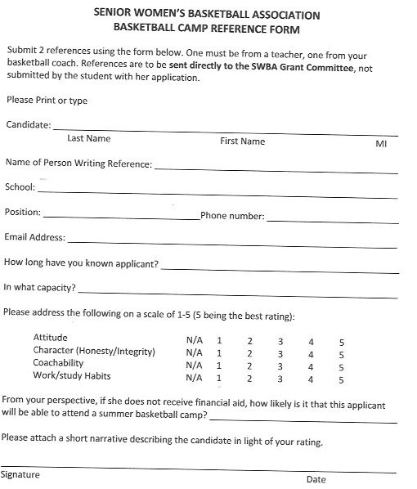Please send this reference **no later than April 30, 2022** to:

Eileen Timmins, SWBA Scholarships

6350 Glidden St, San Diego, CA 92111

Or email to her at: etsandiego@gmail.com