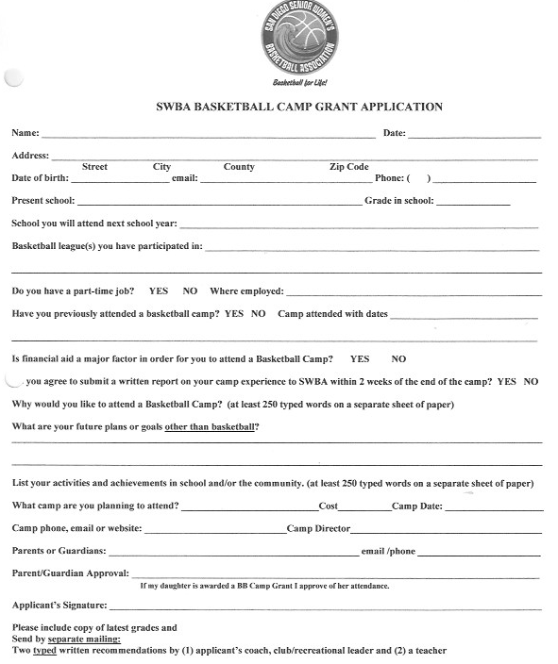Send your application by April 30, 2022 by mail or email to:

Eileen Timmins, Scholarship Committee, SWBA
6350 Glidden St, San Diego, CA 92111 or
etsandiego@gmail.com

