GPP November 2015 Newsletter Vol. 3
60 GPP students from across Georgia had an amazing time this year’s Leadership Adventure Weekend held at Fortson 4H Center, November 4-6th. Students and chaperones came from Jackson, DeKalb, Chattooga, Tombs, and Whitfield counties. Read on to learn more about our adventure!

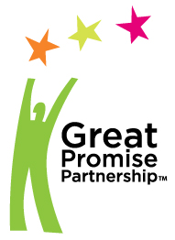

Don’t forget to:
- Submit your student rosters to your GPP site coordinator
- Submit your enrollment cards to your GPP site coordinator
- “Like” GPP on Facebook

Jonelle Simpson II, University of Georgia Student Government Association President speaks with GPP students about pursuing their dreams and achieving goals.
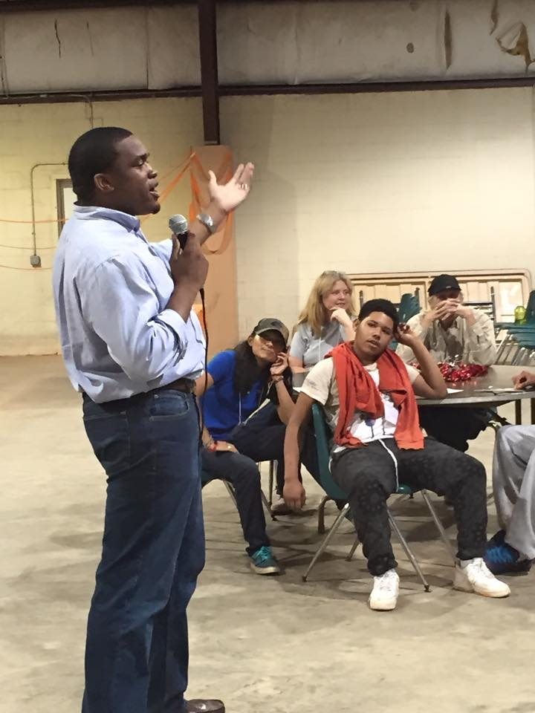

What happens at Leadership Adventure Weekend?
Students begin to arrive on Friday afternoon, and are often unsure about what to expect. Adult chaperones offer encouraging words and begin to raise the enthusiasm of the groups of teenagers. The weather is rainy, the ground is muddy, and students are scurrying around to find their cabins. The fun is about to begin. After a delicious spaghetti dinner, the students are ushered into the gym at Fortson 4H Center for an evening of ice breakers, and very special guest speaker Jonelle Simpson II. Jonelle’s positive attitude and encouraging story, becomes the perfect segue for a weekend filled with self-discovery, career exploration, leadership skill development, teamwork activities, making friends and lots of fun!

On Saturday and Sunday, GPP students were actively engaged in hands on, experiential workshops, facilitated by University of Georgia alum and students. Most of the volunteers have been working with GPP’s Leadership Adventure Weekends for several years. This year, the themes of the workshops included: Dressing for Success, Creating, Maintaining, and Understanding the Importance of Your Digital Footprint, and How to Interview Successfully. Students and adults also participated in the high and low ropes courses, which included team-building activities, wall climbing, and a zip line. All of the activities encourage the students, and some adults, to conquer their fears and be open to having new experiences.
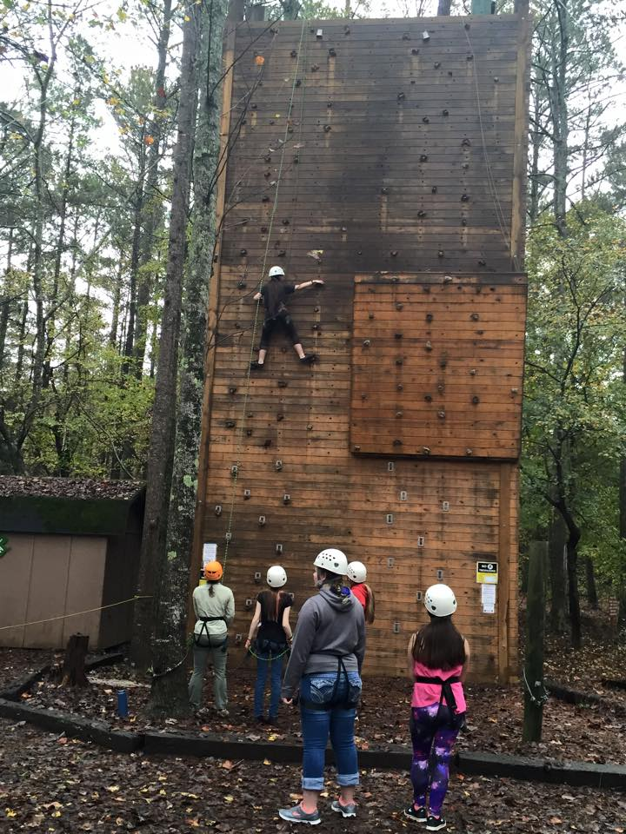
GPP students encouraging one another to get to the top of the climbing wall.

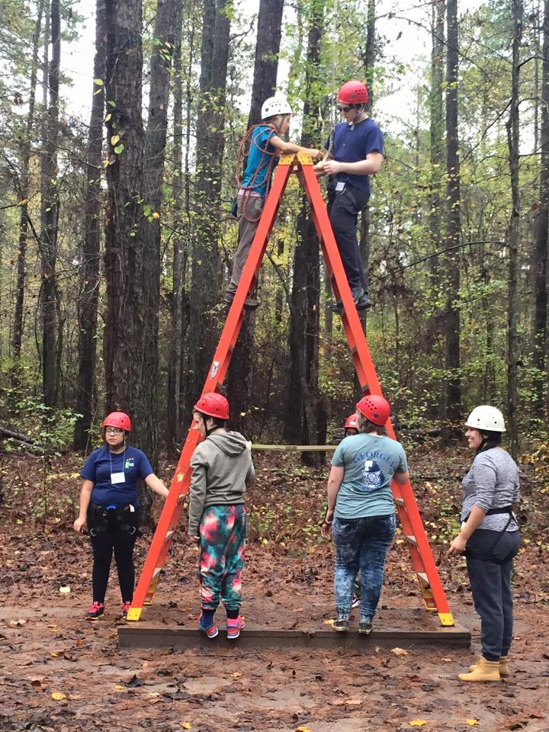
Students working together at the zip line.

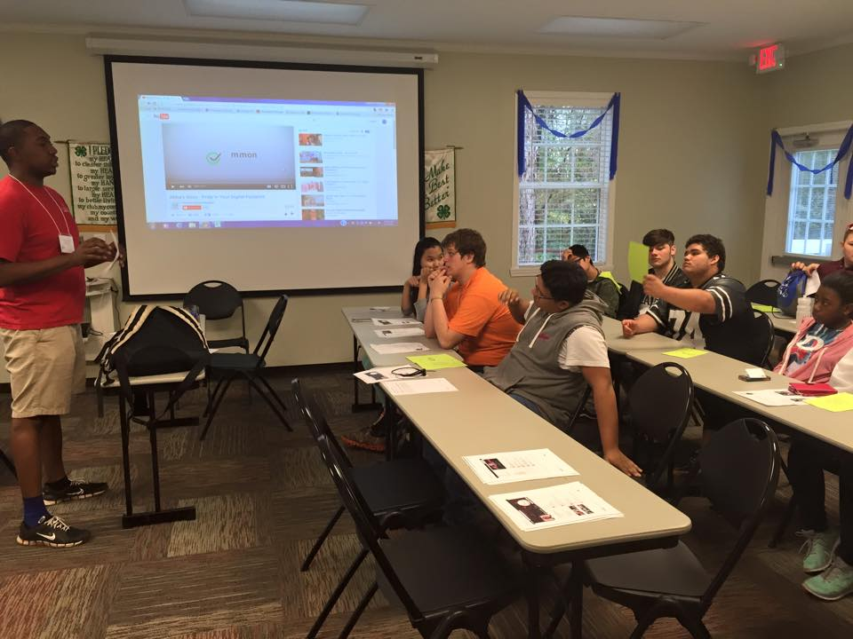
UGA facilitator leads a workshop on the impact of your “digital footprint”.
As the weekend comes to a close, new friendships are formed, and the enthusiasm has reached its highest level. Although everyone is exhausted, there’s an air of sadness, because the weekend is over and there is a feeling of a “job well done!” It is up to our GPP students to now take what they’ve learned back to their schools and communities!
We want to give a huge THANK YOU to the following Sponsors: Shaw Industries, Pat and Joan Williamson, Jackson EMC, North Georgia Technical College, Zaxby’s Inc. Beaulieu America, Buhler Quality Yarns, James H. Rainwater Conference Center/Valdosta-Lowndes County Conference Center and Tourism Authority, East Georgia State College, Technical College System of Georgia, Caterpillar and Nordson.
Have a safe and Happy Thanksgiving!! We are grateful for your continued support for the Great Promise Partnership.

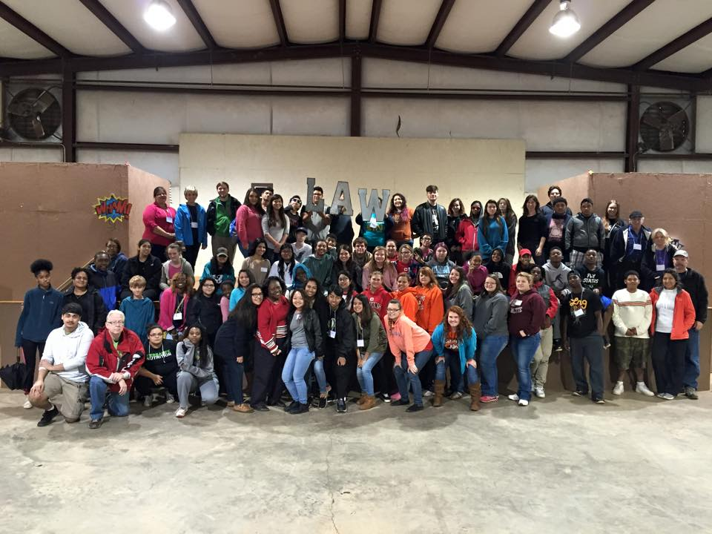
2015 Leadership Adventure Weekend students, chaperones, and staff

