GPP September 2015 Newsletter Vol. 1
Welcome back to school and to GPP’s news and information blast! We are so happy for the continued commitment from our all of our sites. You will receive an email once a month, which will include information relevant to your site and/or business, dates to remember, upcoming GPP events, success stories, and shout outs. Stay tuned… it only gets better!

Don’t forget to:
- Have your students fill out their enrollment cards
- Save the Date for GPP’s Leadership Adventure Weekend November 6-8
- “Like” GPP on Facebook

Students working together at Leadership Adventure Weekend, Fortson 4H Center, Spring 2015.

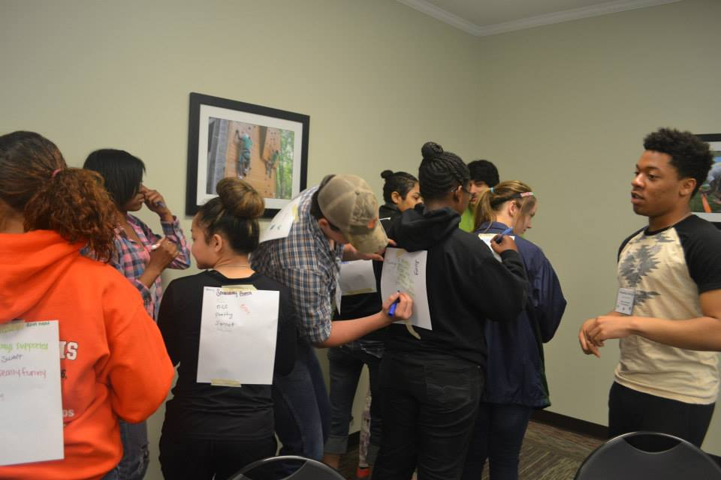

GPP has a DOE course number! What does this mean? Students can now leave school early to work through the GPP program and receive Work-based Learning credit!! GPP is now officially a sub-set of Georgia’s Department of Education’s Work-based Learning.

Here’s how it works: GPP’s CIP Code begins with 35.7 and then is followed by numbers that indicate year, semester, period, credit hours and local distinguishers. 35.7114000 indicates the student is in GPP (35) and Work-based Learning (7), in the first year (1) and the first semester (1) and for one period thus receiving one credit (4). The last two zeros can be used by local schools to indicate section or period.

Be sure to contact your school’s Work-based Learning Coordinator or your GPP Regional Coordinator for more questions or information.

GPP students having “real work experiences” at the Georgia Department of Revenue and Buhler Yarn
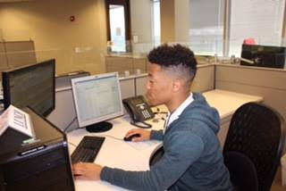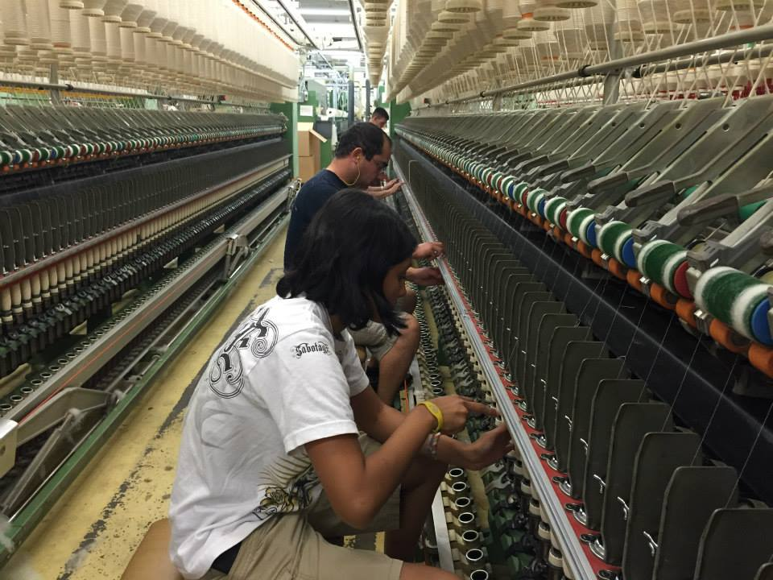
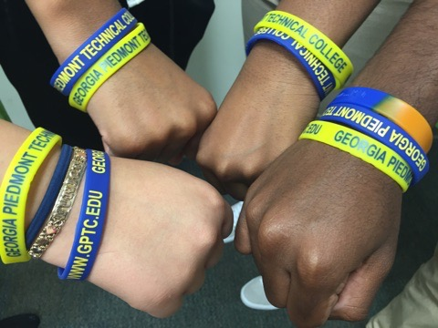
GPTC student employees show off their swag as they begin work!

Leadership Adventure
Weekend… Spring 2015

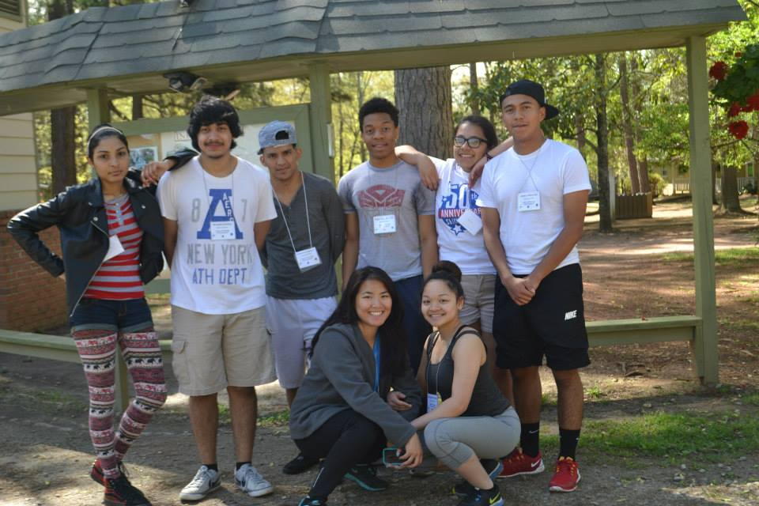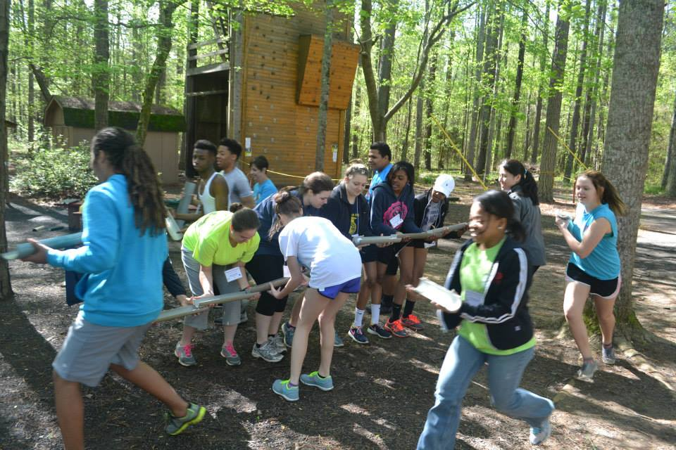

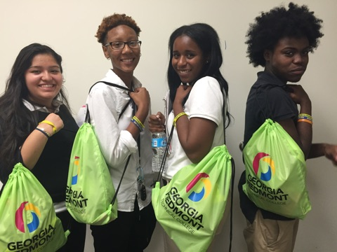

Page As we begin another school year, we look forward to new adventures and partnerships! GPP would like to welcome Georgia Piedmont Technical College (GPTC) as one of our brand new sites. GPTC has hired four new students from Clarkston High School located in DeKalb County. The students will be working in the Office of Student Affairs. Not only are these students employed at GPTC, they’re also dual enrolled in courses at GPTC! We are thrilled to have another technical college on board!

We can’t thank ALL of our business and school leaders enough for the hard work and dedication to making GPP work! Your continuous effort and support, are valued and is what makes GPP a success. Mentors, positive workplaces, and YOU, give at-risk students, meaningful experiences, a reason to complete high school, and a path to succeed!
Have a Great School Year!!

