GPP Newsletter October 2015 Vol. 2
Happy Fall everyone! The leaves are changing, the weather is crisp, and GPP is gearing up for the Leadership Adventure Weekend on November 6-8th. We have more than sixty students and counting attending, as well as a host of amazing guest speakers. A shout out also goes to all of the fantastic adults who have volunteered to be chaperones and facilitators! This is an exciting event, and we are looking forward to reconnecting with students from last year and welcoming new GPP students!

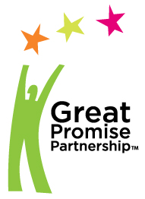

Important Reminders:
- Adult paperwork for the LAW must be turned in by Wednesday, October 21
- LAW Registration will close on Friday October 23
- Submit your GPP student Enrollment Cards by 11/1
- Link for information pertaining to Leadership Adventure Weekend (LAW) http://gppartnership.org/news-resources/leadership-adventures-weekend/
- “Like” GPP on Facebook

GPP wants to promote your organization!
We are seeking small promotional items such as pencils, keychains, cups, etc., to provide to our students in “swag bags” during the Leadership Adventure Weekend. If your organization has promotional items that they would be willing to donate, please contact your GPP site coordinator.

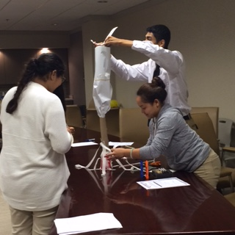

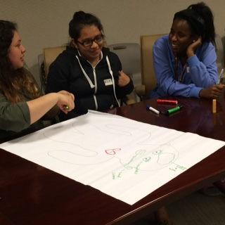

DeKalb County Students working collaboratively during a Life Skills Session hosted by The Georgia Department of Community Affairs.

As we continue to plan for the LAW, GPP would like to give a huge THANK YOU to Shaw Floors for the generous contribution of $5,000.00 to use toward transportation needs for the LAW. This is a tremendous help for GPP and ensures that both students and adults can attend GPP’s annual event.

GeorgiaBEST Information
GPP is partnering with the Georgia Department of Labor’s GeorgiaBEST (Business Ethics, Student Training Program). DOL’s standards for the GaBEST program mirror those we encourage GPP sites to cover during Life Skills sessions. The GaBEST program gives GPP students the opportunity for state recognition for the hard work they’re already doing. The Life Skills sessions you have already covered and those you will cover over the course of the school year, will allow for the students to earn points towards a certificate of completion from the Department of Labor at the end of the school year. Your GPP Site Coordinator will send more information pertaining to the GeorgiaBEST modules.

Thank you again to all of our businesses and school leaders who continue to help GPP to thrive! We’ll look forward to seeing both the students and adult volunteers at the Leadership Adventure Weekend on November 6-8 at the Fortson 4H Center in Hampton, GA!

