Oxfordshire’s Threshold
of Needs: Updated March 2021
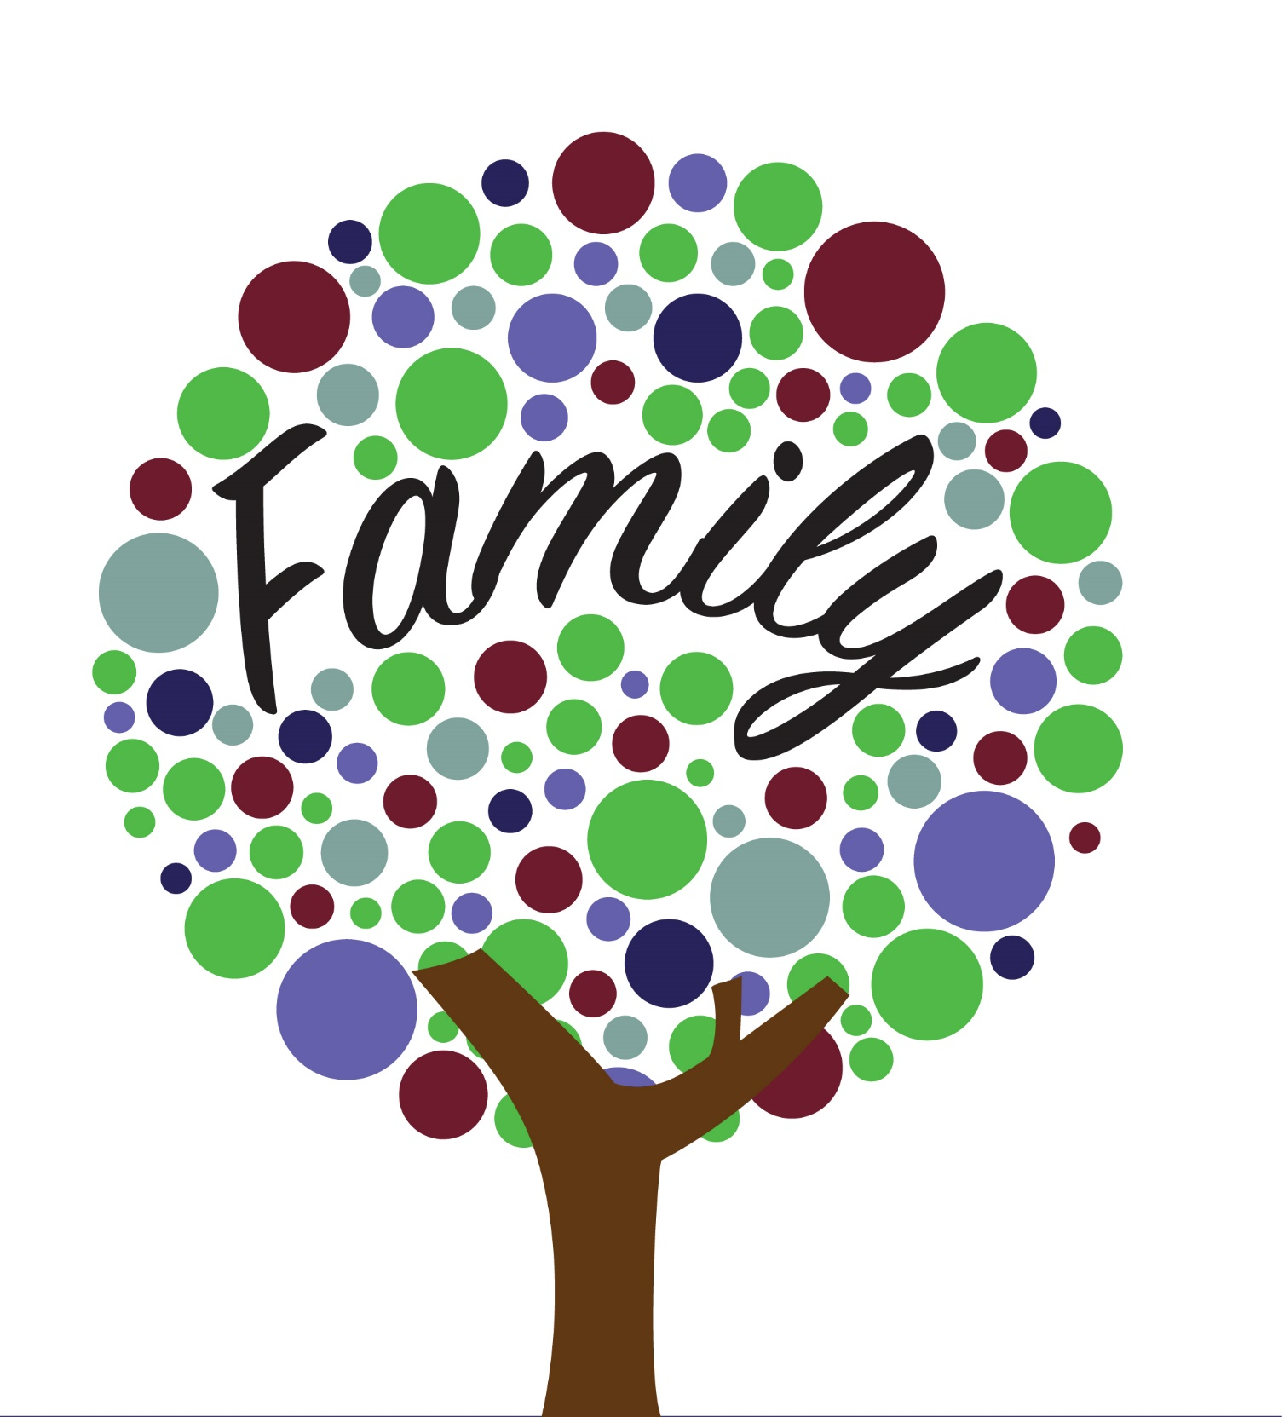

Right Support at the Right Time
For Oxfordshire’s Children and Families
Oxfordshire Safeguarding Children Board
Contents
Welcome 3
Vision 3
Priorities 3
Our approach 3
Our principles 3
October 2020 Version 3
Introduction 4
A whole family approach: 4
Early help 5
Safeguarding 5
Statutory requirements 6
Section 17 – children in need (Level 3) 7
Section 17 – Young Carers (Level 3) 7
Section 47 – children in need of protection (Level 4) 7
Section 20 – duty to accommodate (Level 4) 7
Section 31 – care orders (Level 4) 7
Assessment framework 8
Child-centred assessment 9
The Threshold of Needs 9
Level 2 – Additional needs supported by Community EHA/TAFs & the LCSS Team 10
Level 3 – Complex Needs supported by Targeted Early Help or Statutory Social Work Teams 11
Level 4 – Critical Needs supported by Statutory Social Work teams (Child Protection) 12
Additional Guidance for Threshold Decision Makers 12

rdshire Safeguarding Children Board
2021220

Contents

Welcome 3
Introduction 4
Early help 5
Safeguarding 5
Statutory requirements 6
Assessment framework 8
Child-centred assessment 9
The Threshold of Needs 9
Additional Guidance for Threshold Decision Makers 12
Tools and resources 16
Further information 16
Glossary 17

Welcome

Vision
We want Oxfordshire to be the best place in England for children and young people to grow up. By working with every child and young person to develop the skills, confidence and opportunities they need to achieve their full potential.

Priorities
Oxfordshire’s Children’s Services are committed to ensuring:
- All children have a healthy start in life and stay healthy into adulthood.
- Narrowing the gap for our most disadvantaged and vulnerable groups.
- Keeping all children and young people safer.
- Raising achievement for all children and young people.

Our approach
We will focus on social disadvantage, help communities and individuals to help themselves and support locality working.

Our principles
In order to meet our priorities, we need to take a whole family approach, encourage early intervention, get input from children and young people, work in partnership, ensure smooth transitions and deliver cost effective services.
For more information on the Children Trust Plan please visit:
Children and Young People's Plan 2018 - 2023 | Oxfordshire County Council

March 2021 Version
This version of the Threshold of Needs was updated in March 2021, in order to reflect the learning from the Serious Case Review for Child M, including consideration of wider family members in the family system, parental vulnerability and the family’s past history. This guidance is reviewed every two years.

Introduction

This document has been developed to provide guidance for children, families and professionals, to identify the needs of children and families in Oxfordshire and provide support to manage the identified need. It will assist in promoting the health, emotional and social development of all children and families in Oxfordshire and aid in the safeguarding and protection of children.
The purpose of this guidance is to:
- identify strengths, needs and risks for the whole family
- build on strengths
- identify multiple and cumulative risk factors
- suggest actions to manage difficulties and risks
- clarify circumstances in which children’s services will assist and safeguard children
- provide a shared and common language

A whole family approach:
Improved outcomes are achieved for children and families by having a whole family approach, where children and young people are not viewed in isolation and, wherever appropriate, action is taken to address issues that affect the whole family.
The Government’s Troubled Families Programme (currently in operation until March 2021) is focused on families with the highest level of needs and who are facing the greatest challenges. It seeks to identify and improve outcomes relating to crime and anti-social behaviour; school attendance; level of need; financial exclusion and out of work; domestic abuse; health problems. The essential elements of this work include: a whole family assessment; a whole family, multi-agency, outcome focused plan, driven by a named key worker, leading to transformation of public services and improved outcomes for children and families.

Early help

Evidence and research show certain factors place children at risk of abuse and neglect, mental health problems, disengaging from education or becoming involved in crime or antisocial behaviour.
Early help is early identification of these factors and quick response to emerging problems for children, young people and their families. It refers both to help in those critical early years of a child’s life when the fundamental building blocks for future development are laid, and to timely help throughout a child, young person’s and family’s life. When early help is not offered there is a real risk for some children. Their social and emotional development may be impaired, they may experience harm, or family life and relationships may break down.
Early help is a way of working effectively across agencies and services that supports families’, children and young people to overcome difficulties and build their resilience so that problems do not escalate, and they are able to thrive, live and engage happily in their communities.
The ethical and financial rationale and evidence base for providing “early help” within a whole -family model is very strong. Many recent publications, including Keeping Children Safe in Education 2018 and Working Together to Safeguard Children 2018 highlight the need for strategic partners to provide a coordinated targeted and evidenced-based early help offer. This is particularly important for families with multiple and complex needs.
Preventative services cost less and are more effective than reactive services. They are also more effective in improving the life chances of children, young people and families. Early Help is a core principle of practice in Oxfordshire and there is substantial commitment and energy to support and work with families as outlined in the Children and Young People’s Plan.
When a child or family is identified as benefiting from early help, a whole family, multi-agency Early
Help Assessment (EHA) should be completed by the practitioner identifying the concern. The Early Help Assessment should identify what help the child and family require, preventing needs escalating to a point where intervention would be needed via a statutory assessment.
If early help or other support is appropriate, the situation should be kept under constant review by a lead professional via an outcome focused, Team Around the Family (TAF) Plan. This should be linked to the identified needs in the EHA.
Early help would be expected across levels 1, 2a, 2b and 3a of the Threshold of Needs.

Safeguarding

Safeguarding and promoting the welfare of children is everyone’s responsibility. Everyone working with children and families should work in a child-centered, whole family approach to gather high quality information, identify concerns, risk assess, share information and take appropriate action to ensure that children have the best outcomes.
The Threshold of Need document should assist in deciding the child’s level of need and provide advice on what to do, when, to ensure that children and families get the right support at the right time.
For additional support, advice and guidance, professionals can contact their local Locality and Community Support Service.
If a child is in immediate danger or is at risk of significant harm, a referral should be made to children’s social care and/or the police immediately.

Identify
Safeguarding
Concerns
Discuss concern with child
and seek advice from your
safeguarding lead
Consult threshold of
need document to
make decision of next
course of action
Discuss concerns with
child's family/carer
as appropriate
Contact LCSS for
advice and guidance
or MASH if immediate
safeguarding concern
Complete EHA/TAF
or MASH referral
Appropriate
action taken
Safeguarding
7
step referral process

Statutory requirements

Where there are more complex and enduring concerns, which are likely to or are, impacting on a child’s health and development then the local authority is required, under the Children Act 1989, to provide an assessment and appropriate services for the purpose of safeguarding and promoting their welfare. Partners play a key role in supporting the assessment process and support a child and family whilst the assessment is being undertaken and following conclusion.
Statutory assessments under the Children Act 1989 include:

Section 17 – children in need (Level 3)
A child in need is defined as a child who is unlikely to achieve or maintain a reasonable level of health or development, or whose health and development is likely to be significantly or further impaired, without the provision of services; or a child who is disabled.

Section 17 – Young Carers (Level 3)
When children’s caring responsibilities become ‘excessive or inappropriate’ and when caring affects their emotional or physical wellbeing, education and life chances then this enhances children’s vulnerability, and they should be considered children in need.

Section 47 – children in need of protection (Level 4)
A child is in need of protection where there is reasonable cause to suspect that a child may be suffering significant harm or is at risk of significant harm. Concerns about maltreatment may be the reasons for the referral of a family to the local authority or concerns may arise during the course of providing services to a family. In such circumstances, the local authority is obliged to consider initiating enquiries, with partners, to find out what is happening to/for a child, under section 47 and decide whether they should take any action to safeguard and promote the child’s welfare.

Section 20 – duty to accommodate (Level 4)
Some children may require accommodation because there is no one who has parental responsibility for them, because they are lost or abandoned or because the person who has been caring for them is prevented from providing them with suitable accommodation or care. The local authority has a duty under section 20 to accommodate such children in their area.

Section 31 – care orders (Level 4)
Where a child is cared for by the local authority, the local authority as ‘corporate parent’, must assess the child’s needs and draw up a care plan, which sets out the services which will be provided to meet the child’s identified needs.
For further information please see Working Together (2018): http://www.workingtogetheronline.co.uk/chapters/chapter_one.html#early

Assessment framework

At whichever level an assessment is being completed, the purpose of the assessment is always to gather information, analyse need and decide on appropriate actions to improve child’s outcomes. A high-quality assessment should be child centered, rooted in child development, outcome focused, holistic, strengths based and inclusive of the child, family and those supporting them.
The Framework for the Assessment of Children in Need and their Families provides a systematic basis for collecting and analysing information to support professional judgements about how to help children and families in the best interests of the child. Practitioners should use the framework to gain an understanding of a child’s developmental needs; the capacity of parents or caregivers to respond appropriately to those needs, including their capacity to keep the child safe from harm; and the impact of wider family and environmental factors on the parents and child.
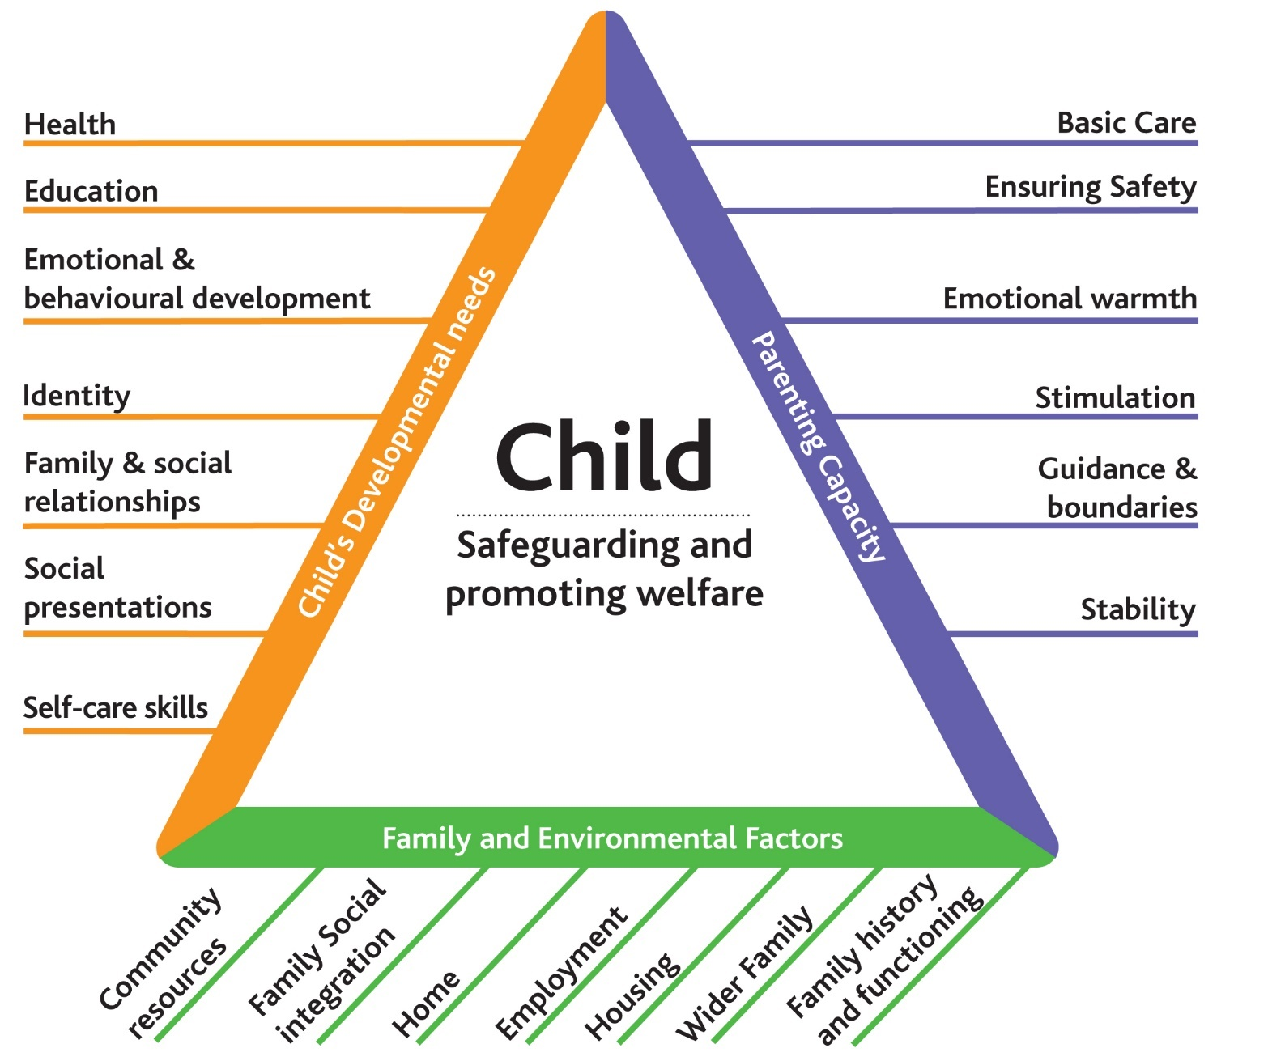
http://www.workingtogetheronline.co.uk/chapters/chapter_one.html#early

Child-centred assessment

Designed by the Scottish Government, ‘My World’ defines needs and risks as two sides of the same coin. It promotes the participation of children, young people and their families in gathering information and making decisions as central to assessing, planning and taking action.

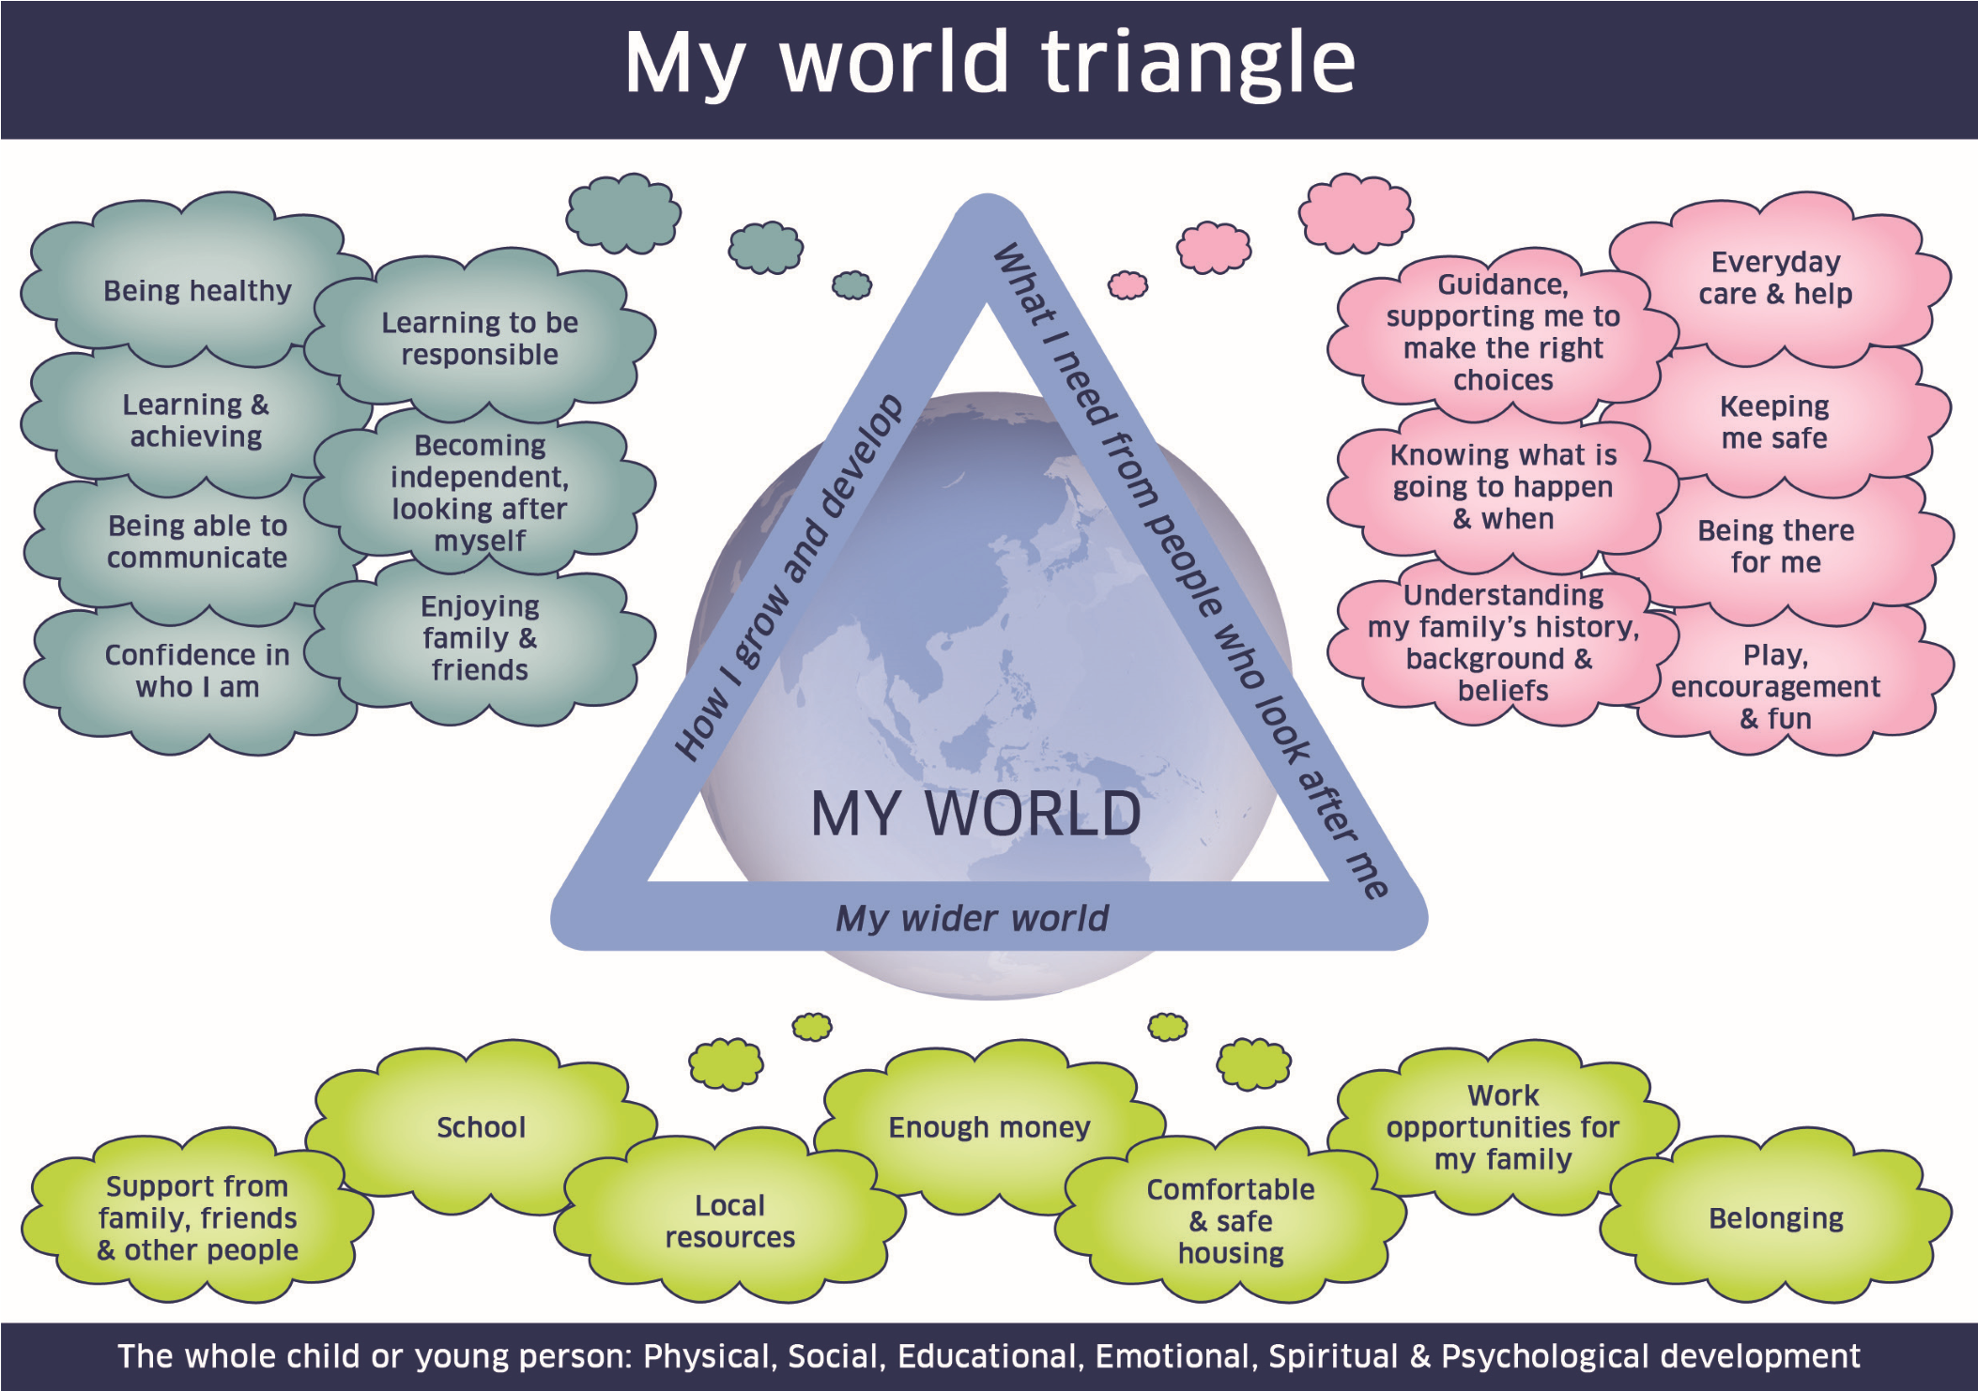
For further information please visit:
http://www.gov.scot/Topics/People/Young-People/gettingitright/national-practice-model/my-world-triangle

The Threshold of Needs

The Thresholds of Needs creates an explicit link between the Assessment Framework, so assessments produced clearly illustrate both a child’s level of need and any associated risks, thus determining the most appropriate support and service.
This threshold document describes criteria, level and type of need and level of help to be provided at each stage. Children can move between these levels according to their circumstances. Divisions between levels should not be conceived as ‘hard and fast’. The presence of single or multiple combinations of factors, the age of the child and protective factors should all be taken into account.
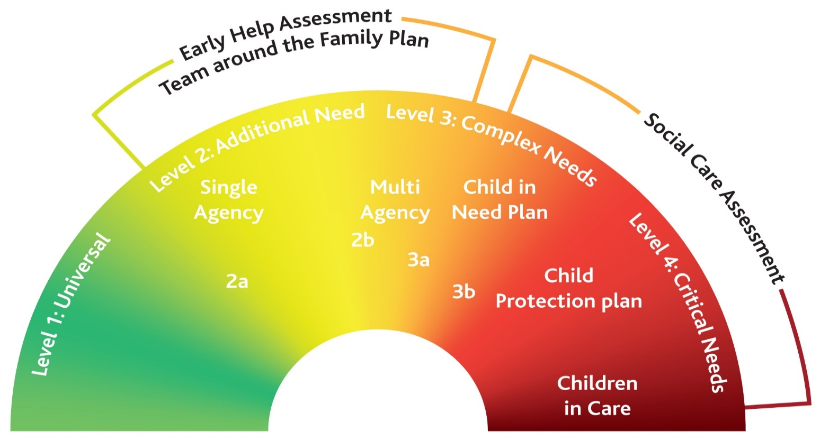
Level 1 – Universal Needs supported by Universal Services
Children and young people, including those who are disabled/seriously ill and young carers, who reach their full potential, make good overall progress through the care of their families, communities and the support of a range of universally provided services e.g. schools, primary health care, leisure services, and some specialist disability services such as health care/education.

Level 2 – Additional needs supported by Community EHA/TAFs & the LCSS Team
Children and young people, including those who are disabled/seriously ill and young carers, who may become vulnerable and who will require additional support due to their own development, family circumstances or environmental factors. They are at risk of not reaching their full potential and life chances may be impaired without additional services. This can be a single or multi-agency response and won’t always necessitate a response from the Local Authority.
There are 2 subcategories in Level 2, namely:
Level 2a: Single Agency (additional needs) - Children and young people, including those who are disabled/seriously ill and young carers, who may become vulnerable and who will require additional support due to their own development, family circumstances or environmental factors. They are at risk of not reaching their full potential and life chances may be impaired without additional services.
Level 2b: Multi Agency (additional needs) - Children and young people, including those who are disabled/seriously ill and young carers, who may become vulnerable and who will require additional support due to their own development, family circumstances or environmental factors. They are at risk of not reaching their full potential and life chances may be impaired without additional services.
It is recommended that Level 2b Children be supported by an Early Help Assessment and a Team Around the Family to ensure additional needs are being met and coordinated approach in place with agencies involved.
The Locality Community Support Service can advise professionals and families about the Early Help Processes and provide support where necessary within the Level 2 threshold.

Level 3 – Complex Needs supported by Targeted Early Help or Statutory Social Work Teams
Children and young people, including those who are disabled/seriously ill and young carers, whose needs are complex and who require support from more than one agency. They are at risk of social or educational exclusion; their health, welfare, social or educational development is being impaired; and life chances will be impaired without the provision of additional services.
Children and families with complex needs will either be supported by Targeted Early Help Teams or by Statutory Social Work Teams under S17 of the Children Act, 1989. In order to guide professionals as to which would be the most appropriate service, this level has been divided into two subsections.
Level 3a: Targeted Early Help
Level 3b: S17 Children in need
As both Level 3a and Level 3b are children and families with complex needs; the professional is asked to make use of the additional criteria (please see section Additional Guidance for Threshold Decision makers) to guide their decision making as to whether Targeted Early Help or Statutory Intervention is the most appropriate service to support families.
The 3 most important of the additional criteria listed in Additional Guidance for Threshold Decision makers that would guide the decision making are:
History and previous intervention (Principle 1 & Principle 2)

If a family has a history of previous involvement with services including but not limited to Social Care and/or Early Help, Mental Health Services, Substance Misuse, DA services ,Criminal Justice Services and the previous intervention has not been successful in maintaining the changes; resulting in a re-referral for the family (same difficulties) statutory intervention is likely to be a more appropriate response.
Parents may state that they are willing to engage in a new assessment but this willingness must be carefully assessed and balanced given that previous intervention has not made the changes required to improve the living circumstances of the children irrespective of the family’s willingness to engage. A robust approach will be required in these circumstances which not only takes into account the impact on the child but ensures that children are not left unprotected experiencing some or little change only for their home circumstances to revert back to unacceptable care standards. Be careful to avoid “start again syndrome”.

Willingness (Principle 3 & Principle 4)

If a family with complex needs is willing to engage with support and in the contemplation and/or decision and planning stage of the cycle of change, Targeted Early Help is likely to be a more proportionate response in the first instance but this must be balanced with previous history and impact on the child, particularly the cumulative impact of neglect over time.

Impact on the child (Principle 5 & Principle 6)
If the impact on the child is significant, statutory intervention is a more proportionate response, irrespective of willingness and the family history.

Level 4 – Critical Needs supported by Statutory Social Work teams (Child Protection)
Children and young people, including those who are disabled/seriously ill and young carers, who have critical and enduring needs. They are at risk of significant harm or removal from home. If a child is in immediate danger or is at risk of significant harm, a referral should be made to children’s social care and/or the police immediately.

Additional Guidance for Threshold Decision Makers

Consistent application of established thresholds for statutory intervention and non-statutory early help provision is crucial to managing demand whilst maintaining quality of service provision.
Threshold consideration is not just about the front-door to children’s social care and early help. It happens throughout the journey of the child, especially at transfer points. High numbers of transfer points, movement between statutory and early help services, and differences between areas can create variation in application of thresholds. This can cause confusion to families and to partners.
This guidance helps you apply the Threshold of Needs consistently throughout the child’s journey and across the County. It also helps ensure social care intervention only happens when necessary.
Principles
When decision-making in response to a new referral or transfer, consider the following alongside the OSCB Threshold of Need guidance. This balances the child/children’s safety and welfare against a proportionate response, so the intervention offered is not greater than that required, to ensure safety, and assist the family with meeting identified unmet needs.
- Child & family history –have there been similar incidents to the presenting concerns and if so, how many, and how long ago? Consider here, but not exclusively, is there a family history of one parent or both parents having mental health needs? Is there a history of domestic violence with either or both parents being victim or perpetrators? Have either or both parents experienced difficulties with substance misuse or involvement in criminality?
Consider the frequency of the risk; regular exposure can lead to gradual harm to the child building up over time. But also consider intensity – one incident can be very serious. Chronology is crucial to decision-making; many serious case reviews enquiries have found that a careful chronology could have helped form an earlier, more accurate identification of risk

- Previous agency involvement including CSC involvement – has there been previous involvement from other agencies, including but not exclusively, Social Care and/or Early Help involvement, mental health services, substance misuse services, DV services, criminal justice services. How many previous involvements have there been, and how long ago? What were those involvements and were those involvements due to similar concerns? How successful was the intervention provided? If previous interventions have not been successful, careful consideration of the likelihood that more of the same will assist the family is achieving the changes required. Be careful to avoid “start again syndrome”.

- Parental response to presenting incident – how have parents/caregivers responded to the incident of concern? Have they denied their part in the incident, are they defending or rationalising an unsafe or inappropriate parenting style, or are they demonstrating remorse and a willingness to work to reduce risks? Is there a risk of “disguised compliance”?

- Parental engagement – what do we know already about parents’ willingness and/or capacity to engage with intervention, from previous work with the family? Parents/caregivers’ verbal commitment to engage with intervention must be balanced against historical evidence of ability to engage with professional intervention. Do they have sufficient capability to change?

- Direct impact on child/children – what is the evidence of any direct impact on the child/children of parents/caregivers’ behaviour? Is there a direct disclosure from children which evidences impact? Child impact can vary depending on protective factors, individual resilience, history and more. Worrying parental behaviours should be considered alongside evidence of direct impact on the child/children. Be alert to hidden or disguised impacts, but do not assume.

- Child’s timescale – the paramountcy principle of childcare legislation requires consistent focus on the child’s timescale. How old is the child/children in the family, how much of their lives to date have been adversely affected, and what is the prognosis, based on chronology, for timely and sustained parental change? Repeating plans and intervention tried previously may not accord with the child’s timescale. This must always be considered carefully on receipt of new referrals raising concerns about families well known to CSC.

Threshold consideration at transfer points
There are several potential transfer points within the child’s journey in Children, Education and Families. Threshold decision-making needs to be considered carefully at these stages. They are:
- Locality Community Support Service transfers to:
- Supporting Universal Services
- Targeted Early Help
- Community Early Help (LCSS)
- MASH for Family Solutions Plus/Disability/Youth Justice & Exploitation Teams

- Multi Agency Safeguarding Hub transfers to:
- Family Solutions Plus Teams
- Targeted Early Help
- Community Early Help (LCSS)
- Disability Service
- Youth Justice & Exploitation Team
- Closed to services

- Family Solutions Plus Teams transfers to:
- Community Early Help (LCSS)
- Targeted Early Help
- Children-We-Care-For Teams
- Closed to services

- Hospitals Team (John Radcliffe & Horton) now aligned with the MASH Team transfers to:
- Community Early Help (LCSS)
- Targeted Early Help
- Family Solutions Plus Teams
- Disability Teams
- Youth Justice & Exploitation Team
- Closed to services

Transfer points can be a point of vulnerability for families. There may be disagreements between professionals and teams. This is an opportunity to explore the risks to the family and reach an agreed, transparent and consistent application of thresholds. This should consider individual factors, and history, but also the impact of changes to service provision and/or support levels going forward.
Community Early Help – application of Troubled Families criteria
If a family has been provided with robust community support and outcomes have not improved within agreed timescales or are deteriorating, targeted early help can be provided if –
- The family consents to Early Help
- Two or more of the Troubled Family criteria is met; these are:
- Parents or children involved in crime or anti-social behaviour.
- One or more children not attending school regularly
- Children who need help
- Adult out of work/at risk of financial exclusion/young person at risk of worklessness
- Families affected by domestic violence and abuse
- Parents and children affected by a range of health problems
Closure summary
At each transfer point where a recommendation is made regarding the status and type of plan going forward, the lead worker should complete a brief closure summary. This says what work has been done and provides a rationale for the recommendation. The transfer/closure summary should include:
Brief history
- Original presenting concern(s)
- Previous service involvement.
- Any additional concerns found/changes in current presenting issues.
- What interventions took place and whether they were successful.
- Summary of your team’s involvement.

Current parental response to the current incident /concern
- Have parent/s/caregivers acknowledged current concern?
- How have they responded? Denying, defending, rationalising?
- Does parent show understanding/insight?
- Are parent/s denying, defending or rationalising?
- Are parent/s demonstrating remorse and a willingness to work to reduce risk?
Parental engagement
- What do we know about parents’ willingness and or capacity to engage with interventions from previous work with the family and current information?

Direct impact on the children
- What is the current “lived experience for the child/ren?
- What is the evidence of direct impact on the children of parenting behaviour?
- Is there a direct disclosure from the children which evidences impact?

Summary and conclusion
- Outline reasons for transfer to the team you are transferring to and priority actions for that team.
Tools and resources

The Threshold of Needs will provide an overview of the issues facing a family and the strengths to be harnessed. To gain fuller insight, a number of additional assessment and support tools are available including:

Tools Will help with

Childcare Development Checklist (Neglect Toolkit) Assessing care of children and identifying neglect

Graded Care Profile Assessing care of children and identifying neglect

Outcome Star Tool for supporting and measuring change across a range of issues

Neglect Practitioners Portal Supports practitioners to successfully identify and record neglect.

Child Sexual Exploitation (CSE) Screening Tool Assessing the risk of children and young people of
Child Sexual Exploitation

CAADA DASH Risk Assessment Assessing the risks of harm from Domestic Abuse, Stalking and Honour-based violence

Parental Substance Misuse Toolkit Identify substance misuse, its impact and where to get support

Female Genital Mutilation (FGM) Screening Tool Assessing the risks of Female Genital Mutilation

3 Houses Tool Tool to actively involve children in child protection assessment and planning

Signs of Safety A solution focused framework for risk assessment and safety planning

Multi-Agency Risk Management Plan (MARAMP) Multi-agency risk assessment and plan where there are concerns about risky behaviour and there is no child protection plan

Further information

For further information on resources, teams and services available. Please visit:
Oxfordshire Safeguarding Children Board: www.oscb.org.uk
Oxfordshire Practitioner Toolkit: www.oxfordshire.gov.uk/practitionertoolkit
Oxfordshire County Council: www.oxfordshire.gov.uk

Glossary

Term Meaning

MASH Multi Agency Safeguarding Hub EHE Electively Home Educated MISPER Missing Person Return Interview
EHA Early Help Assessment (formally CAF)

CAF Common Assessment Framework (now EHA) TAC/F Team Around the Child/Family
LCSS Locality and Community Support Service

EHCP Education, Health and Care Plan

NEET Not in Education, Employment or Training

EET In Education, Employment or Training

TF Troubled Families/Think Family

CSC Children’s Social Care

CSE Child Sexual Exploitation

SEN Special Educational Needs

OSCB Oxfordshire Safeguarding Children Board

MARAMP Multi Agency Risk Management Plan

FGM Female Genital Mutilation

SEND Special Educational Needs and Disabilities
The Threshold of Needs processes are vital components of ensuring that children and families get the right support at the right time. This is sponsored by all partners represented on Oxfordshire Safeguarding Children Board.

