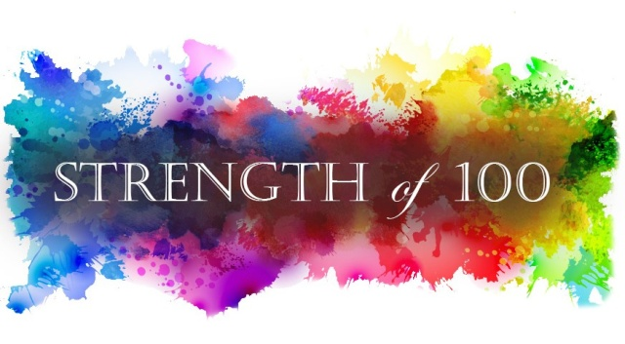

**SPONSORSHIP FORM**

Donor/Company Contact

**(as it should appear on Marketing Materials)**

Address City State Zip

Phone Email

**DONATION (Contributions for bags or in-kind donations of gift certificates, raffle prizes, etc)**

I wish to contribute the following items:

Value is $

Donation enclosed OR Please pick up my Donation

**CASH DONATION (Checks payable to *Strength of 100*)**

I wish to make a donation enclosed in the amount of $

**SPONSORSHIP OPPORTUNITIES\*\***

|  |  |  |
| --- | --- | --- |
| $1,000.00 | PLATINUM Sponsorship | $ |
| $500.00 | GOLD Sponsorship | $ |
| $200.00 | SILVER Sponsorship | $ |
| $ 100.00 | BRONZE Sponsorship | $ |
| $ 50.00 | SO100 FRIEND | $ |

**Please make sure that any/all donations, logos, art work, payments and contribution sheets be returned to Strength of 100**

**Email ads, logos, art work to: info@Strengthof100.com**

Please make checks payable to ***Strength of 100***

For questions or more information contact:

Sue Ellen Eichholz at 630-935-9030 or email info@strengthof100.com

*\*\** ***Sponsorship Opportunities are listed on the back of this sheet.***

**Sponsorship Opportunities**

## PLATINUM SPONSORSHIP - $1,000

* Logo positioned as an “Official Presenting Sponsor” for 1 year
* Special verbal recognition from the podium during all of the events (8/yr)
* Logo featured on any marketing material
* Logo placement on printed materials: Newsletter, Email Blast
* Logo placement on the webpage with hyperlink to your company website
* Social media recognition
* Opportunity to showcase your company and branded products

## GOLD SPONSORSHIP - $500

* Logo positioned as an “Official Sponsor”
* Special verbal recognition from the podium at all events
* Logo placement on printed materials: Newsletter, Email Blast
* Logo placement on the webpage with hyperlink to your company website
* Social media recognition
* Opportunity to showcase your company and branded products

## SILVER SPONSORSHIP - $200

* Logo positioned as an “Official Sponsor”
* Special verbal recognition during program
* Flier/merchandise distributed to runners
* Logo placement on the webpage with hyperlink to your company website
* Social media recognition

## BRONZE SPONSORSHIP - $100

* Logo placement on the webpage with hyperlink to your company website
* Social media recognition

## FUN RUN FRIEND - $50

* Name Listed on Table Display
* Social media recognition

**We are happy to tailor a benefit package to fit your needs.**