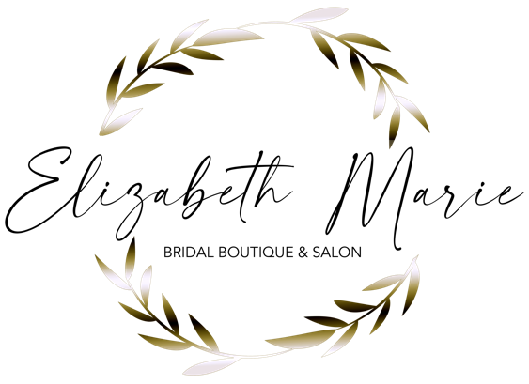

Bridal Hair & Makeup Contract
11 N. Main Street
Homer, NY 13077

Name:________________________________________________________________________

Address:_______________________________________________________________________

Today’s Date:________________ Phone Number:______________________________________

Email:___________________________________________________________

Date of Wedding:_________________ Start Time of Wedding:__________________

Time Bride Must Be Finished:_______________ Time Bridal Party To Be Finished:____________

Location For Services:____________________________________________________________

Best Contact Phone # Day of Wedding:______________________________________________

Bridal Makeup:
Regular Application $60.00
Airbrush Application: $75.00

Bridal Hair:
Formal Styles: $60.00 & up
Flower Girls: $30.00

Travel Fees:
$100/Stylist up within 30-mile radius of Homer, NY
Extra Milage: $50.00 & up

Thank you for inquiring about our hair and makeup services. Please read over our policies below.
Deposit Policy: We tend to book quickly for weddings and require the travel fee as a deposit in order to lock in your date and get the right amount of stylists needed to accommodate your wedding party. Deposits are non-refundable. Trails for hair and makeup are half price. Contracts and travel are due the day of your trail.

