

FOR IMMEDIATE RELEASE

IsoGuardian Completes Milestone Pilot Study
Clinical Evaluation at Albany Medical Center Demonstrates Procurement-Ready Performance for Hospitals
Media Contact:
Sara Rudin
Founder & CEO, IsoGuardian, Inc.
Albany, NY
info@isoguardian.com
www.isoguardian.com

ALBANY, N.Y. — February 28, 2026
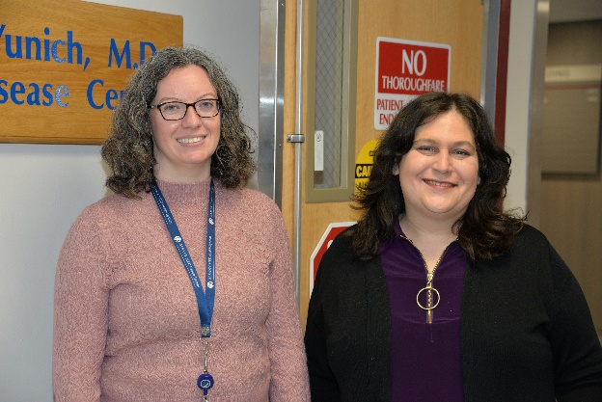
IsoGuardian, Inc., a medical device company based in Albany, New York, announced the completion of a clinical pilot study at Albany Medical Center evaluating its FDA-registered reusable Level 2 isolation gown. Conducted across inpatient and procedural outpatient units, the study found strong positive results and marks a formal institutional validation milestone for the company, signaling institutional readiness.
Left to right: Stephanie Dosiek, Director, AMC OTR, and Sara Rudin, Founder, IsoGuardian, Inc.
Photo courtesy of Albany Medical Center.

Plot was facilitated in conjunction with Albany Medical College Office of Translational Research, Innovation, and Technology Transfer (OTR) with 3rd party principal investigators. Evaluations took place over the course of 2 week in 4 departments in Albany Medical Center. A total of 116 daily surveys and 41 end-of-week surveys were collected from participating clinicians.
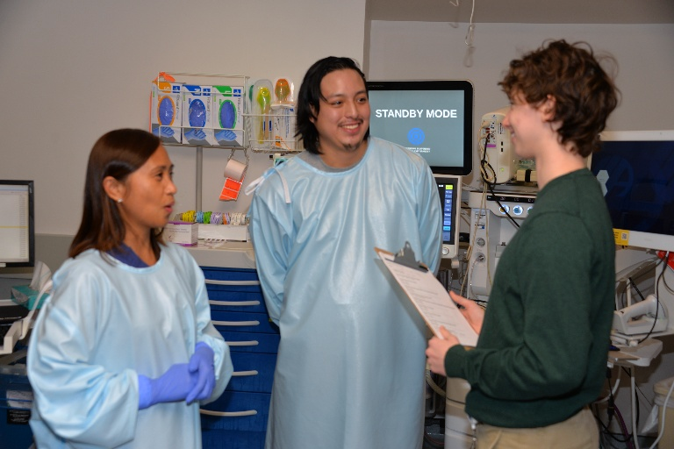
Daily survey responses indicated:
- Protective — 95% positive
- Easy to use — 91% positive
- Comfortable — 85% positive
Clinicians described the gown as “comfortable/stylish/high quality,” noted that it “feels more protective,” and highlighted its “fully encompassing” coverage compared to standard gowns.
Principal Investigator Surveying Users
Photo courtesy of Albany Medical Center
Albany Medic Health System release of results can be found at: https://www.albanymed.org/news/pilot-study-tests-isolation-gowns-in-collaboration-with-colleges-business-incubator/ The article further noted that “conversations are ongoing about the potential use of the gowns on a larger scale at Albany Medical Center.”
IsoGuardian’s progress reflects active collaboration across Albany’s innovation ecosystem. The company is supported through a joint incubation initiative with the Albany Medical College Office of Translational Research, Innovation, and Technology Transfer (OTR) and STEAM Garden. OTR is assisting with medical market entry strategy, including coordination and execution of the Albany Med pilot study, while STEAM Garden has provided operational space and funding support, including IsoGuardian’s FDA registration activities. Funding for the pilot was provided through an award from FuzeHub’s Commercialization Competition, a highly competitive, statewide competition recognizing emerging technologies with strong commercial potential.
“This milestone represents the completion of formal clinical validation in a real hospital environment,” said Sara Rudin, Founder of IsoGuardian. “The strength of results provided meaningful confirmation and proved our product claims of safety, usability, and comfort.”
Independent laboratory testing demonstrated significant improvements in tear strength, hydrostatic pressure resistance, and breathability compared to standard gowns. The IsoGuardian gown is engineered for 300 industrial wash cycles, supporting durability and cost efficiency in clinical settings.
IsoGuardian has secured regulatory compliance, strong and scalable supply partners capable of providing 7M gowns a month, and with pilot validation complete, IsoGuardian’s next step is securing bridge funding for operational readiness as the company prepares for broader institutional engagement.

