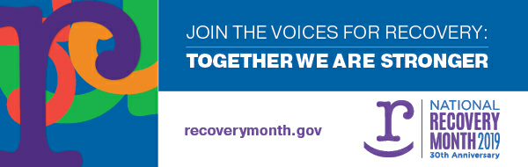 **Community Recovery Rally**

**Saturday, September 21st, 2019 from 6:00-9:00 pm**

**Rotary Square, 120 Union Street South, Concord NC**

.

September is National Recovery Month. Cabarrus and surrounding counties have come a long way in reducing overdose deaths. Cabarrus County statistics for overdose remain near the top in the State of North Carolina.

“***Join the Voices for Recovery****”*

Join us on September 21st to promote awareness and end the stigma surrounding substance use recovery. Managing the effects of recovery can help people achieve healthy lifestyles, both physically and emotionally.

.

**How can YOU help?**

**If you are a community member, agency/organization, or church…**

**.**

* [**Attend the Rally**](https://www.eventbrite.com/e/community-recovery-rally-tickets-64979482381) – Show your Support! Recovery is possible! #RecoveryRocks!!!
* **Be a Vendor** -provide a resource table at the rally that includes information about your services and/or area detox and treatment resources
* [**Be a Volunteer**](https://www.signupgenius.com/go/8050948a5ab2fa1fc1-venue)– Assist the Recovery Rally with set up and breakdown/Venue and logistics
* [**Make a Donation**](http://bit.ly/2Z2fMxT) **–** Your financial contribution will ensure the Recovery Rally is able to link individuals to treatment and provide recovery supports as needed.
* [**Participate in the rally walk**](https://forms.gle/P8yMLrwxG8jo7toq9) **–** Join us as we walk the streets of downtown Concord to raise awareness and combat stigma!
* [**Participate in the Twilight Memorial**](https://forms.gle/P8yMLrwxG8jo7toq9) – Have you lost someone to the disease of addiction? Click on the [link](https://forms.gle/P8yMLrwxG8jo7toq9), submit their name, and join us for the memorial walk!
* [**Promote the Rally**](https://www.facebook.com/groups/recoveryrally19/) – Post Recovery Rally Flyers on your social media
* **Include us in your prayer** – Pray for the success of this event

This event is organized and sponsored by the Cabarrus County Substance Use Coalition and Brandon’s Bridge. Donations of support can be made to Brandon’s Bridge, just [click here](http://bit.ly/2Z2fMxT).

For more informatn contact Recoveryrally19@gmail.com[](https://www.instagram.com/communityrecoveryrally)[](https://twitter.com/RallyRecovery)[](https://www.facebook.com/groups/recoveryrally19/)