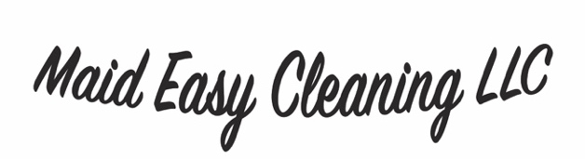(563)-495-2585
maideasydubuque@gmail.com

Date of SERVICE: ______________
The following services were done today:
Rooms | Regular Cleaning | Deep Clean (Extra Charge)
Kitchen | - Clean Outside of Fridge  - Clean all Counters  - Sweep and Mop Floors  - Vacuum Rugs  - Dusting Light Fixtures  - Cabinets and Drawers Exteriors  - Clean Sink  - Clean Windows  - Clean Doors  - Disinfecting all Surfaces  - Clean Microwave Inside and Out  - Clean Baseboards  - Wipe Down Garbage Lid | - Clean/Organize Fridge Interior  - Deep Clean Garbage Can  - Clean/Organize Cabinets
Living space | - Clean side tables  - Clean Coffee Tables  - Clean Couches/Recliners  - Clean Dining tables  - Clean Dining Chairs  - Dust Picture Frames/Wall Décor  - Dust Base Boards  - Sweep Floors (Hardwood/Laminate)  - Vacuum Rugs/Carpet  - Clean Windows  - Clean Doors and Handles  - Dust Ceiling Fans and Lightings  - Dust Electronics  - Dust Entertainment Stands  - Disinfect all Surfaces  - Clean up clutter | - Clean Inside of windows
Bedrooms | - Make Beds  - Dust Headboards/Legs  - Clean windows  - Clean side tables  - Clean Stands/Dressers  - Clean Doors  - Vacuum carpet  - Sweep Flooring  - Clean up clutter | - Clean Inside Windows
Bathrooms | - Change Trash  - Dust baseboards  - Clean in and around toilet  - Clean plumbing handles  - Sweep/mop  - Clean Mirrors  - Clean sinks  - Organize Toiletries  - Clean doors and handles  - Clean vanity fronts | - Deep Scrub showers and Bathtubs

