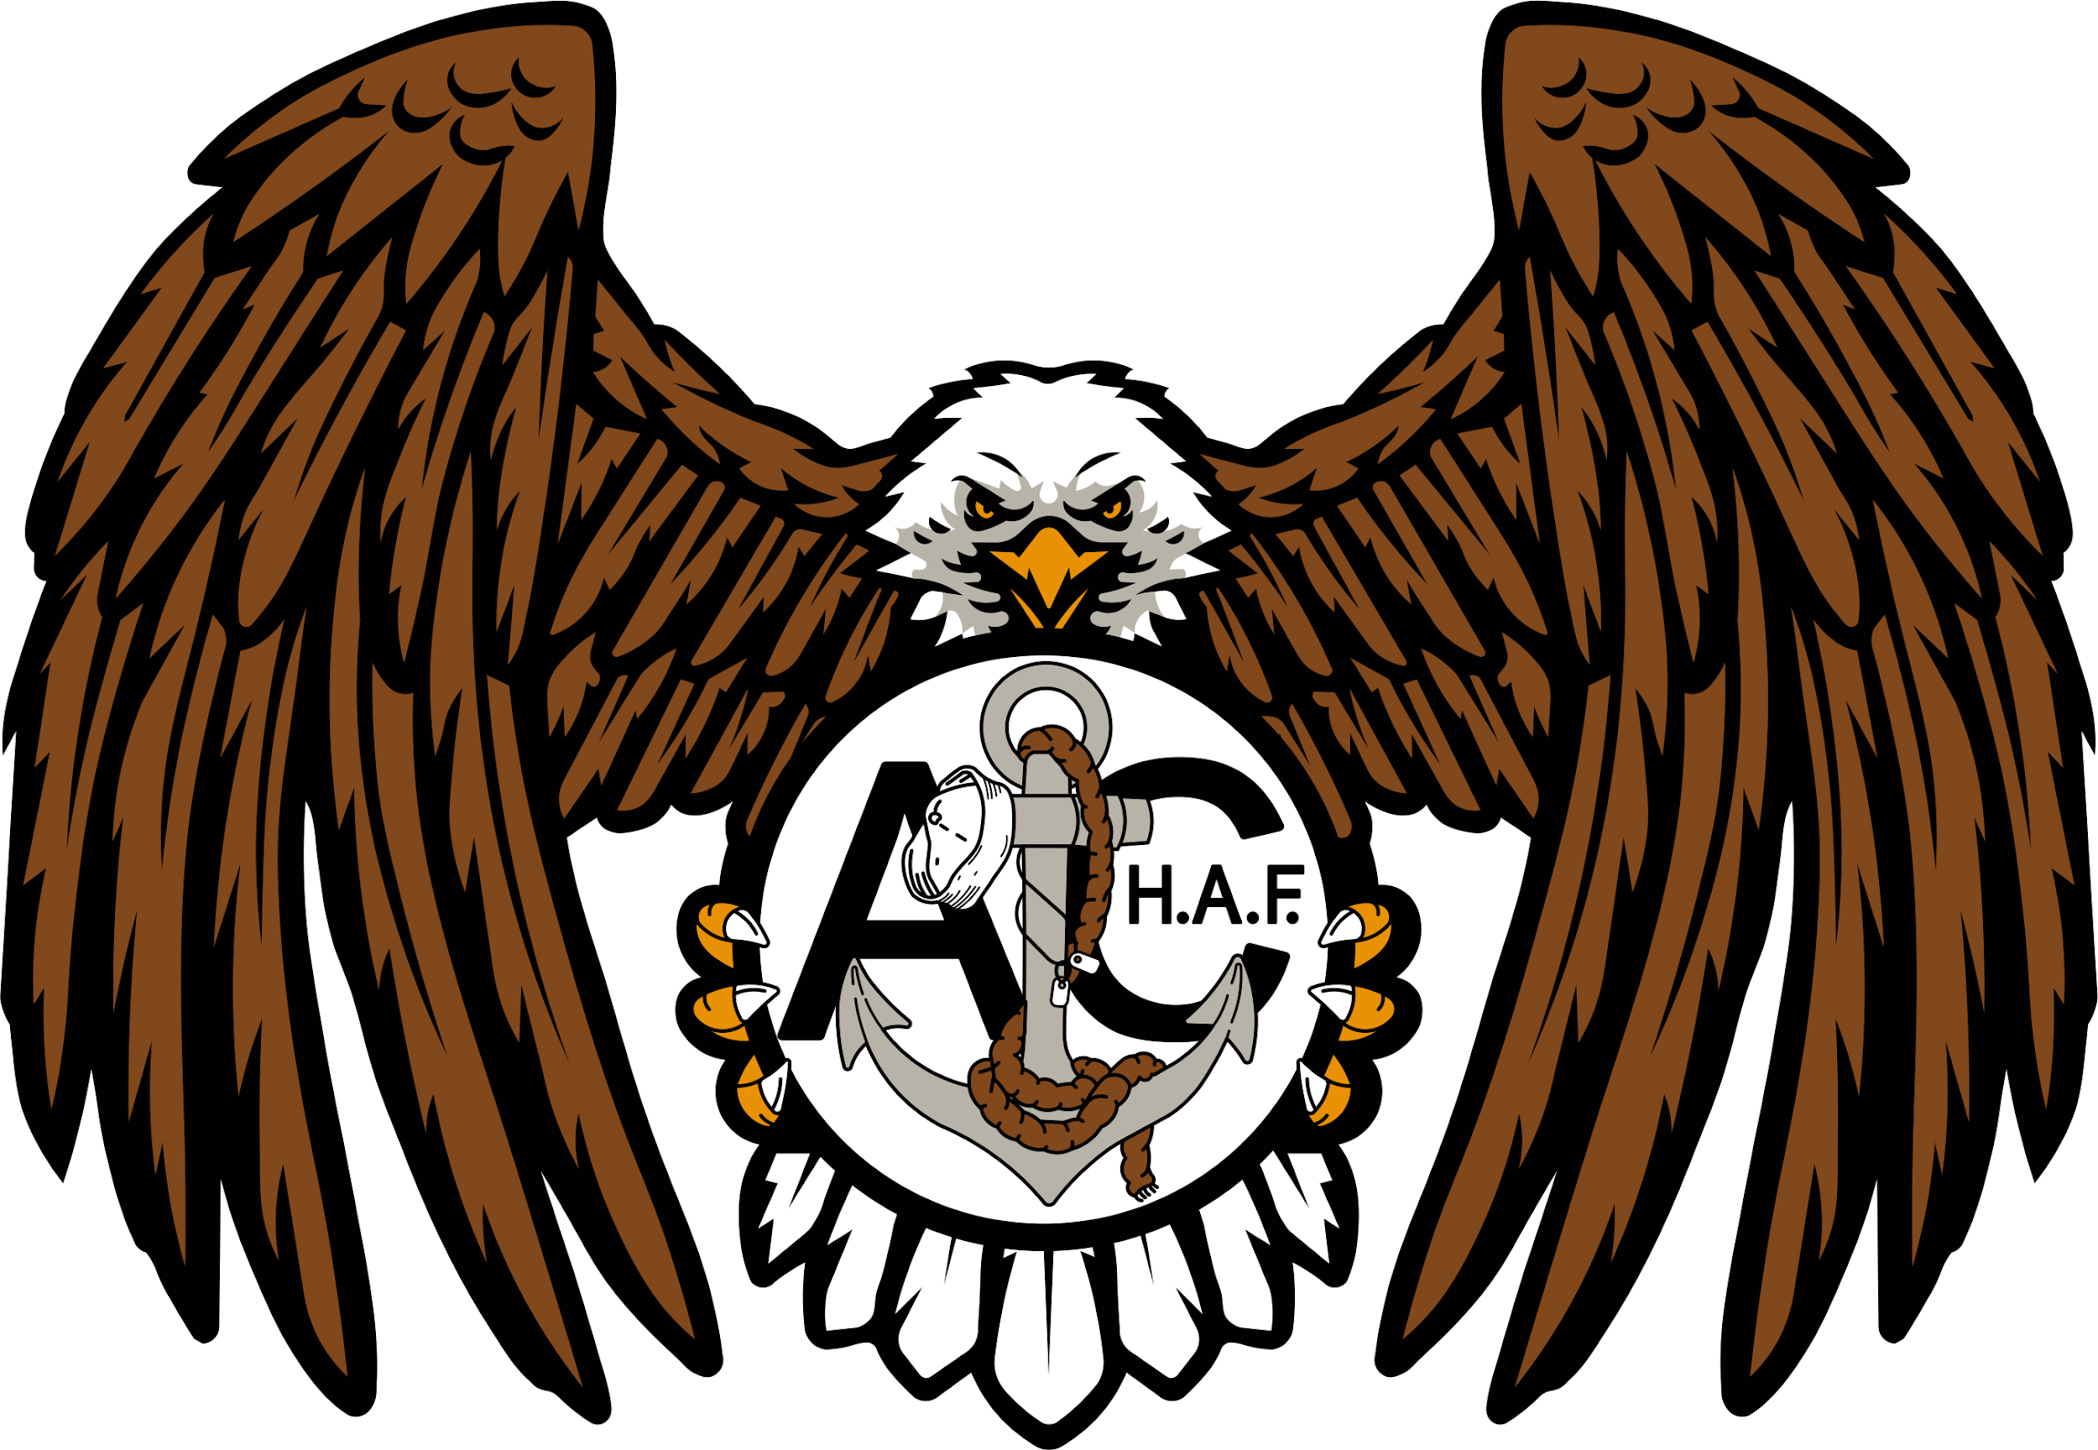
THE HUNTER ALEXANDER FRANK MEMORIAL FOUNDATION
1749 SW 48th St Owatonna, MN 55060 | 507-363-1569 | EIN: 93-4537606
hafmemorial@outlook.com | www.hafmemorial.org

2026 HAF Memorial Event Donation Form

Name/Company: _______________________________________________ Date: _______________________
Address: __________________________________________________________________________________
Phone Number: ______________________ E-mail: ________________________________________________

OPTION 1:
I would like to donate silent auction or raffle item(s). (Deadline: Friday, September 4th, 2026)
Name of Item(s):____________________________________________________________________________
Description of Item(s): _______________________________________________________________________
Name to acknowledge as the donor (if different from above): _________________________________________
__ I would like to remain anonymous
__ Item(s) is/are included with this form.
__ I will deliver item(s) at a later date. (We will contact you to set up a time/date)
__ You can pick up the item(s) at a later date. (contact us when ready for pickup)

OPTION 2:
I would like to donate $________. Name for acknowledgment, if different than above: _____________________
__ I would like to remain anonymous
__ Check (make payable to Hunter Alexander Frank Memorial Foundation or HAF Memorial)
__ Venmo (@hafmemorial)
__ Online at www.givebutter.com/HAF2026 (select donate button)

OPTION 3:
__ I would like to volunteer at the event

EVENT SPONSORSHIP:

The criteria to be recognized as an event sponsor is as follows, if you would like to be recognized as an event sponsor please select one;
__ Supporter: Goods and/or services equating to $100
Name listed on event program and website
__ Patriot: Goods and/or services equating to $250
Sponsor certificate, 2 Dinner Tickets, and name listed on our website, social media, and event program
__ Freedom: Goods and/or services equating to $500
All Patriot Above PLUS Banner with Company Name/Logo Displayed At Event*
*Banner can be self-provided, otherwise a 3’ x 4’ Banner is complimentary with sponsorship.
__ Visionary: Goods and/or services equating to $1,000+
All Patriot Level above PLUS 4 Dinner Tickets total, Social Media Shoutout, and Media Recognition
__ Star Spangled Banner: Limited to 1 sponsor (FCFS) This is our Title Sponsorship $1,500
All Visionary Level above PLUS Reserved Table w/Custom Table Tent, and Verbal Recognition throughout event.
__ Check here if you would like us to send you a tax donation form

Thank you for your donation! With your generosity, YOU have changed lives!

Donation Value: $_____ EIN: 93-4537606 Authorized Signature: ______________
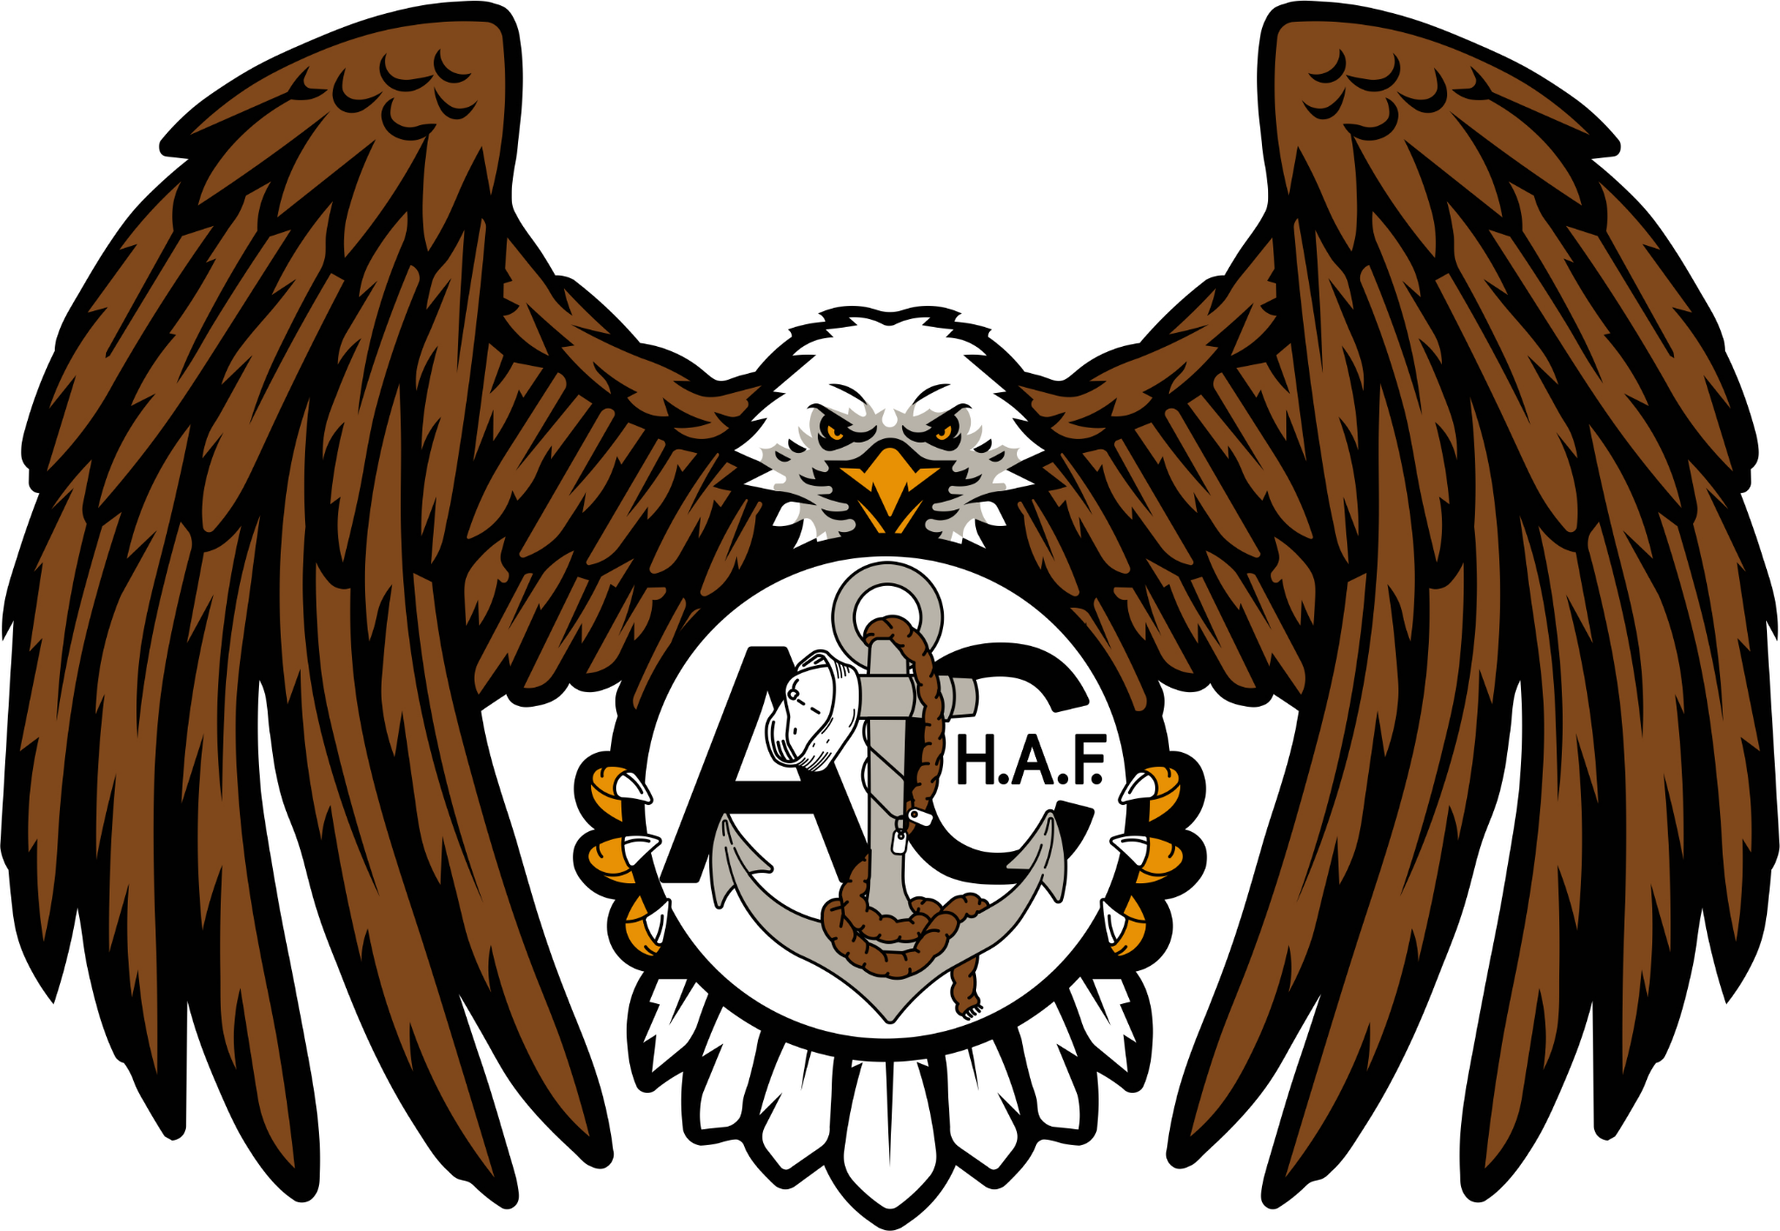
THE HUNTER ALEXANDER FRANK MEMORIAL FOUNDATION
1749 SW 48th St Owatonna, MN 55060 | 507-363-1569 | EIN: 93-4537606
hafmemorial@outlook.com | www.hafmemorial.org

Hello, We are the Hunter Alexander Frank Memorial Foundation and we will be hosting our 6th Annual Fundraising Event on September 19th, 2026 at the Owatonna Eagles Post 1791!

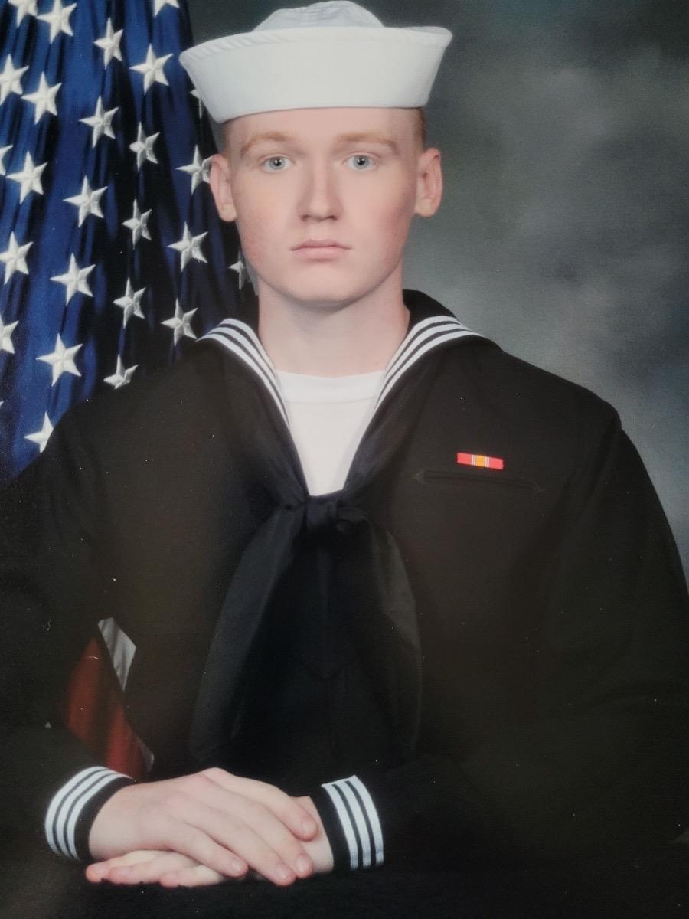
Who are we?
Our foundation was created following the first motorcycle memorial ride for Hunter Frank. Hunter was an Owatonna native, graduating the Owatonna Senior High School in 2018, and enlisting in the United States Navy immediately following graduation. He was best known for his caring and helpful personality, giving help wherever needed. Unfortunately in October of 2020, he lost his life while he was deployed in El Salvador. On the anniversary of his death in 2021, his older brother hosted a memorial ride to carry on his memory, which was met with an overwhelming amount of support from the community. Friends and family of Hunter decided to band together and create a foundation based on keeping Hunter’s memory alive and carrying on his legacy, thus the Hunter Alexander Frank Memorial Foundation was formed. We are a 501c3 non-profit organization as well as a member of the Owatonna Area Chamber of Commerce and Tourism, raising funds to help veterans right here in our community while keeping alive the memory and legacy of Hunter Frank.

What do we do?
Each year, we host a fundraising benefit for veterans AND their families. We started off crowd funding until we were able to obtain our 501c3 non-profit status in 2024. With the Community's help we have been able to donate over $30,000 to Wounded Warriors Family Support between 2022 and 2024, as well as adopting a highway and now we are able to assist our veterans right here at home!

Where are funds distributed?
After the event, proceeds are to be split between Operation 23 to Zero and Ride for Heroes, both local organizations focusing on helping our veterans, right here at home, so donors can be rest assured that every cent stays local and goes to literal life-changing causes.

What can you do to help?
We are seeking donations to make the event successful and raise as many funds for veterans and their families as possible. There are many ways to donate such as:
Monetary Donations - donating directly towards our goal, this is the most straightforward way to help.
Silent/Live Auction, Raffle, and Service Donations - the silent auction has been our biggest source of income for the event, typically raising about half of the total funds, this year we will be trying some new things to get us closer to our $15,000 goal!
Volunteering Opportunities - due to the scale of the event, we typically need volunteers for various duties throughout the event such as; apparel sales, ride registration, hall staff, and more.

How can you benefit from donating?
Each person/business/organization that donates in any capacity will be recognized and accredited through our social media, event program, and even on our website! Taxable Donation forms can be obtained by requesting one with your donation. By donating to our event you can rest easy knowing that your contributions are staying within the community, supporting our local veterans, and changing lives!

Our goal for the 6th Annual HAF Memorial Event is to raise $15,000. To learn more about us and what we do, please visit our website www.hafmemorial.org or follow us on facebook. For more information about the event benefactors, please visit www.https://www.op23tozero.com/ and www.https://www.rideforheroes.net/

Thank you for your time, we look forward to the opportunity to work with you!
If you are interested in donating, please fill out and return the form on the back of this page.

