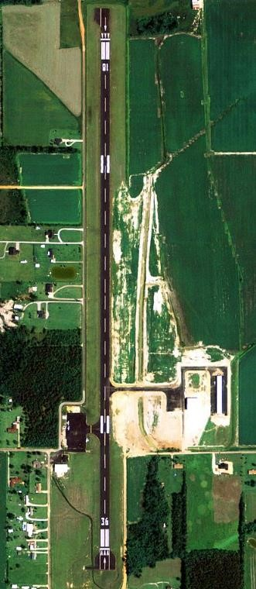

**Atmore Municipal Airport (OR1) Operating**

**Procedures Atmore, AL**

**Location:**

31-00-58.1000N 087-26-48.3000W

31-00.968333N 087-26.805000W

31.0161389, -87.4467500

**Field elevation:** 286’ MSL.

**Frequencies:**

CTAF/UNICOM: 122.8

GLIDER BASE: **122.8**

PENSACOLA APPROACH: 127.35

PENSACOLA DEPARTURE: 127.35

WX AWOS-3PT at 12J (20 nm E): 119.325 (251-809-2987)

**Runway Information**

Runway 18/36

Dimensions: 5001 x 80 ft. / 1524 x 24 m Surface: asphalt, in good condition

Weight bearing capacity: Single wheel: 16.0

Runway edge lights: Medium intensity

**RUNWAY 18** **RUNWAY 36**

Latitude: 31-01.381432N 31-00.556477N

Longitude: 087-26.806668W 087-26.803960W

Elevation: 283.2 ft. 279.9 ft.

Traffic pattern: West West

Runway heading: 183 magnetic, 180 true 003 magnetic, 360 true

Markings: nonprecision, in fair condition nonprecision, in fair condition

Visual slope indicator: 2-light PAPI on left 2-light PAPI on left

Touchdown point: yes, no lights yes, no lights

**A/C Parking**

Turn out areas provided to clear runway. Parking is on the West side of the airfield on the ramp.

**Airfield Lighting**

1. Atmore Municipal Airport has runway and taxiway lighting, with PAPI indicators on both runways.
2. Pilot controlled lighting is available using 122.8 VHF.

**General Operations**

SkyWarrior aircraft may perform day Touch & Go and full-stop landings using the following standard operating procedures:

a. Direction of Traffic:

* 1. **No Gliders**:
     1. SkyWarrior aircraft patterns will be flown as normal when there are no gliders present.
  2. **Gliders in Operation:**
     1. SkyWarrior aircraft patterns will be flown to the West.
     2. Glider aircraft pattern will be flown to the East.

1. Glider aircraft have the right of way and will land on the grass to the East to the max extent possible. If the grass is wet, the gliders may have to utilize the prepared surface.

1. If the gliders are using the runway to land, communication and cooperation are of extreme importance.

1. Pattern Operations while gliders are operating is allowed. Sound judgment and communication on CTAF (122.8) is mandatory. Extending downwind to accommodate gliders or waving off in the event a glider is on base or final is encouraged in order to operate safely.

1. Glider approach speed is roughly 65 Kts.

1. If a glider is on the runway, SkyWarrior aircraft shall execute a wave-off offsetting to the West side of the runway for traffic deconfliction.
2. Glider base frequency is **122.8.**
3. SkyWarrior aircraft shall communicate on CTAF.
4. Touch & Go and full-stop landings shall only be conducted on a clear runway.
5. Aircraft entering or departing Atmore shall depart straight ahead or to the West when gliders are operating to deconflict with the gliders in the pattern. Gliders will utilize a traffic pattern to the East.

**Restrictions/Hazards**

WARNING: Gliders operate within the Atmore County airport environment.

a. To reduce the risk of mid-air collision and due to the high volume of glider traffic, aircrew shall communicate on CTAF and monitor the glider frequency on 122.8.

WARNING: A-292 & Pensacola North MOA

1. A-292: High Volume of rotary and Fixed Wing Traffic Surface-17,500
2. Pensacola North MOA: 10,000-17,999

Warning: Area FOX on western side of A-292 from 1500’- 4500’

a. SkyWarrior aircraft must remain below 1500’ within 4 miles of OR1 if traffic is utilizing the western side of A-292 under the North MOA.

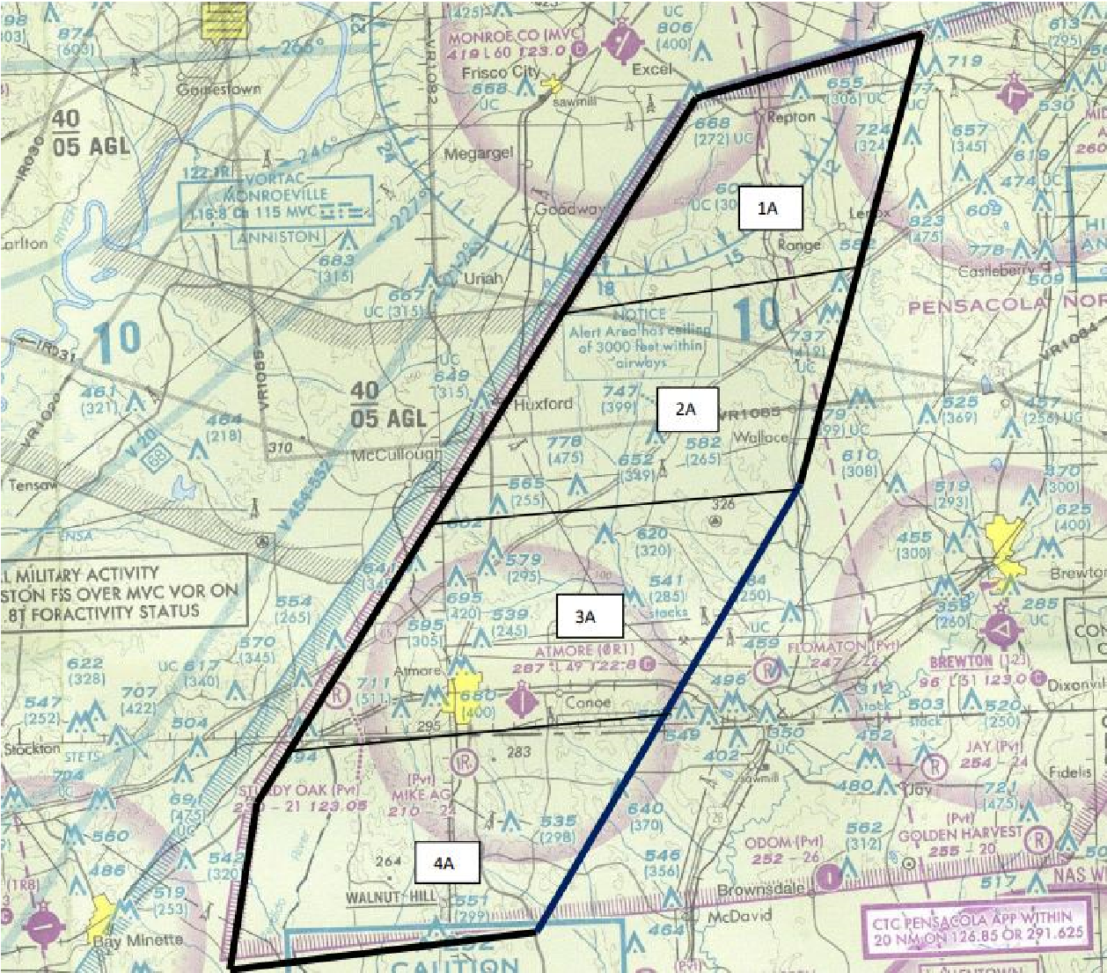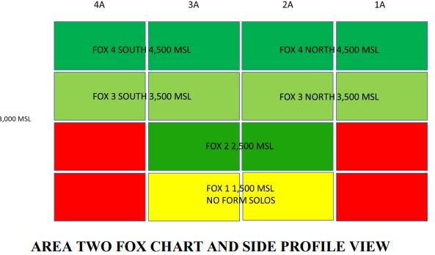

**Safety and Security**

1. Gates will remain closed at all times that a vehicle is not actually in transit through them. The pedestrian gate will remain closed, but not locked at any time.
2. Non-electric vehicle gates will be locked when not in use, and at all times when the airport is unattended.
3. Vehicular traffic on any aircraft movement surface is restricted to vehicles displaying FAA approved lights or flags, or vehicles closely escorted by airport service vehicles displaying FAA approved lights/flags.
4. Vehicular speed limit is ten (10) miles per hour, except for emergency-response vehicles.
5. Vehicular traffic by t-hangar renters is restricted to direct route to/from the proximity access gate to/from the individual’s t-hangar and nowhere else. A vehicle must be locked inside the t-hangar if it is to remain while the aircraft is gone.
6. Foot traffic to/from the t-hangars is limited to direct route to/from the proximity gate to/from hangar, or to/from t-hangar to/from large hangars via the grassy areas only, and not cross any aircraft movement or aircraft parking areas.
7. Foot traffic will be restricted to a direct route from personnel gate to destination building or aircraft with no deviations.
8. The fuel farm will be locked at all times when not in actual use, and access to it will be limited to authorized personnel only who have been trained in its use.
9. Emergency numbers and the Safety and Security Ordinance will be posted in prominent places such as: At the main gates or the airport.
10. Privately-owned vehicles will not park in the security fence at any time.
11. Inside the security fence, vehicle parking is limited to fuel trucks, aircraft, airport, service vehicles, and rental vehicles awaiting pickup or after return.
12. Extended parking (overnight or longer) is restricted to the airport parking lot.
13. All hangars will be closed and locked when the airport is unattended. All hangars are required to have current fire bottles.
14. Local Law Enforcement will perform regular patrols of Airport facility and maintain a record of such patrols.
15. Passengers and non-rated pilots must be escorted by a Certified Pilot at all times once outside the footprint of the FBO.

**Glider Assembly/Disassembly and Ground Support**

1. Glider assembly or disassembly may be done on the north side of the west ramp whenever practicable. Glider assembly/disassembly may also be done on the East ramp.
2. Once assembly is complete, the glider trailer and tow vehicle should be parked alongside of the west fence or on the North side of the maintenance hangar.
3. Glider trailers and tow vehicles may utilize the west gate to access the west ramp.
4. Glider operations should utilize a golf cart or similar vehicle to assist in the safe and timely movement of gliders on the ramp and on the AOA.