Business

Conlin does the math on solar billboard lighting
July 27, 2017 1:05 am · Conlin does the math on solar billboard lighting. Views: 673
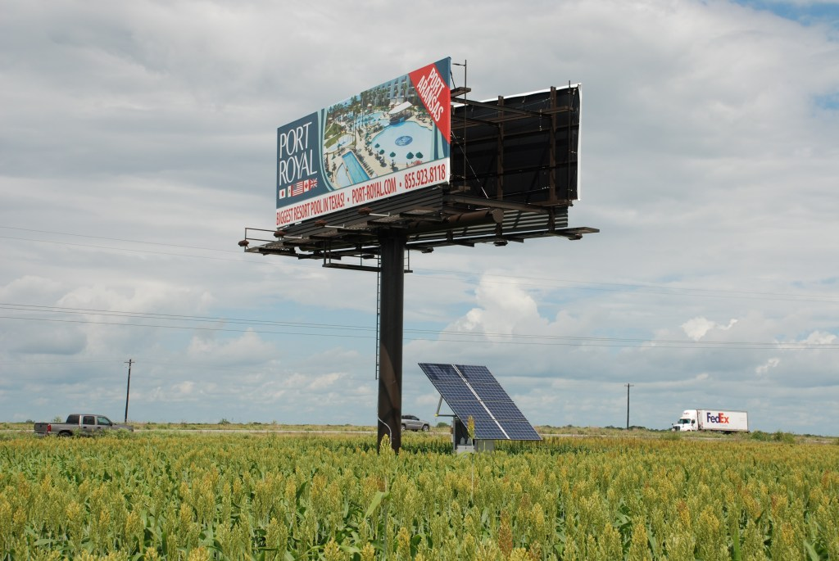
2KW solar array powering 8 lights in South Texas. The solar array is oversized to compensate for partial shading from the sign, as the site has space constraints. Photo courtesy Legacy Advertising.
By Kevin Conlin, Autonomous Power Solutions
When does solar lighting make sense? – let’s do the math
In previous articles, I’ve discussed some of the technical aspects of building a reliable solar lighting system.
But when does it make the most sense, financially?
Answer: when conventional power is unavailable, and your customer is willing to pay the premium for a lit board.
Here’s the math for a double sided 14’ x 48’ bulletin
The solar lighting consists of (3) Holophane LED fixtures per side
The lights will burn for 6 hours per night, or 5 at night and 1 before dawn
A well-designed solar power system, with at least 7 days battery reserve, will cost approx. $12,000 (may vary by location based on sunlight hours)
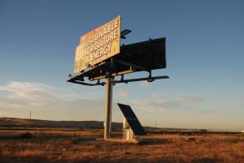
Billboard at dusk….1300W ground mount system near Boardman, OR, powers 4 lights. The larger solar array is required because of weak winter sunlight conditions. Photo courtesy Meadow Outdoor.
Solar system cost…….$12,000
Lights…………………………..3,600
Freight…………………..…..$1,000
Installation…………………$2,500
Total installed cost……$19,000
Last, let’s assign a battery replacement cost of $600/year
Since solar lighting system qualify for the 30% Federal Investment Tax Credit: $19,000 x .7 = $13,300 Net Cost
Let’s also assume, as the board owner, you’re looking for a 30-month payback on your investment.
$13,300/30 months = $443/month
+ $50/month battery replacement
$443 + 50 = $493, or $500/month
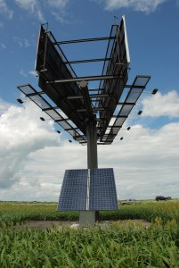
2KW solar array powering 8 lights in South Texas. The solar array is oversized to compensate for partial shading from the sign due to space constraints. Photo courtesy Legacy Advertising
Conclusion: If you can generate $500/month, or $250/side, your solar investment will pay for itself in 30 months.
With a 30-year design life, including battery replacements, your $19,000 investment, $13,300 after taxes, should return over $180,000, not adjusted for inflation.
Note: some assumptions are made in these calculations, your actual numbers may differ. Accelerated depreciation and other tax benefits, such as property tax exemptions, are not factored into these calculations for simplicity sake.
Solar system and battery bank size may also vary depending on annual sunlight availability, but these numbers are a good starting point.
Remember, this scenario only applies to situations where conventional power is unavailable or too expensive.
Kevin Conlin is a 30 year veteran of the solar industry. His company, Autonomous Power Solutions, has developed the Work Horse line of solar lighting systems for the outdoor advertising industry. You can reach Kevin at kconlin@autonomouspwr.com.

