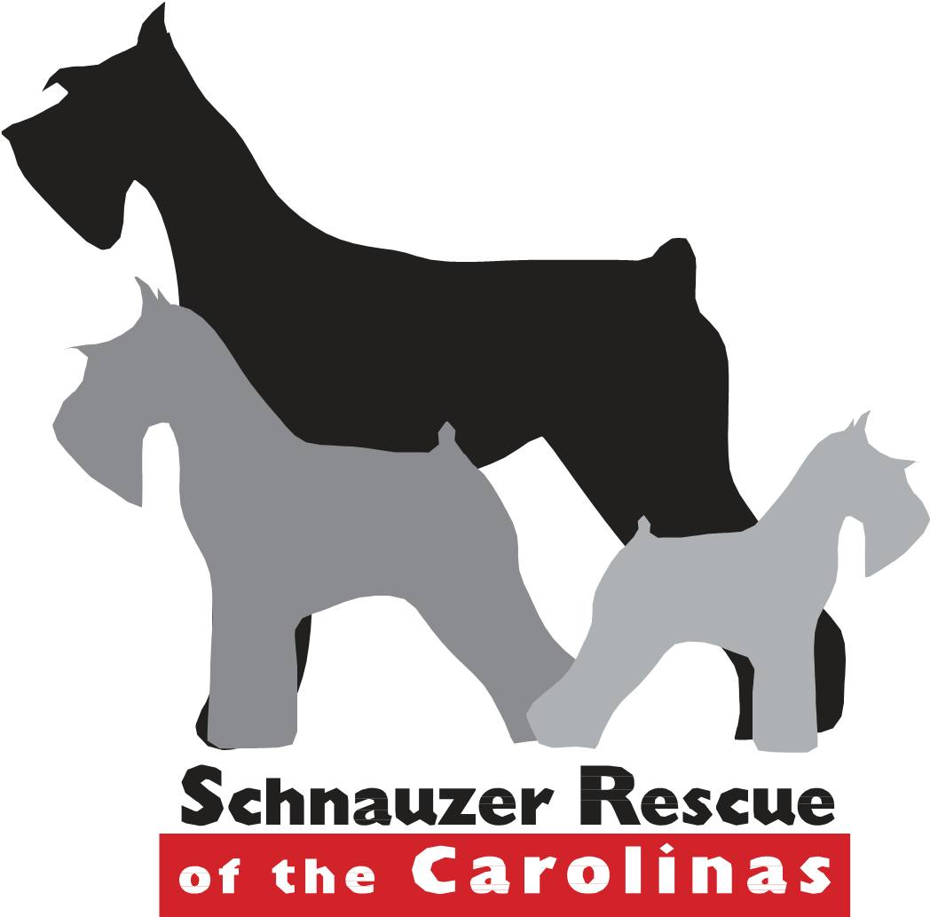
A $5 non-refundable processing donation due before any application will be considered.
Donate at www.schnauzerrescueofthecarolinas.org
***IMPORTANT DOCUMENTS NEEDED FOR APPROVAL PROCESSING***

- ATTACH A COPY OF EACH APPLICANT’S DRIVER’S LICENSE TO THE COMPLETED APPLICATION AT SUBMMISSION
- MEDICAL RECORDS FOR ALL DOGS (CURRENT AND DECEASED) FOR THE LAST FIVE YEARS – THESE SHOULD BE SCANNED AND INCLUDED WITH THE APPLICATION OR FAXED WITH THE APPLICATION TO 910-401-1317

All questions on this form MUST be answered, even if the response is n/a. If any of the answers are incomplete, your application WILL NOT be processed.

Acceptable Forms of Submission: Fax: 910-401-1317 Email: adoptions@schnauzerrescueofthecarolinas.org

Date: | Transaction # for $5 Processing Donation:
Your Full Name and Date of Birth: | Spouse/Partner Full Name & Date of Birth:
Your Email Address and Cell Number: | Spouse/Partner Email Address and Cell Number:
Complete Address (Street, City, State, Zip): States in Adoption Area are NC, SC, VA and E TN
HOME SETTING: ___Single-Family Home ___Apartment/Condo ___Townhouse ___Other (describe)

Type of Fencing: ______________________________________________________________________
If no fence, plan for exercise and toilet duties:_______________________________________________

Is there a swimming pool or pond on property? (yes) or (no) If yes, how it is enclosed: _______________

Your occupation/place and length of employment/typical work schedule:

Spouse/Partner occupation/place and length of employment/typical work schedule:

Please describe below your experience with rescued animals, your plan to help a rescue adjust to new home, and your plan to help rescue and other pet in home adjust to each other (if applicable): (please elaborate; use extra paper as needed).

What temperament do you hope for in a rescued dog; what are your plans for house training, if there are issues? What issues would be unacceptable to you (incessant barking, destructive, biting?

What circumstances would cause you to need to rehome an animal?

What will a typical day be like for your dog? Sleeping arrangements for adopted dog?

If approved to adopt from SRC, where will your new dog be kept when you are away from home? When you are on vacation?

Could you possibly relocate? If yes, what will you do with your adopted dog?

Please list all pets currently in your home as well as when and how you acquired them.

Are your current animals: (Vet records for last five years should be included at application submission.)
- Spayed/neutered?
- Up to date on vaccines?
- On heartworm preventative? What kind?
- On Flea/Tick preventative? What kind?
- Seen by a vet yearly?
- Dentals done as recommended by your vet?
- Date of last dental?
Please list any and all pets not mentioned above that have lived in your home and where they are now? Give Full details.

What are your first and second choices for adoption?

- SRC #: ________ Name:____________ 2. SRC #: ________ Name:____________
What are you looking for in your adopted dog?

___male ____female ____ no preference;
Age range desired:__________
____Crate Trained ____Good with Children ____Good with Dogs ____Good with Cats ____House Broken ____Special Needs

List ALL persons living in your home and their ages. NOTE: Each person MUST approve of adopting a rescued dog.

Who is assuming the responsibility for the care of this dog?
If not living with them, will this dog EVER be around children? How often? What are their ages?

Veterinarian contact information

Veterinarian’s Office Name, Vet’s Name, Telephone Number:

By submitting this application via email or fax, I/We are agreeing to the following:
- This action constitutes a legal and binding signature.
- The information gathered is the sole property of Schnauzer Rescue of the Carolinas and may be transferrable to other entities as we see fit. This information may be used for a Do Not Adopt should we see fit.
- Should you be approved to adopt, you are NOT purchasing a dog. You are making a donation towards the medical needs of future incoming rescued canines.
- Your adoption donation is non-refundable.
- Schnauzer Rescue of the Carolinas will pursue legal action against any adopter who relinquishes an adopted dog to another party (to include but not be limited to: a shelter, pound, individual, family, or rescue group) without the expressed written consent of a Board Member of Schnauzer Recue of the Carolinas. Any adopter found to have relinquished an adopted dog will be responsible for all fees incurred by Schnauzer Rescue of the Carolinas in association with reclaiming the adopted dog.
- Adopting a dog from a rescue group is a commitment to the adopted dog for its lifetime. Schnauzer Rescue of the Carolinas cannot guarantee that it will accept a dog back into rescue once it is adopted.
- Your application will be reviewed, references will be contacted, a home visit will be scheduled, and a phone interview will be conducted prior to final approval.
- We reserve the right to refuse adoption without explanation to the applicant. Submitting an application does not guarantee you will receive a rescued dog.
Thank you for completing this application form.
Signature of applicant:

