Check contest locations, day, time, and bus schedule at SkillsUSA WV.org

Thursday, March 27
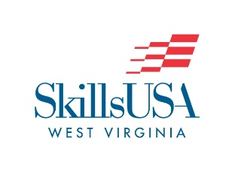2025 SkillsUSA SLSC Agenda
2pm – 6pm | Registration  FSU
2pm – 6pm | Advance Setup for Specified Contests (OPTIONAL)  *Promotional Bulletin Board  *Chapter Display  *T-Shirt Design  *Pin Design  *Showcase

Friday, March 28
6:45 am | Bus Routes depart to offsite locations
7:45 am | Contestants to Contest Locations  See Contest List Spreadsheet on SkillsUSAWV.org
8am – 4pm | Contest Competitions (See contest list for specific contest, location and times)
8am – 4pm | Carpentry & TeamWorks – Both contests will build Friday and Saturday
7pm – 8pm | Delegate Session – Feaster Center
 | NO OPENING SESSION!!!!

Saturday, March 29
6:45 am | Bus depart from Feaster Center to: See Bus Schedule at SkillsUSAWV.org  - Monongalia Technical Education Center  - United Technical Center  - Cummins Crosspoint  - FSU ANG Armory  - Fred W. Eberle Technical Center
8am - 3pm | Competitions  Lunch – See list located at SkillsUSAWV.org for lunch arrangements.
Noon | Lunch  Registered Advisors – If an advisor requested lunch delivery via the SkillsUSAWV.org website – the lunch will be delivered to offsite locations.  If no request was made the advisor received a Falcon Center Dining Hall Buffet as part of their name badge.  For Non-Registered guests - Chic-fil-A and the Falcon Center Dining Hall Buffet is available for purchase.
3pm - 6pm | Relax and Unwind  TOTAL PARTICIPATON DINNER AT DINING HALL
6:00 pm | Second General Session  - Announcement of 2025-2026 State Officers  - Awards Presentation  - Closing Ceremony  - Adjournment  Feaster Center Gymnasium

