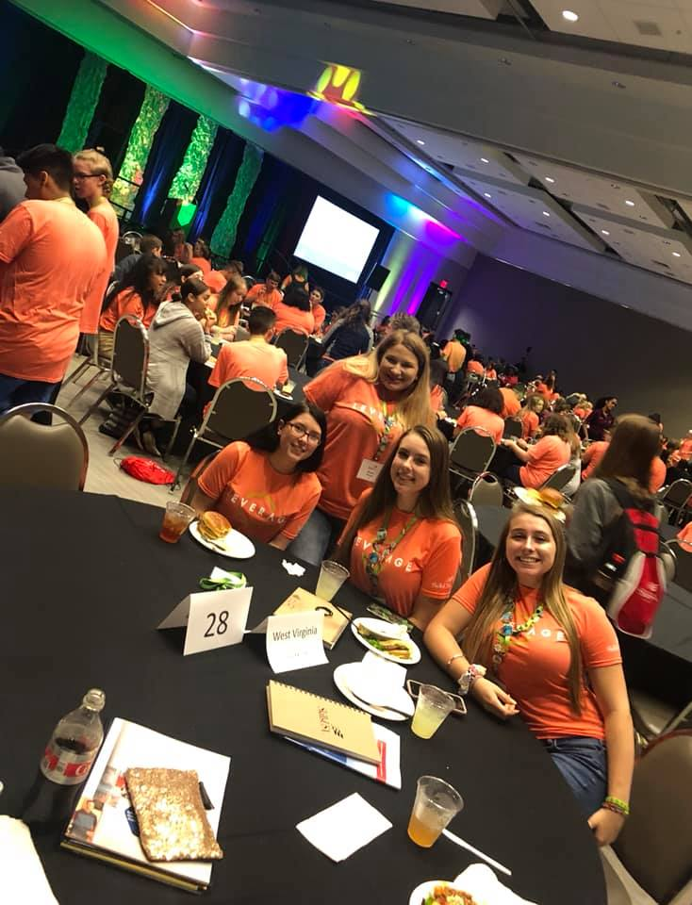



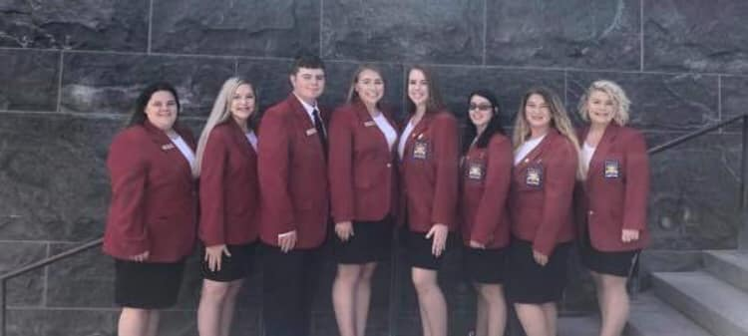

**2020-2021**

**WV State Officer Packet**

# þÿ2020-2021 SkillsUSA West Virginia State Officer Candidate Guidelines and Application Packet

##### Are you thinking of becoming a State Officer?

Ask yourself the following questions:

* Can you explain, to a complete stranger (in professional dialogue), the purpose of SkillsUSA? Are you able to convey to others the way your program benefits students, business and industry, and society?
* Will SkillsUSA be one of your top priorities in your school and around the state?
* Will you be able to attend the State Officer Retreat during the summer prior to your term of office?
* Will you be able to miss up to 10 class days during the school year for SkillsUSA business and still maintain your grade point average?
* Are you willing to travel across the state for leadership training and to promote SkillsUSA?

**If you can honestly answer yes to the above questions, SkillsUSA West Virginia is looking for you!**

**OFFICER CANDIDATES ARE REQUIRED TO REVIEW THIS HANDBOOK IN ITS ENTIRETY**

***Officer Application and Supporting Documents Due to the State Director by March 6, 2020***

**Mail completed applications to: SkillsUSA West Virginia**

**PO Box 335**

**Ripley, WV 25271 or**

**Email to** [**mwilkinson@k12.wv.us**](mailto:mwilkinson@k12.wv.us)



###### JOIN THE SKILLSUSA OFFICER TEAM

Thank you for considering candidacy for the SkillsUSA West Virginia State Officer Team. This is an excellent opportunity to develop your leadership skills and the professionalism that is essential for a successful career. Please strongly consider running for state office only if you are organized, motivated, and eager to work as a team, show initiative, exhibit high moral and ethical standards and have a desire to serve others. You will need to be ready to make SkillsUSA your first priority and be willing to present favorable image on behalf of our organization.

SkillsUSA seeks qualified candidates for the West Virginia State Officer Team. If you wish to improve on the areas of social maturity, communication, initiative, integrity, enthusiasm and teamwork, you may be state officer material!

## Contents of Officer Candidate Application Packet

* + SkillsUSA West Virginia State Officer Candidate Guidelines
  + Application Review & Notification of Acceptance Information
  + Procedure for becoming a SkillsUSA State Officer
  + Application Packet Check-List
  + State Officer Candidate Application/Nomination Form
  + State Officer Candidate Commitment Form
  + States Officer Expectation Form
  + Advisor/Administrator Expectation Form
  + State Officer Code of Conduct
  + Officer Candidate School Grades Check Sheet
  + State Officer Information Form
  + State Officer Candidate Activity/Award Form
  + Medical Liability Release Form
  + Video/Photo Release Form

## State Officer Candidate Guidelines

###### ARE YOU ELIGIBLE TO RUN FOR OFFICE?

To be eligible for office, you must be a SkillsUSA Member currently enrolled in a Career & Technical Education program at an active SkillsUSA West Virginia Chapter.

Each school (Campus) may nominate a total of two (2) Secondary (High School) State Officer Candidates and one (1) Postsecondary (Adult) Officer Candidate.

All candidates must carry a scholastic overall **G.P.A of 2.5** or higher (on a 4.0 basis). You will be required to maintain the above stated standards. Therefore, submission of each report card reflecting grades and attendance is required throughout your term in office.

You must also maintain **acceptable attendance.** A successful candidate will have no more than 5 days unexcused for the current school year. Acceptable attendance must be maintained throughout your term in office. Submission of school ***attendance record for current and previous year*** as well as ***school transcript*** required with the candidate application.

###### Officer Candidate 2020-2021 School Year Enrollment Requirement

**For Secondary State Officer Candidates:** must be returning students in their Career Tech training program as a secondary (high school) student during the 2020-2021 school year. **Example:** Candidate is currently enrolled as a junior student and will be returning as a high school senior during the 2021-2022 school year.

**For Postsecondary Officer Candidates:** must be returning students in their Career Tech training program as a postsecondary student during the 2020-2021 school year.

**Examples:** Candidate is currently enrolled as a graduating high school senior and returning the following school year (2020-2021) as a postsecondary student, or currently enrolled as a postsecondary student and returning the following school year (2020-2021) to complete their training. *\*Candidates must be committed to completing the entire 2020-2021 school year.*

###### This officer candidate application packet contains some very important information. Carefully read it prior to completing the forms. Once you, your parents, your advisor and administrator have thoroughly reviewed the packet, provide all the required information and return them by mail to SkillsUSA West Virginia SkillsUSA, PO Box 335, Ripley, WV 25271 postmarked no later than March 6, 2020, or submit electronically by email to [mwilkinson@k12.wv.us.](mailto:mwilkinson@k12.wv.us.)

**Entire application must be typed (Except required signatures).**

**Application Review & Notification of Acceptance**

1. Each candidate’s application forms and materials will be carefully reviewed for accuracy and completeness. Candidates who submit handwritten, incomplete and/or late application forms and materials WILL BE automatically eliminated from consideration as a candidate.
2. Candidates and candidate’s local advisor will be emailed confirming acceptance as a nominee for the State Officer Team.
3. ***Each candidate and their local advisor*** are required to attend the Officer Candidate Screening on April 17, 2020 at the SkillsUSA West Virginia State Leadership and Skills Conference.

## Procedure for becoming a SkillsUSA State Officer

###### To Qualify for State Officer Candidacy:

* 1. Complete, sign and submit the State Officer Candidate Application Form and all other required documents by the specified date.
  2. All candidate applications are due to the SkillsUSA State Director postmarked by

###### March 6, 2020.

* 1. Application may be submitted via mail (postal service) or email. DO NOT SUBMIT APPLICATION VIA FAX.
  2. Meet all academic (GPA) and attendance requirements.
  3. Commit to attending all required SkillsUSA events and activities if elected.

###### State Officer Candidate Screening

* 1. Attend the State Officer Screening at the SkillsUSA WV State Leadership and Skills Conference during registration on **Friday, April 17, 2020**
  2. Official SkillsUSA Dress is required
  3. Candidates will be interviewed, asked some informational questions, and be asked to read a partial script.

###### Making the Ballot at the State Leadership and Skills Conference

* 1. The announcement of candidates making the ballot will be at the end of the State Officer Screening meeting.

###### Campaigning for candidates making the ballot

* No campaigning can be done until after permission is granted by State Director.
* All Candidates will give a campaign speech. (Limited to 2 minutes for speech)
* No unwrapped candy or gum will be allowed.
* No items containing liquid of any type are allowed.

###### Announcement of Election Results

* Results of election and new officers will be installed during the General Session, on Saturday evening at the State Leadership and Skills Conference
* A brief new officer meeting will be held following the conclusion of the General Session

###### SAMPLE- SkillsUSA Officer Candidate Script Reading

Welcome to the SkillsUSA State Leadership and Skills Conference.

SkillsUSA is a partnership of students, teachers and industry working together to ensure America has a skilled workforce. This partnership of students, teachers and industry is what makes this organization work so well in preparing you for your career.

The first awards we will recognize today is the Breaking Tradition Awards.

The “Breaking Traditions” Student Award Program recognizes outstanding students who are enrolled in programs which have 25% or less of their gender in the program. This program is sponsored annually by the West Virginia Department of Career & Technology Education, the West Virginia Career Tech Foundation, and West Virginia Career and Technology Education Equity Council.

## APPLICATION PACKET CHECKLIST

(ALL ITEMS BELOW DUE BY FEBRUARY 22, 2019 DEADLINE)

ALL Application Packet Materials listed below should be received by the SkillsUSA West Virginia State Director by **March 6, 2020. *Incomplete or late applications will not be accepted.***

No additional pages or materials outside the items listed above should be included in this packet.

**Included in packet:**

State Officer Candidate Application/Nomination Form Advisor/Officer Candidate Commitment Form

State Officer Expectation Form

Advisor, Administrator School Expectation Form State Officer Code of Conduct

Officer Candidate transcripts and attendance for pervious 3 semesters Officer Candidate Information Sheet

State Officer Candidate Resume/Activity Information Sheet Medical Liability Release Form

Video/Photo Release Form

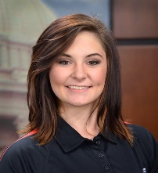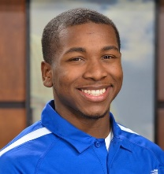**Provided by officer candidate, to be included with application and all other required documents:** “Passport” style “color” picture of candidate (Head and Shoulders only with head centered in photograph). Must be at least 3” x 3”. Can be printed on normal printer/copy paper.

Photo paper not required.

Samples 3”

3”

Proof of SkillsUSA Membership (Print SkillsUSA Membership roster from training program) School Transcript (Previous three (3) completed semesters for all Career Tech AND High School classes)

Three Letters of Recommendation. For the 3 Letters of Recommendation – one must be from your local chapter advisor and one from a Career Tech Administrator of sponsoring school. Make sure these letters are included in your application packet.

###### Due at Officer Candidate Screening:

Current Resume

## State Officer Candidate Application/Nomination Form

All information MUST BE TYPED

**Name of Candidate:**

**Which position are you running for as an officer candidate?**

Secondary State Officer  Postsecondary State Officer

**For Secondary State Officer Candidates ONLY”**

If elected, would you consider running for a National Officer position if selected by the Selection Committee during the State Officer Training?

Yes  No

**Officer Candidate Information**

Applicant’s home phone number: Applicant’s cell phone number:

Applicant’s email address:

Home Address

State:

Zip:

City:

**SkillsUSA Advisor and Instructor Information**

SkillsUSA Advisor’s Name: Advisor’s email Address:

Advisor’s office number: Advisor’s cell number:

Instructor’s Name: Instructor’s office number:

*(If different from advisor’s) (If different from advisor’s)*

**Applicant’s Parent or Guardian Information**

Applicants Parent or Guardian Name:

Parent/Guardian home phone: Parent/Guardian cell phone:

**School Information (Complete all that apply)**

Technical Center / Comprehensive High School:

School Mailing Address:

School Physical Address:

City:

State:

Zip:

Administrator Office Phone:

Administrator Name

*(For emergency use only)*

Administrator Cell Phone:

Administrator Email:

High School Administrator (if secondary):

High School Name (if secondary):

High School Administrator email (if secondary):

## SkillsUSA Officer Candidate Commitment Form

Desire and willingness to work are major qualities a state officer must possess. Please be sure you have the desire to do your part and are willing to devote your time and efforts for a full year of service to SkillsUSA if elected.

Please read the commitment form carefully and review all required dates of SkillsUSA events and activities for State Officers. The Candidate, Advisor, Technical Center Administrator, High School Administrator and Parent/Guardian are required to sign this form with the understanding that:

1. Elected state officer will attend all required events
2. State officer may be removed from office if he/she does not satisfactorily follow the standards listed below.
3. Sponsoring school will cover all travel expenses for the elected state officer. *Note: All other student expenses such as housing, meals, registration, etc., will be covered by SkillsUSA WV.*

*\*\*Sponsoring school is responsible for transportation to ALL EVENTS LISTED BELOW*

1. State Officer’s Advisors will chaperone the Officer to, from and during all State Officer events including but not limited to the National Leadership and Skills Conference in Louisville, KY and the Washington Leadership Training Institute in Washington D.C.

**Required Activities for SkillsUSA State Officers**

April 17-18, 2020… ........... State Officer Candidate Screening & State Leadership and Skills Conference

May 16-17, 2020............... New State Officer Training, Location TBD *(mandatory)*

June 19-26, 2020 .............. National Leadership and skills Conference, Louisville, KY *(mandatory)*

Sept. 19-23, 2020 ............. Washington Leadership Training Institute, Washington D.C. *(mandatory) TBD*

Sept. 26, 2020…………………Fall Leadership Preparation Training, Roane-Jackson Technical Center (mandatory)

October 27-29, 2020 ........ Fall Leadership Conference, *(mandatory)*

January 16-18 2021 .......... Training/Executive Council Meeting, *(mandatory)*

February 2021 .................. CTSO State Officers “Day at the Capitol” Legislative Breakfast

March 25-27, 2021 ………............... State Officer Candidate Screening & SLSC *(3 days) (mandatory)*

Type Name of Student Signature of Student Date

Type Name of Advisor Signature of Advisor Date

Type Name of Parent/ Guardian Signature of Parent/Guardian Date

Type Name of School Administrator Signature of School Administrator (Sponsoring School) Date

Name of High School Administrator Signature of School High School Administrator Date

## West Virginia SkillsUSA State Officer Expectations

* State officers should maintain a positive team attitude and use their knowledge and skills to provide life changing leadership experiences for all West Virginia SkillsUSA members.
* Continually give encouragement to fellow officers and all members.
* Avoid negative words, gestures and thoughts.
* Show each team member respect: respect each other’s feelings, thoughts and ideas.
* Keep all lines of communication open, be open with each other, and speak your mind.
* Share knowledge and expertise with others.
* Be a positive example to all members.
* Be honest in your thoughts, words and ideas.
* Remember that you are a state officers 24/7, and your actions, dress and grooming should reflect the pride you have in the organization.
* Maintain a positive attitude and continually work toward building a strong team.
* Attend all required activities with a smile on your face and a willingness to serve all members of SkillsUSA.

I understand all of the expectations required of a SkillsUSA State Officer, the local advisor, and the local school administration and I am committed to this responsibility.

(Officer Candidate’s Signature) (Date)

(Advisor’s Signature) (Date)

(Parent/Guardian Signature Secondary Officer only) (Date)

(Sponsoring School Administrator) (Date)

## Expectations of the SkillsUSA Officer Advisor, Administrator and School

* See to it that the state officer follows his/her expectations.
* Ensure that the State Officer attend all meetings, trainings, and conferences during the term of office and accept responsibilities as a SkillsUSA Advisor.
* Serve as the state officer’s positive role model with dress, language, habits, assistance, ethics, etc.
* Understand that there is no extra compensation to serve in this position.
* Provide and/or arrange all travel for the state officer, per school policy to all required SkillsUSA events and activities.
* SkillsUSA West Virginia will provide the state officer all meals, housing, registration fees EXCEPT travel. The sponsoring school for the State Officer is required to provide and fund all transportation to and from all required events.

I understand all of the expectations required of a SkillsUSA State Officer, the local advisor, and the local school administration and I am committed to this responsibility.

(Officer Candidate’s Signature) (Date)

(Advisor’s Signature) (Date)

(Parent/Guardian Signature Secondary Officer only) (Date)

(Sponsoring School Administrator) (Date)

IMPORTANT NOTE: Sponsoring School is responsible for all travel expenses and travel arrangements as well as all Advisor expenses.

**SkillsUSA West Virginia Code of Conduct**

**By accepting the positions of my elected office, I agree to abide by the following guidelines:**

As a state officer of SkillsUSA, you have the responsibility to represent all members of the organization. Your conduct must be exemplary at all times while representing the organization, as well as, on your personal time. You will have an opportunity to meet students, advisors, administrators, business and industry leaders, and state government officials during your term of office. Your actions will set a standard for all SkillsUSA members to follow. When you sign this State Officer Contract, it should be with the understanding that your obligations are great, as are the rewards of serving your fellow members. You will also be reaffirming the ideals of the SkillsUSA.

**As a state officer of the SkillsUSA, West Virginia Association, I agree to adhere to the following code of conduct:**

1. My conduct shall be exemplary at all times.
2. I will maintain proper cleanliness and proper grooming at all times.
3. I will, at all times, respect all public and private property, including the hotel in which I am housed.
4. I will spend each night in the room of the hotel in which I am assigned.
5. I will keep my advisor or assigned state SkillsUSA staff persons informed of my where-a-bouts at all times.
6. I will strictly abide by the curfew established and shall respect the rights of others by being as quiet as possible after curfew.
7. I will not enter a sleeping room of the opposite gender without the supervision of an advisor.
8. I will not use any type of alcoholic beverages, tobacco products, or drugs. If I have been ordered to take certain prescription drugs by a licensed physician, I will report such orders to my advisor or State Director.
9. Attendance at school is mandatory anytime it is in session. Grades must be kept at an above average level. All work missed while on SkillsUSA business will be made up in a timely manner.
10. For my term of office, any content I post on Instagram, Facebook, YouTube or other sites are subject to review by a supervising adult such as my advisor, parent or guardian. I also understand that these websites will be monitored and I may be requested to remove material.
11. I must attend all meetings and activities deemed necessary by the SkillsUSA State Director.
12. I will commit the ENTIRE year to State SkillsUSA Officer activities and to properly perform duties of my elected office.
13. I will adhere to the dress code set by the State Director during SkillsUSA events.

***PENALTIES***

Violations of any items above will result in a warning with consequences, suspension of duty, or dismissal. Violations may be grounds for disqualification or suspension from an activity or office. The violator may be sent home at his/her own expense. Proper notification of the violation and action taken will be sent to the appropriate authority, school administrator and parents or guardians.

**I understand that, by signing this contract, if I am in violation of the above regulations and/or conduct myself in a manner unbecoming of a SkillsUSA, West Virginia Association State Officer, I may be brought before the State Director for an analysis of the violation. I further agree to accept the penalty imposed on me with the understanding that all such actions will be explained to me. I realize the severity of the penalty may increase with the severity of the violation.**

**I understand that any failure on my behalf to comply with ANY of the above stated guidelines may result in my immediate dismissal from office.**

(Officer’s Signature) (Date)

(Parent or Guardian’s Signature) (Date)

(Advisor’s Signature) (Date)

(Sponsoring School Administrator) (Date)

## State Officer Information Sheet

### PLEASE PRINT CLEARLY

#### This information will be used to print business cards and officer shirts. We need to be able to do them correctly the first time!!

Rob

Name: Nickname:

Cell Phone: Home Phone: Birthdate:

Home Address:

City: State: Zip:

Tech Center/Campus:

Center/Campus Address: Phone:

City: State: Zip:

Program/Class at Tech Center or College:

Instructor Name:

Instructor Cell Phone: Work phone:

SkillsUSA Advisor Name *(If different):*

Advisors Cell Phone: Advisor Work Phone:

Parent or Guardian:

Parent/Guardian Home Phone: Cell Phone:

Parent/Guardian Email:

Guardian Address (if Different):

City: State: Zip:

T-Shirt/Polo Size: Pants: Shoes:

###### Secondary Student Postsecondary Student Number of Years in SkillsUSA

**State Officer Candidate Activity/Award Information**

**Candidate Name**

**Year in School: Date Enrolled: Completion Date: SkillsUSA Participation (Select Yes or No)**

**Yes**  **No**  Attended a SkillsUSA Fall Leadership Conference?

**Yes**  **No**  You are/were a School Officer?

**Yes**  **No**  Competing in SkillsUSA Local or State Leadership Contest?

**Yes**  **No**  Competing in SkillsUSA Local or State Skills Contest?

**(Complete the following by typing in box) SkillsUSA Offices Held**

**Other SkillsUSA Activities/Awards**

**School Activities/Awards**

**Community Activities/Awards**

**Future Goals**

**Interests, Hobbies, etc.**

**Why do you want to be a state officer? (In 50 words or less)**

**MEDICAL INFORMATION AND LIABILITY RELEASE FORM (*PLEASE TYPE ALL INFORMATION)***

**Student Information**

Student Name.       Date of Birth:       Gender:       Grade:       Home Address.       City:       State:       Zip Code:

City:

Home Phone:       Cell Phone:       Email Address:

Place of Employment:

Work Address:       City:       State:       Zip Code:

**Parent/Guardian Contact Information**

Parent/Guardian Name(s) Relationship

Telephone Home:

Work/Ext.

Cell:

Preferred contact phone in case of emergency:       Email Address:

Home Address:       City:       State:       Zip Code:       Place of Employment:

Work Address:       City:       State:       Zip Code:

**Alternate Contact Information**

Name:       Relationship:

Telephone: Home:       Work/Ext:       Cell:       Preferred contact phone in case of emergency:       Email Address:

Home Address:       City:       State:       Zip Code:

Place of Employment:

Work Address:       City:       State:       Zip Code:

**Doctor’s Information**

Student’s Physician:       Office Phone:

Office Address.       City:       State:       Zip Code:

City:

**Medical Insurance Information**

Is student covered by group or medical insurance?  Yes ( If yes, complete the following)  No (if not, skip the next section) Name of Insured:

Insurance Company:

Group Number:       Policy Number:

**Students Medical Information (*Please completely describe any medical condition which may recur or be a factor in medical treatment)***

Allergies.       Physical Handicap:

Medicine Reactions:       Blackouts:

Convulsions:       Disease of Any Kind:

Heat & Lung Problems:       Other (Be specific):

**If currently taking medication, please provide the following information:**

Name of Medication(s):

**PARENT/GUARDIAN:** Please check one of the following and sign your name.

Should it be necessary, I **give** my permission for immediate medical treatment as required in the judgment of the attending

physician. Notify me and/or any persons listed above as soon as possible.

I **do not give** permission for medical treatment until I have been contacted.

**LIABILITY RELEASE.** I certify that the information described above is accurate and complete to the best of my knowledge. I understand that each individual is responsible for his/her own insurance coverage. I hereby release to SkillsUSA State Office, the National Staff, State and Local SkillsUSA advisors, local school staff, ODCTE staff, and any designated individual or group in charge of the SkillsUSA group or specific activity from any legal or financial responsibility with respect to my personal or my student/child’s participation in or contact with any known element associated with an activity including competitive events.

Parent/Guardian’s Signature: Date:

Student’s Signature: Date:



### VIDEO/RECORDED VOICE/PHOTOGRAPHY RELEASE

I hereby give and grant to the West Virginia Department of Career and Technical Education and/or SkillsUSA West Virginia the absolute and unconditional right to use, publish, display, electronically distribute and/or reproduce in any manner, video/recorded voice/photographs, in which I appear, including the right to edit or use a portion of such video/recorded voice/photographs **that positively promotes the image and benefits of career and Technical education through educational, trade materials and/or the West Virginia Department of Career and Technical Education web site or social media sites.**

I hereby waive any right, to inspect or approve the finished video/recorded voice/photographs, or any finished materials, copy or other matter which may be used in conjunction with, or the manner in which any of the same are used, reproduced, published, or displayed.

I further release the West Virginia Department of Career and Technical Education and/or SkillsUSA West Virginia from any liability whatever that may occur or be produced in the talking, reproducing, publishing, showing, or displaying of said video/recorded voice/photographs, and agree that the West Virginia Department of Career and Technical Education and/or SkillsUSA West Virginia shall be the owner of the photographs and all rights to them, may copyright the video/recorded voice/photographs in its own name, and may grant others permission to use them.

I further understand that I am not to receive payment for said video/recorded voice/photographs and that these video/recorded voice/photographs will not discredit or distort my person in any way.

Student’s Name (Please Type):

Student’s Signature: Date:

Parent’s Name (Please Type):

Parent/Guardian’s Signature: Date: