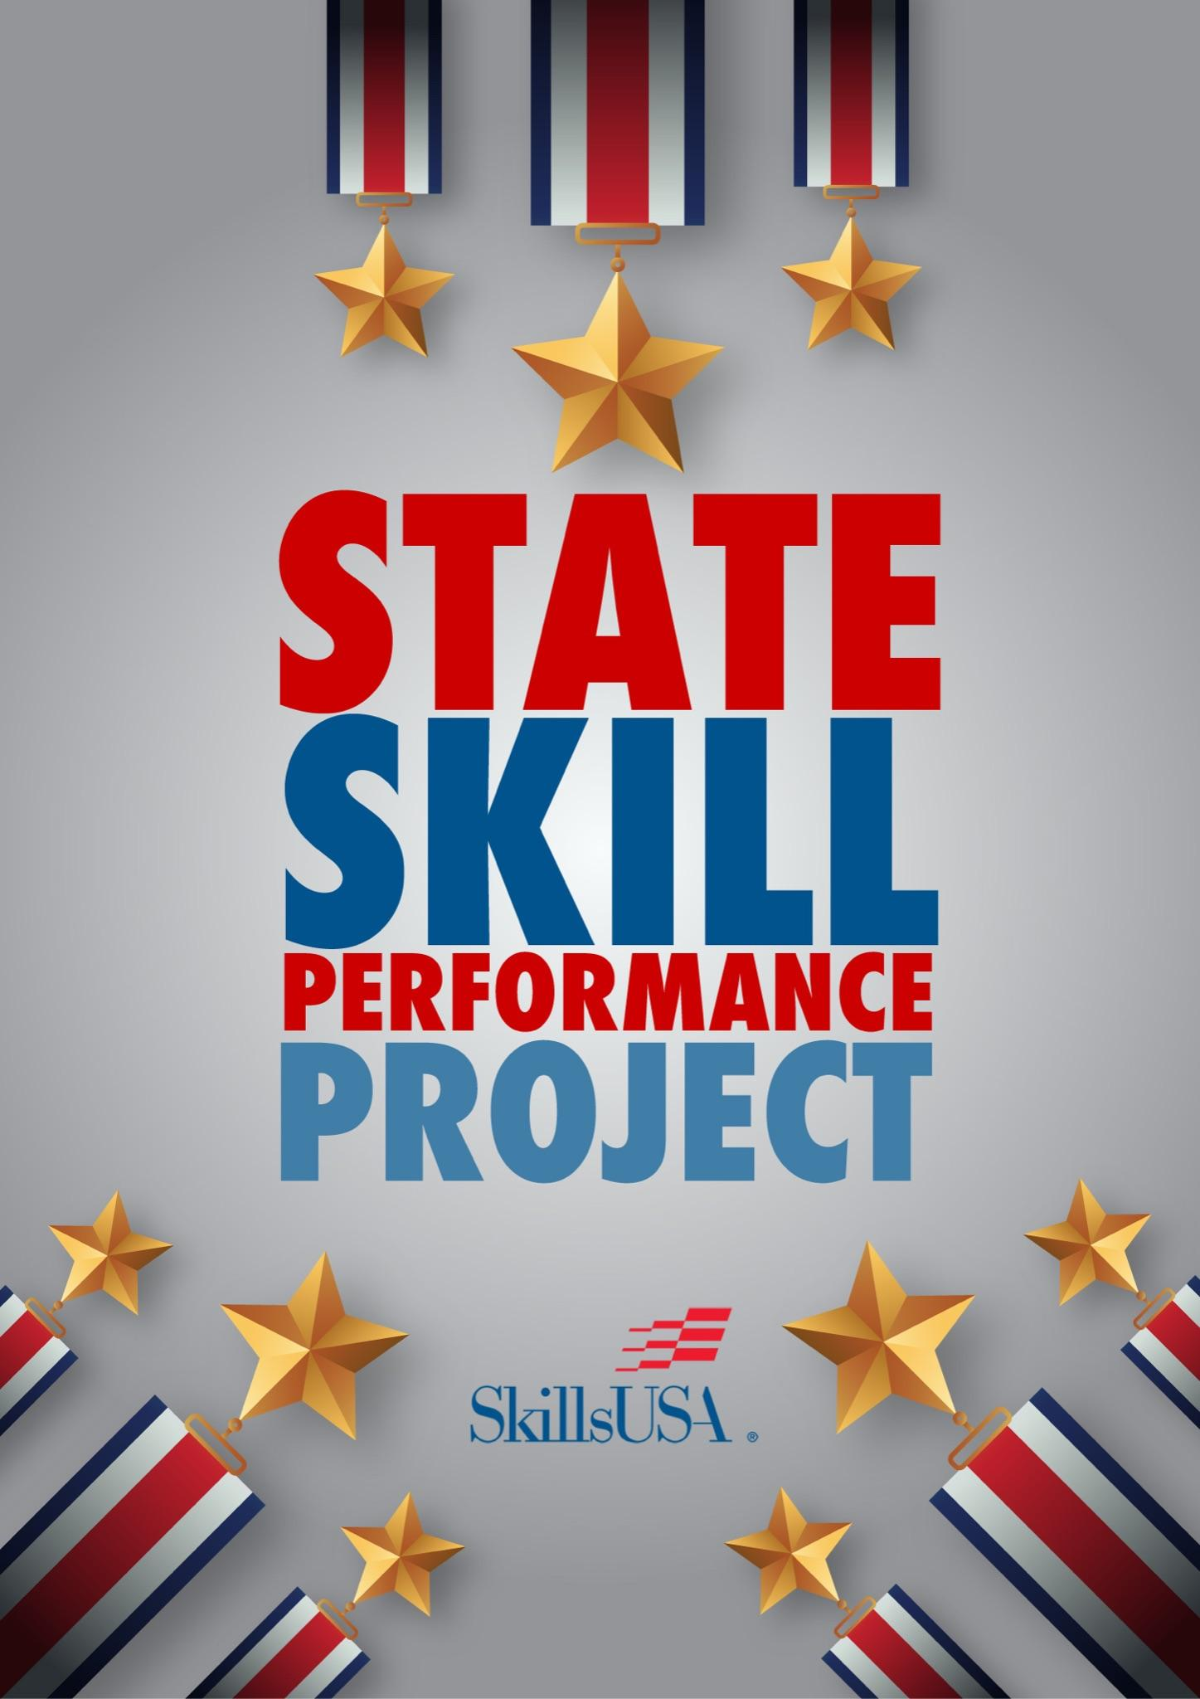

# Introduction

Thank you for your dedication to ensuring student growth and achievement through the management of this SkillsUSA state competition event. The SkillsUSA state director and the national SkillsUSA organization appreciate your commitment to preparing America’s future workforce. The purpose of this document is to equip you with the necessary competition specifications that will allow you to host a successful state competition.

# Competition Technical Standards

The state director will provide the state technical committee with a copy of the current SkillsUSA Championships Technical Standards. The Technical Standards are the official competition guide/rules for the national SkillsUSA Championships. SkillsUSA Championships clothing requirements included in the technical standards have been established for the National Leadership and Skills Conference.

# Disclaimer

***The state project information is confidential. To ensure fairness and integrity in all competitive events, please do not share this packet with teachers or students.*** The following suggested SkillsUSA State Skill Performance Project is intended as a supplement to the guidance found in the SkillsUSA Championships Technical Standards. While most state competitive events are modeled after the national Technical Standards, rules for state events may vary from the national guidelines based on the time and/or equipment available at the state level. It is crucial that all student competitors understand any state specific requirements which should be communicated as state competition updates.

# State Competition Update - Optional

Definition:A competition update is anything that is not already listed in the SkillsUSA Championships Technical Standards that a competitor and/or advisor needs to be aware of and/or bring for the upcoming state competition.

State specific competition updates may include a list of materials the competitor must bring, state specific scorecard, and/or clothing allowances. Please be sure to check the “Supplied by the Technical Committee and Competitor(s)” section in the SkillsUSA Championships Technical Standards and adjust these requirements as necessary. The state technical committee, working with the state director, should establish any additional requirements needed to successfully complete the state-level competition.

**The following items should be reviewed, and a State Specific Competition Update posted if applicable:**

1. Supplied by the State Technical Committee:
2. Supplied by the Competitors: Each student MUST bring the following equipment in addition to what is printed in the technical standards: This is a minimum list of tools needed. Competitors may bring additional materials*, but they must be stored in your workplace. Judging will include a neat and clean workspace. \**Additional equipment brought is subject to the competition chair’s review and approval for use.*
   1. See * Tool Checklist
   2. Standing mixer
   3. 2 sheet pans
   4. 2 - ½ sheet pans
   5. 2 - 3 qt. saucepans
   6. 1 palette knife
   7. Food coloring
   8. 1 grease brush
   9. Tasting spoons
   10. Sanitation bucket/spray bottle
   11. Plastic wrap and aluminum foil
   12. Cake box/ baked good boxes
   13. Band-aids

For Service and Display:

* 1. Plates/Platters for display of all final produced recipes/formulas.

# 

# Competition Site Logistics

**Supplied by the technical committee:**

* Competition problem (menu, instructions)
* All necessary food items for the competition, paper goods, etc. No outside food will be allowed. (See recipe packet for products supplied.)
* The host site should provide all ingredients necessary for competitors to create the competition menu.
* Do not allow competitors to bring in any additional ingredients.
* Items do not need to be pre-scaled, though you can pre-set boxes of menu ingredients for each competitor with any/all their ingredients.
* A “commissary table” may be set up for spices, optional ingredients, etc. These containers and ingredients should not leave the commissary table area to be scaled, etc. to allow all competitors fair access. Replacements for burned, spilled, or wasted products are not supplied to competitors.

**Host Site Supplies:**

* Sani buckets/chemicals
* 3 bay sink with soap, sanitizer and scrub pads or dishwashing area (if available)
* Tables for public display of dishes outside of kitchen
* Orientation room/ judges’ area, and judges’ tasting table.
* Holding room for parents/ teachers (if available- not allowed in the kitchens)
* Garbage bins and bags
* Mops/Mop buckets
* Paper towels and hand soap
* First Aid Kit
* Coordinate Lunches and bottled water from SkillsUSA Competition Coordinator/State Director, for students and judges

Optional - Coordinate safe storage and any donations of unused products.

**Equipment (and quantity):**

**Supplied by the technical committee:**

* Competition site organized: (workstations, ovens, stoves, refrigeration, access to product and additional equipment) in as fair a manner as possible for each competitor.
* This must be based on your competition and any constraints in the kitchen competition area. It is preferable to provide a minimum of: two burners, oven space, ½ to 1 work bench of prep space and refrigeration space. Water and ice should also be accessible to all competitors.
* Competition host facilities should provide all plates/platters necessary for the courses or let competitors know what to bring in advance. All plateware should be plain white and pattern free.
* It is up to the host/state if they provide pots and pans, or you can require competitors to bring their own equipment. Any tools or equipment not on the list will not be permitted for use during the competition.

**Electrical needs (voltage & amperage):**

* Electrical needed for the oven/stove.
* Please adjust the power requirements based on the specific equipment and facility utilities/rules.

**Competition utility requirements (water, plumbing, etc.):**

* Water is needed.
* Access to sinks for handwashing, prep and ware washing should be in near vicinity.

**Note for State Tech Chair:**

The baking and pastry competition is designed to showcase the skills needed for jobs within commercial foodservice operations. The performance phase of this competition will be the actual preparation of food products as per the recipes provided and the presentation of finished products. Competitors should be given a predetermined menu with a selection of all necessary food items to produce the courses assigned.

At the state competition, competitors will prepare products selected to showcase their skills in the following areas:

* proper execution of mixing and baking cookies utilizing the drop method.
* proper execution of mixing and baking soft rolls.
* proper execution of mixing, baking and tart dough and galette dough with appropriate fillings
* proper execution of an iced and decorated cake, sliced in half, decorated with pre-made cake and pre-made buttercream icing.

Related skills such as proper temperature, seasoning/flavor profiles, plating, as well as station organization, sanitation, clean up, and written exam/s, etc. are also scored*.*

**Special Judge and Facility Notes:**

* **Competition Lead Judge**: The competition lead judge should be a volunteer from the local restaurant industry, preferably with some competition logistics experience. It is recommended that the lead judge does not have any direct connection to any of the competing programs, whenever possible. Please feel free to contact the National Baking and Pastry Arts committee in advance for competition assistance or advice.
* **Judges:** It is best to allow the lead judge to assist with the selection of the judges. Lead judges should plan to provide an orientation prior to the start of the competition, as the competitors are students, not professionals. Competition judges should be experienced in restaurant operations, sanitation best practices, and cookery methods. The tech committee recommends a minimum of 6-10 judges based on the number of competitors.  Two of the judges to score sanitation and floor judging sections, and at least 4 judges to be assigned technique/methodology and tasting.

It is very important that each segment is evaluated by the same group of judges, for example: the judges evaluating proper technique/methodology will judge all competitors’ methodology for pies to ensure consistent scoring across all segments.

For additional resources: ACF Chapter locator website, contact your local chapter/s for potential volunteer judges at: <https://www.acfchefs.org/ACFSource/Membership/Chapters.aspx>

**Competition Host Site**:

Please plan to give a kitchen and facility tour, to explain clean up procedures, and please have a program representative available in the competition area for questions.

# Sample State Competition Schedule

As you develop your overall competition schedule, the SkillsUSA state director will provide information about how the written knowledge test will be offered in your state.

|  |  |  |
| --- | --- | --- |
| **Time** | **Item** | **Item Description** |
| 7:00 a.m. | Check-in for Group 1. | Competitors meet in the competition area to check in, room 123. |
| 7:15 a.m. | Orientation, Clothing Check, Kitchen Tour with Competition Host and Judges. Open question and answer with Lead Judge. | If a competitor is late and misses this session, the questions will not be repeated or re-answered. |
| 7:30 a.m. | Every competitor has from 7:30 a.m. until 7:55 a.m. to set their station. |  |
| 8:00 a.m. | Competition starts. | Judging starts |
| 12:00 p.m. | Competition ends. | Clean up begins for the competitors. |
| 12:15 p.m. | Clean up ends for Group 1. |  |
| 12:30 p.m. | Check-in for Group 2. | Competitors meet in the competition area to check in, room 101. |
| 12:45 p.m. | Orientation, Clothing Check, Kitchen Tour with Competition Host and Judges. Open question and answer with Lead Judge. | If a competitor is late and misses this session, the questions will not be repeated or re-answered. |
| 1:00 p.m. | Every competitor has from 1:00 p.m. until 1:25 p.m. to set their station. |  |
| 1:30 p.m. | Competition starts. |  |
| 5:30 p.m. | Competition ends. |  |
| 5:45 p.m. | Clean up ends for Group 2. |  |

**Competition Timeline and Late Point Deductions:**

* Competitors have 4 hours to complete all items. There is no presentation window.
* Competitors can present/display items as they are complete. Competitors will present the required quantity of items on the judging table and the display table. Items, such as decorated cake and pie, will be judged first and then transferred to the display table for the public to view and for optional post competition critiques.
* Judges will evaluate the products at the end of baking time.
* Any items presented between 5-10 minutes late will result in a 25% point loss for that item.
* Any items presented between 10-15 minutes late will result in a 75% point loss for that item.
* Any items presented 15 minutes late may be submitted but will not be scored.

# 

# Competition Layout

This must be based on your competition and any constraints in the kitchen competition area. It is preferable to provide a minimum of three burners, oven space, ½ to 1 work bench of prep space, refrigeration space, and water and ice should also be accessible to all competitors.

The Judging Tables should be clearly marked with competitor numbers and have enough space to display the required items. Tasting forks should be provided, as well as a sharp knife.

The Viewing Table should be clearly marked with competitor numbers and have enough space to display the required items. Constructive and encouraging critiques may be available after the competition, at the judge’s discretion.

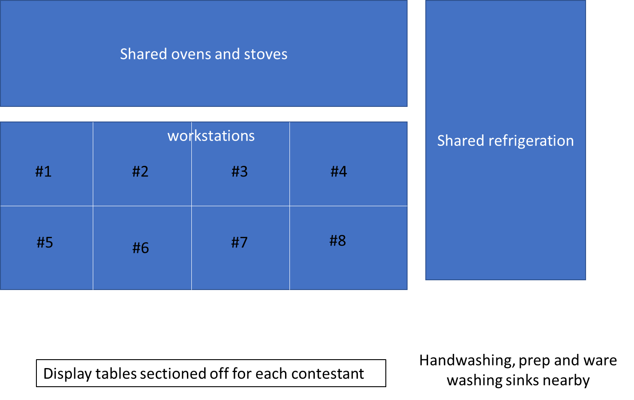

# Competition Project

Please use the baking and pastry competition provided or past national competitions, removing any segment needed to best fit any anticipated space, time, or equipment constraints.  You may also be able to compress the proposed competition timetable based on the layout of your competition area.

**2025 State Competition Products:**

* Soft Rolls (10 for display / 10 for judging)
* Cranberry Orange Cookies (12 for judging/12 for display)
* Galette with savory filling (2 for judges / 2 for display)
* Decorated Cake with white shell border, three roses, red with green leaves, inscription: Happy Birthday! (cut in half to display filling)
* Tart Dough 4” tart pan (3 total) (2 for display (one filled with crème patisserie, one unfilled to evaluate blind baked crust) / 1 for tasting)
* Crème Patisserie (evaluated hot, then used in tart dough)
* Orange supreme (one) Evaluated first then can be used as a garnish with tart dough.

Any identifying information, school logos or competitor names on uniforms should be covered and the competitor’s number should be marked on their assigned workspace/bench, as well as visible on the competitor.

Competitors do NOT have access to recipes prior to the competition.

During the competitor’s briefing, a member of the technical committee will review the competition packet with competitors and allow for Q&A prior to the start of the competition.

The following areas should be covered:

* Recipes
* Kitchen space
* Ingredients
* Equipment locations
* Sink locations
* Cleaning tools for cleanup
* Competitors will have 25 minutes to set up their stations with their tools.
* At the start of the competition, competitors can get ingredients and start baking!
* Completed items can be placed on the judging/display table as competitors complete them.
* Judges will be observing, taking notes, and talking to competitors throughout the competition.
* Final products will be judged at the end of the competition time. Competitors will clean their workstations and wash tools.

**Other Notes for Competitors:**

* Please only use the amount of each ingredient as necessary. Return unused products to the supply tables for others to use.
* Please check standards for dress requirements. If you have a chef coat or apron with your name, city or school logo, the marking must be covered. Masking tape may be used. Your competitor number must also be visible, we recommend it be taped or pinned to your back for least distraction.
* Competitors with long hair or beads, that may pose a possible safety or sanitary hazard, must wear a hair containment or hair net supplied by the competitor.
* Resumes must be turned in during orientation.  Resumes will not be accepted after orientation is complete.
* Raise your hand and ask for assistance if there is anything that you do not understand.  There will be a period just before the start of the first session when all questions will be answered for all competitors to hear.  Any questions that show you do not know the correct technique or definitions, etc. will not be answered. Questions about where to find garbage bags, and the like will be answered.
* Remember two things – This is about LEARNING and it should be FUN.  If at any time you feel overwhelmed and feel that you cannot continue, speak to a judge or member of the Technical Committee.  We are here for you!

**Most commonly asked questions by competitors:**

* Due to limited supplies, spoiled or burnt supplies will not be replaced.
* No cell phones, computers, iPhones or similar electronic devices will be allowed.
* Basic calculators are and will be allowed for both the written test and the culinary practical competition.
* Penalties for late submission of courses or skills assigned competition item:
  + Any items presented between 5-10 minutes late will result in a 25% point loss for that item.
  + Any items presented between 10-15 minutes late will result in a 75% point loss for that item.
  + Any items presented 15 minutes late will be accepted, but will not be scored

**Competitor Dismissal/End of Competition:**

No competitors are permitted to leave until the host program instructor has approved the completed kitchen clean-up. Clean-up includes the garbage emptied, dish sinks drained and dried, floor properly mopped, and all competitor equipment is removed from the kitchen.

**Communication During Competitions:**

No cell phones are permitted in the competition area, even if turned off. No speaking, signing or any other communication with advisors and competitors is allowed once the competition begins. This may result in disqualification of competitor(s) or removal of offending parties from the competition area. Advisors/educators are not permitted inside the competition area kitchen, though may view through windows, if available and approved by the lead judge.

Students who need to use the restroom during the competition should be escorted to near the bathroom entrance by a volunteer, to avoid interactions with other competitors, educators or advisors.

Please note that any competition grievances must be filed on an official form by the competitor, (not an advisor, parent, etc.) during the competition and be submitted to the lead judge. The lead judge must alert the State Director or person overseeing all of the competition as soon as possible, to review and discuss.

# Competition Scorecard

**Judging Categories**

There will be floor judges evaluating:

* Station Safety / Sanitation
* Personal Hygiene / Handwashing
* Professionalism
* Organization/Mise en Place
* Time Management
* Use of Equipment
* Baking Techniques / Skills

Additional judges will evaluate on:

* External Appearance
* Proper Bake
* Internal Appearance
* Taste
* Followed Instructions
* Cake Decorating of each Element.