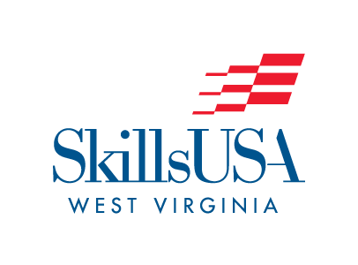SkillsUSA West Virginia

2025 State Leadership & Skills Conference

T-shirt Design Contest

The 2024-2025 SkillsUSA West Virginia State Officer Team is asking for your help in designing the State Leadership & Skills Conference T-Shirt. The theme for the conference is **SkillsUSA West Virginia: Ignite Your Potential**

• Create a design using the SkillsUSA WV State Conference theme.

Key points should include:

• The theme

• Be sure you specify the color t-shirt and you wish your design to be placed on.

• You may use up to 2 solid colors of ink

• If your design is computer generated, please save it in .pdf file format (preferred)

• Please email your designs to mwilkinson@k12.wv.us

• Deadline for entries is February 28, 2025. All entries must be RECEIVED by 4:00 pm.

SkillsUSA WV State Officer Team will choose the winning design.

THIS IS A CONTEST THAT DOES NOT ADVANCE TO NATIONALS – THE WINNER WILL HAVE THEIR PICTURE IN THE 2025 SLSC PROGRAM AND SHIRTS CAN BE PURCHASED FROM THE REGISTRATION SITE.