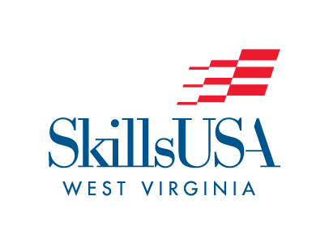
SkillsUSA West Virginia
2026 State Leadership & Skills Conference
T-shirt Design Contest

The 2025-2026 SkillsUSA West Virginia State Officer Team is asking for your help in designing the State Leadership & Skills Conference T-Shirt. The theme for the conference is SkillsUSA West Virginia: Champion Your Future
• Create a design using the SkillsUSA WV State Conference theme.

Key points should include:
• The theme
• Be sure you specify the color t-shirt and you wish your design to be placed on.
• You may use up to 2 solid colors of ink
• If your design is computer generated, please save it in .pdf file format (preferred)
• Please email your designs to mwilkinson@k12.wv.us
• Deadline for entries is February 27, 2026. All entries must be RECEIVED by 4:00 pm.
SkillsUSA WV State Officer Team will choose the winning design.

THIS IS A CONTEST THAT DOES NOT ADVANCE TO NATIONALS – THE WINNER WILL HAVE THEIR PICTURE IN THE 2025 SLSC PROGRAM AND SHIRTS CAN BE PURCHASED FROM THE REGISTRATION SITE.

