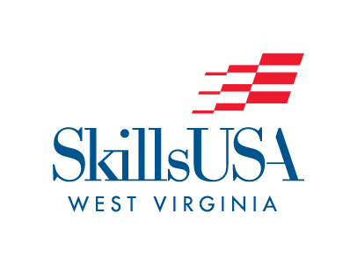

SkillsUSA West Virginia
AUTOMOTIVE TOOL ID CONTEST
STATE ONLY CONTEST

PURPOSE
To evaluate each contestant’s knowledge of the general tools used in the automotive field.

CLOTHING REQUIREMENTS (Select one)
- Official red blazer or jacket, black dress slacks with black socks OR black skirt, white dress shirt with black tie OR plain white blouse, black dress shoes;
- White polo shirt, black slacks, black shoes;
- Light blue work shirt, navy blue work pants, work shoes.

ELIGIBILITY
- Open to active SkillsUSA members.
- Students enrolled in Automotive/Diesel training program
3. Students will compete individually.

EQUIPMENT AND MATERIALS
- Supplied by the host:
- One chairperson
- Computer and Data projector
- Power-Point with tools
- A score sheet
- Two sharpened pencils

SCOPE OF THE CONTEST.
The state contest will consist of identifying 100 hand tools that will be shown on a screen via a data projector. Students will be given 20 seconds to correctly write down the names of the tool shown on the screen. The next tool will be shown automatically until all tools have been displayed. The power point will be played three times from start to finish. This is an individual competition. Ties will be decided by counting the number of misspelled words. The student with the least amount of misspelled words will be the winner. Any additional tie breakers will be the judges’ choice. For a list of tools, please refer to the Automotive Tool ID Tool List at https://skillsusawv.org/conferences.

