
Job Bid Form

Submit Bid To: Job Name: (2) Medal Stands
Melissa Wilkinson Job Location: Your location
PO Box 335
Ripley, WV 25271 Bid Proposal Submission Deadline: 1/31/2020
mwilkinson@k12.wv.us

JOB DESCRIPTON:

The Simulated Workplace bidder will design and build (2) three tiered medal stands. The medal stands need to be designed to accommodate the gold, silver and bronze medals at the State Leadership and Skills Conference. The stands need to be portable, and easy to assemble. All bids must be submitted no later than January 31, 2020. The winning bidder will be notified in writing within (5) days of the bid closure.

The project must be complete and ready for pickup by March 15, 2020.
Please contact me for additional information prior to bid deadline. Example photo included.
The actual design needs to have an additional 3rd row of medals. The enclosed photo portrays 2 rows. Also, the arms and feet need to fold similar to an umbrella for easy storage.

Project MUST BE COMPLETED ON OR BEFORE March 15, 2020.

Note: All bid totals must include an itemized material list and any additional associated costs. The Simulated Workplace bid winner will be notified in writing five days after the bid date closes. If you have any questions, please contact Melissa Wilkinson at 304-531-0603 or mwilkinson@k12.wv.us.

Payment in full will be made to the Simulated Workplace CTE Center upon pickup.

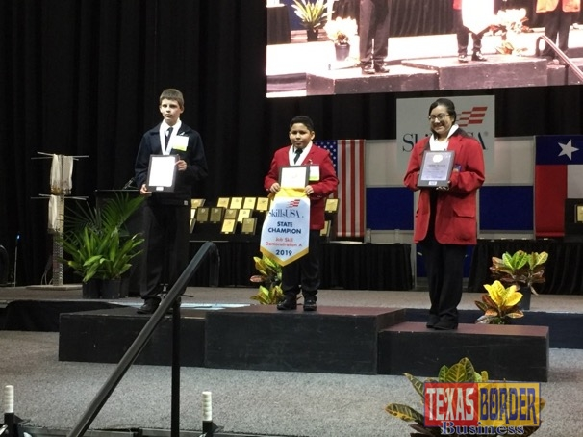

fo
An additional row needs to be added in order to house first, second and third place medals.

