SkillsUSA 2025 Additive Manufacturing State Challenge

Make It Run

Welcome to the “Make It Run” challenge!

The task at hand is to design and fully print a 4 wheeled vehicle powered only by a single rubber band. The vehicles will then be tested on a “track” for functionality, and additional scoring.

Design Considerations:
- Interlocking parts
- Printed Assemblies
- Snap fits
- Printable Tolerances
- Motion
- Kinetic to Potential Energy

Example of Basic Design

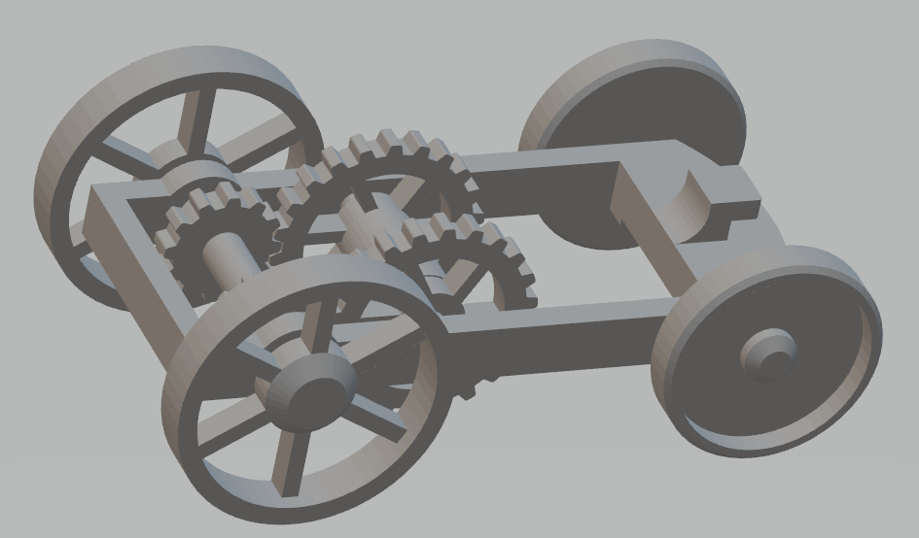

Competition Requirements

- The design must be completely 3D printed.
- The design must not contain any outside hardware (axles, screws, washers
- The design can be 3d printed using any technology.
- The design must contain a legibly printed team number/name
- The design can contain 3D printed bodies that are assembled after printing for the final part.
- The final design can use super glue for assembly, for a loss of points (see grading rubric)
- Parts must have printed wheels
- The design must contain at least 3 moving parts
- Wheels can not be larger than 3 inches in diameter
- The design must be powered only by a single rubber band
- The printed design must have moving bodies.
- The design must not exceed 6” x 4” x 4”
- 3D Printed Design - Students must create a design that:
  - Is original and designed by contestant
  - Print all parts in less than 12 hours total
  - Uses less than 5 cubic inches of model and/or support combined for all parts.

- Students must submit files to be printed via State designated file share site no later than March 5, 2025 at 4:00pm. Final prints will be delivered on the day of the contest so that students can test, assemble/modify and be evaluated.

Tips for Competitors
Here are some tips to maximize the points awarded to you:
- Build debossed text on a horizontal surface for best results. This may require building the part on its edge or standing up.
- Utilize soluble support structures for print in place assemblies
- Understand the achievable design tolerance of your printer for print in place, or hand assembled designs to allow motion between parts.
- Leverage post-processing techniques to smooth printed bodies.
- Additional moving parts may add to your score but can produce more points of failure on the final assembly.
- Use online resources (YouTube, GrabCAD Tutorials)
- Whenever intellectual property (IP) deters you from a project, try using approximate geometries to communicate the design intent.
- Optional design for additive manufacturing learning resources:
- Stratasys Think Additively™ Masterclass:
  - https://youtube.com/playlist?list=PLUYaY5EIPtNBdU-s-7l9rl05lBHHlTarI

State Competition Procedure
Before or on contest day:
- Students submit Engineering Notebook (Engineering notebook guidelines below)
- Students submit print files in both CAD (.step, .iges, .sldprt, etc.) and mesh (STL, 3MF, OBJ, etc) format to [https://wvk12-my.sharepoint.com/:f:/g/personal/mwilkinson_k12_wv_us/EiUkVpKL1nVMkvqjlCz7NxoBcRhLIHQLZQazPTK4fqYLBQ]
- Students submit physical parts
- Students submit final assembly if applicable
- Students submit their Presentation

State Competition Judging Criteria

- The Engineering Notebook should contain robust content, including at a minimum the following:
  - Be clearly labeled with contestant name(s), date and page # on each page
  - Begin with a problem statement
  - Include discovery and documentation of approach to solve problem
  - Include sketched design concepts with critical features labeled
  - Critical dimensions clearly labeled in design sketch
  - Considerations for designing for additive manufacturing distinctly addressed (i.e. part strength, part orientation) especially including any expected risks during printing
  - Screenshots of the print time and material usage for all printed parts
  - Design decisions and alternatives are documented and evaluated thoughtfully

- The design must adhere to the Competition Requirements stated in the prior page.

- Quality of final assembly
  - Does it perform the function in the manner it was designed to do?
  - Does it meet all requirements in contest guidelines?
  - Do inserted components or multiple printed parts mate together properly?
  - Did the students design the part with additive manufacturing in mind?
  - Is there sufficient tolerance between parts for movement?

- The design must illustrate best practices for “design for additive manufacturing (DFAM)”. Below are some potential DFAM metrics to optimize for.
  - Build Time
  - Post-Processing/Support Removal Time
  - Functionality Optimization (gear ratio, pliability, strength, etc.)
  - Monetary Savings
  - Material Consumption
  - Energy Usage
  - Component Consolidation (lack of store-bought hardware)
  - Lightweighting for Ergonomics

- Presentation Criteria
  - The team clearly describes their understanding of the problem to be solved.
  - Design Process: good design logic is used for key design choices. Intentional and well-communicated
  - The presentation is professional and well-rehearsed
  - The presentation emphasizes quantitative improvements (measured and estimated) of the time, quality, or cost of the improvement as well as any DFAM tactics employed.
  - Practical evaluation: team demonstrates visually (videos, photos, drawings, animation, etc) the task they improved, both before and after.
- Racetrack Setup
  - Track will have a stating line and distance markers at 1”, 6”,12”, and with marks every foot after up to 6 feet. Ruler or measuring tape will be used for final measurement above 12”.
  - Front tire/tires must begin behind the starting line.
  - A small nudge can be used to help get the car moving (see grading rubric)
  - Each design will have 2 chances to run on the track. The better of the two scores will be used for final judging.
  - Final distance of vehicle is measured where the front wheels touch the ground

