**BODY ESSENCE MASSAGE THERAPY**

**INTAKE FORM**

Name_________________________________________ Address________________________________________

City___________________________ Province _____________________ Postal Code _______________________

Phone________________________________________ Date of birth ____________________________________

Occupation____________________________________ Employer _______________________________________

Email _________________________________________ Primary Physician _______________________________

Emergency Contact ______________ Relationship ____________________Phone __________________________

How did you hear about us? ______________________________________________________________________

Medical Information

Are you taking any medications? if yes, please list name and use: ________________________________________

Is this involved motor vehicle accident? _______________ Date of accident ________________________________

Please circle any of the following that apply to you.

Cancer Arthritis Diabetes Chronic pain

Stroke Heart attack Numbness High risk factors _______________

Headaches/Migraines Kidneys dysfunction High/low blood pressure Pregnant (how far along)________

Joint Replacement Allergy Sprains/Strains Other _______________________

Please explain any conditions you have marked above:

_____________________________________________________________________________________________

_____________________________________________________________________________________________

Massage Information

Have you had a professional massage before? Yes/No__________ What type of massage are you seeking?

Please circle which type of your massage session today:

Relaxation Deep Tissue Myofascia Cupping Laval Shell Massage Hot Stone

Reflexology Therapeutic Massage Crainosacral Massage Thai Massage Healing Touch

What pressure do you prefer? Light _____Light-medium _____Medium______Medium-Deep _______Deep_______

Please circle any areas of discomfort using the picture below

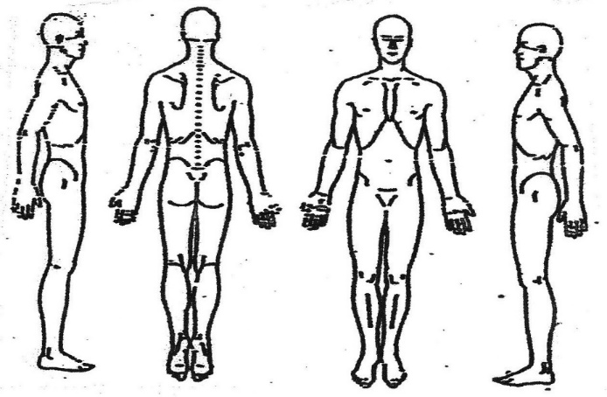

Client Signature _____________________________________ Date ______________________________________