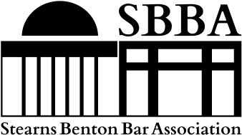
President: Christy Thorson
Vice President: James Morrighan
Secretary/Treasurer: Ashley Bukowski
Administrator: Sarah Keute
Fiscal Year 2026-2027

SBBA Membership Application

Please complete the following sections with your most recent information. In addition to internal SBBA use, this information will be used in a membership directory visible to the general public at www.stearnsbentonbar.org unless you specifically opt out by checking one of the boxes. Thank you for your interest in the Stearns Benton Bar Association and feel free to contact us with any questions at the email address listed below!

MEMBER NAME: ____________________________________________________________________

space
EMPLOYER: ___ _________________________________________________________________________
Last First Middle Initial
space
ADDRESS: _____________________________________________________________________________
Street PO Box
space
ADDRESS: _____________________________________________________________________________
City State Zip Code
space
PHONE NUMBER: _______________________________________________________________________
Main Business Line Direct Line (optional)
space
EMAIL ADDRESS: ________________________________________________________________________
Last First Middle Initial
space
WEBSITE: ____ ________________________________________________________________________
Last First Middle Initial
space
PRACTICE AREA: _______________________________________________________________________
List UP TO 3 areas (optional)

OPT OUT of website listing ENTIRELY

OPT OUT of website listing AS INDICATED (please put an “X” by the sections NOT to include on website)

APPLICATION SUBMISSION:
Mail a hard copy of the completed form to
Sarah Keute c/o SBBA
811 Beech Ln S, Annandale MN 55302

or

Email an electronic copy to
admin@stearnsbentonbar.org

ANNUAL DUES:
$85 Private Sector or In-House Counsel;
$50 Public Sector; $35 Retired

PAYMENT OPTIONS:
(mark one)
Check Enclosed
Electronic Payment Requested

