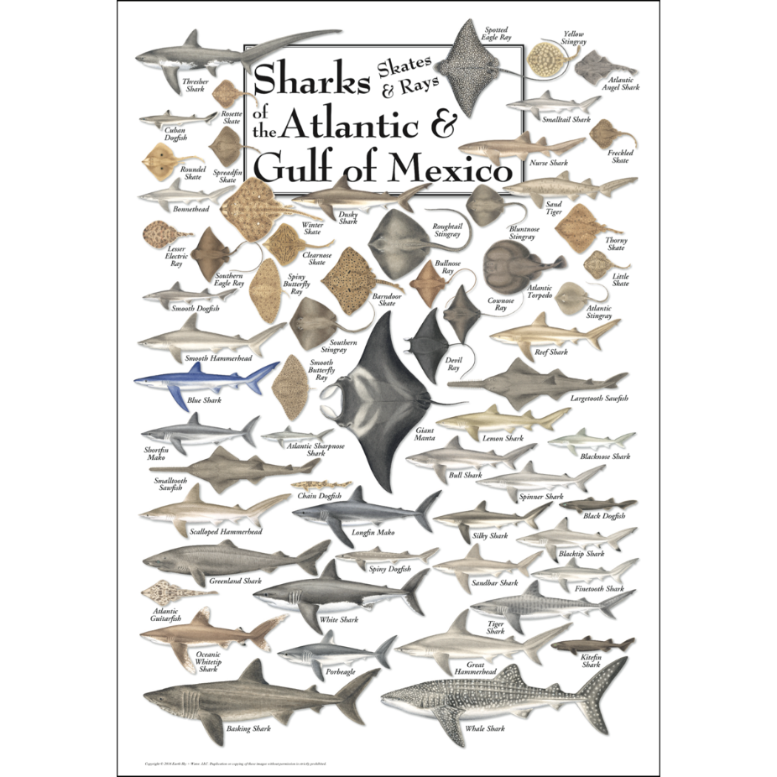
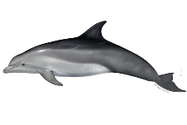
Marine mammals
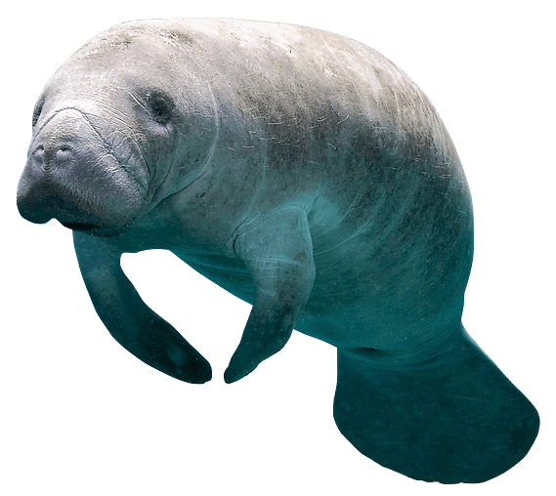
1.Dolphin
2.Manatee
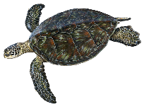
Marine reptiles
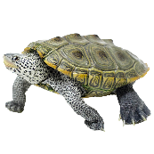
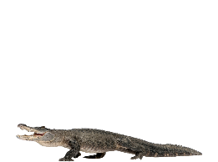
1.Sea turtle (green)
2.Diamondback terrapin
3.Alligator
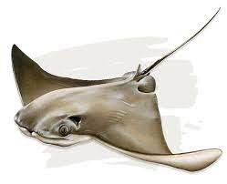
Elasmobranchs

Cownose stingray
Southern stingray
Sharks (bull, bonnethead, nurse, tiger,
black tip, hammerhead, lemon, blacknose)
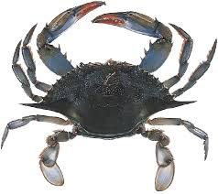
Crab species 1
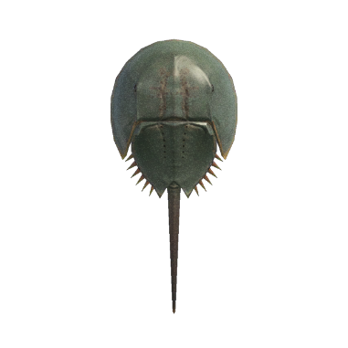
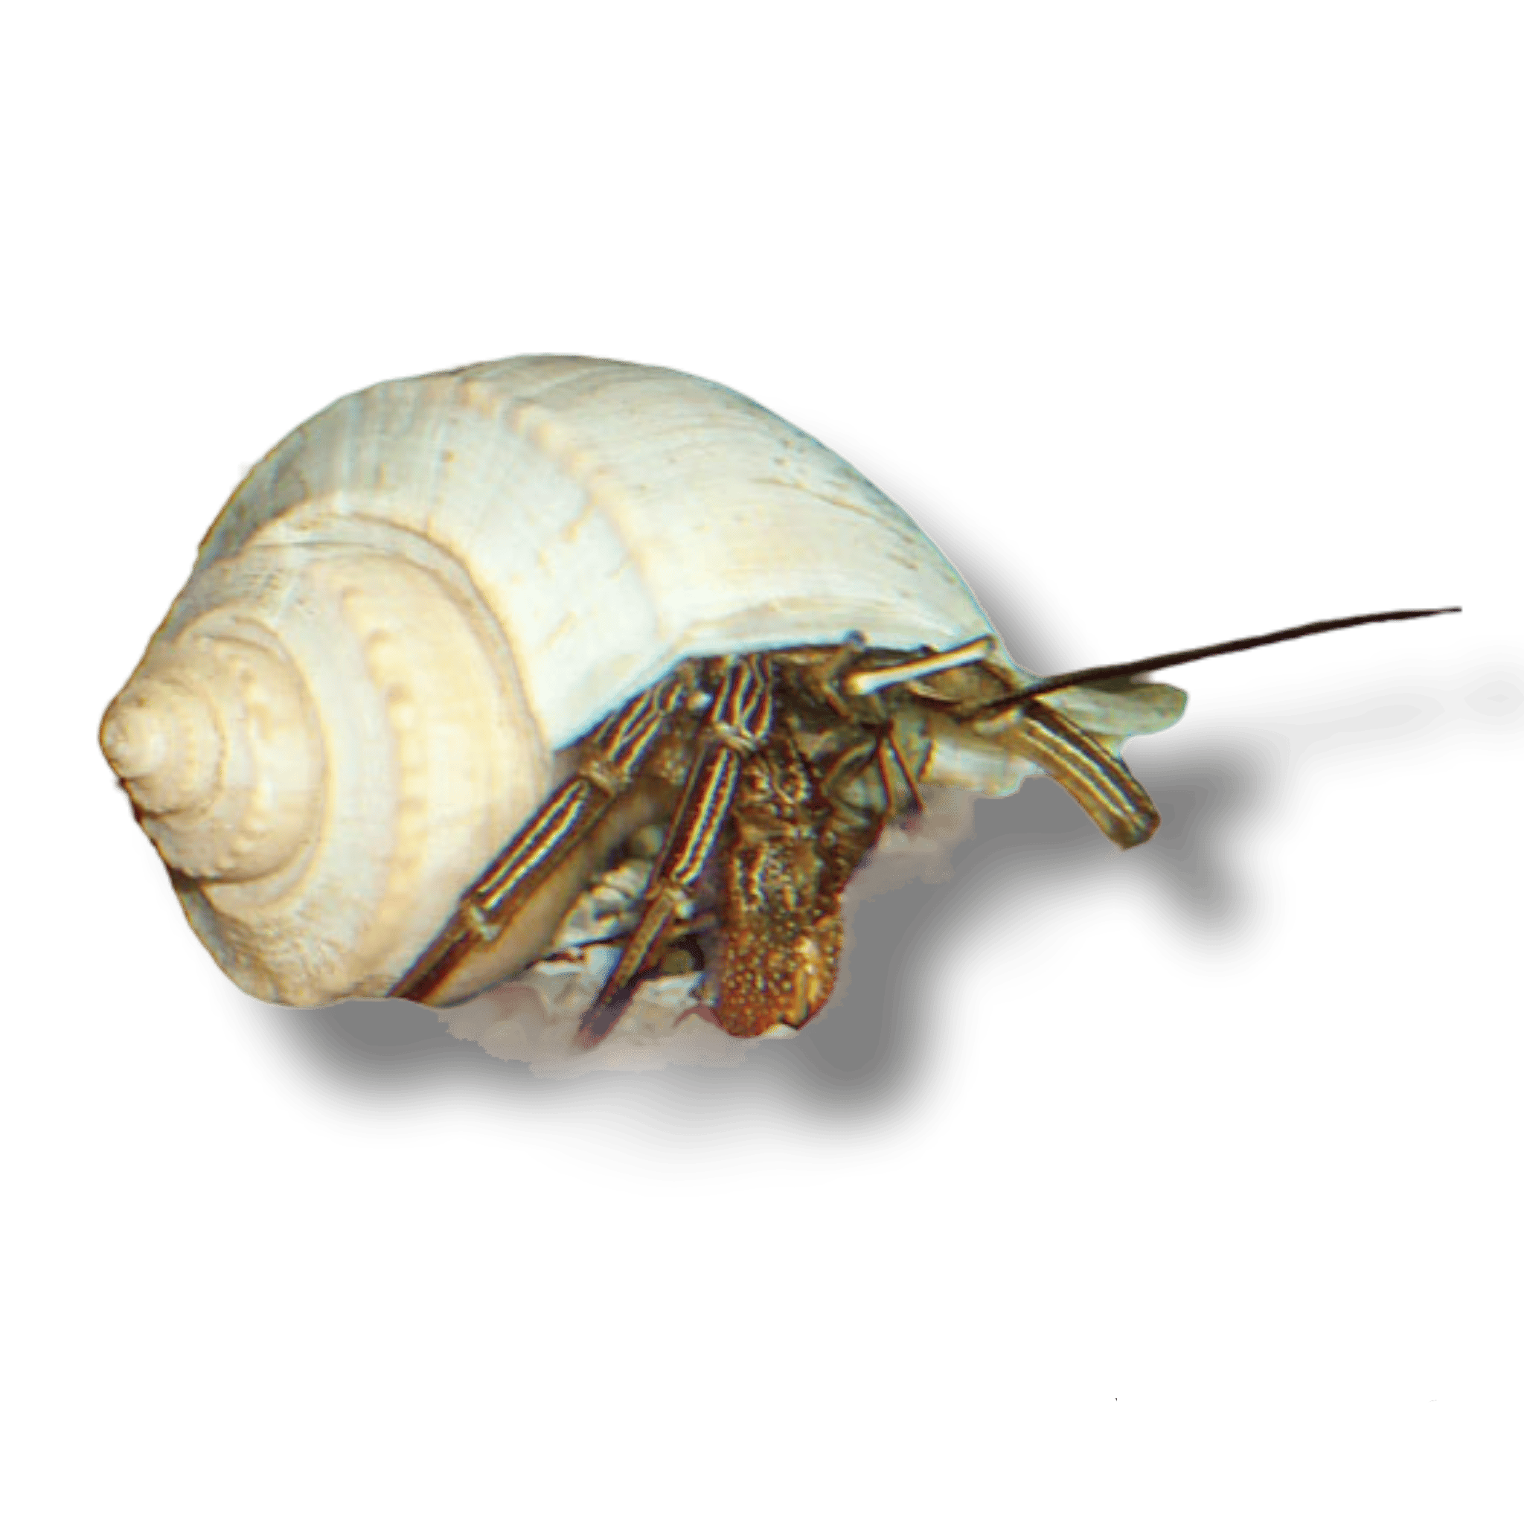
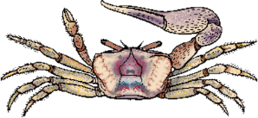
1.Blue crab
2.Fiddler crab 2
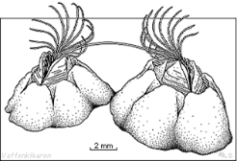
3.Hermit crab 3
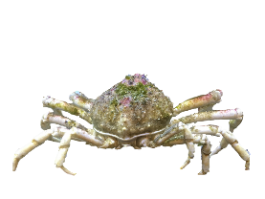
4.Horseshoe crab 4
5.Spider crab 5 6
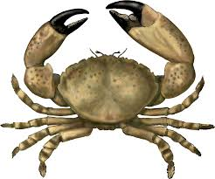
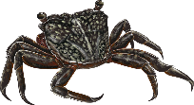
6.Barnacle
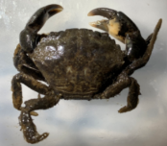
7.Mangrove tree crab 7 8
8.Stone crab 9
9.Mud crab
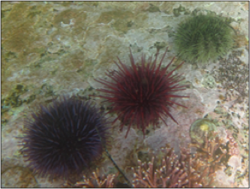
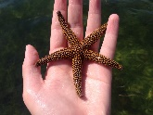
Enchionderms
1.Sea star 1 2
2.Sea urchin
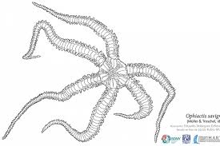
3.Brittle stars 3
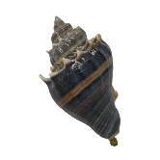
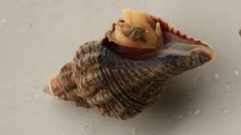
Univalves
1.Crown conch 1 2
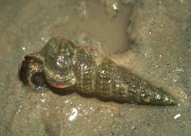
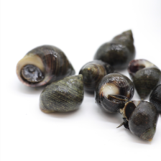
2.Oyster drill
3.Periwinkle snail 3 4
4.Ladder horn snail
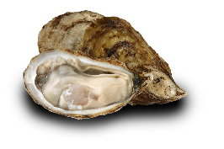
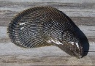
Bivalves
1.Ribbed Mussel 1 2
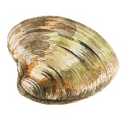
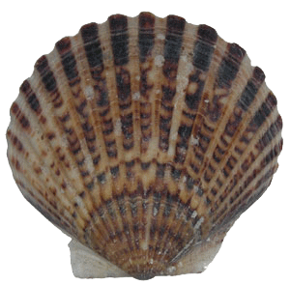
2.Eastern Oyster
3.Scallop 3 4
4.Calm
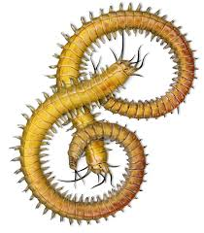
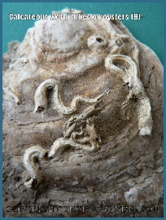
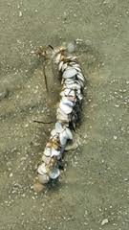
Annelids
1.Decorator worm 1 2 3
2.Tube worm
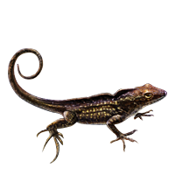
3.Polycheate
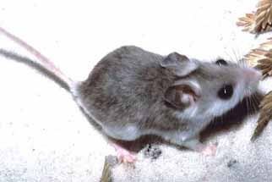
Terrestrial animals
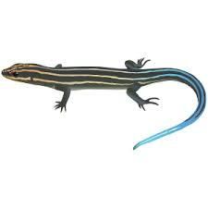
1.Lizard (Brown anole) 1 2
2.5-lined Skink 3
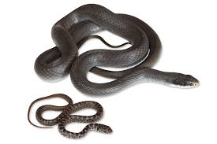
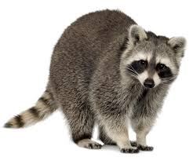
3.Mouse
4.Raccoon 4 5
5.Black racer
Aves
Little blue heron
Great blue heron
White egret
Snow egret
Cattle egret
Double crowned night heron
Cormorant
Anhinga
Pelican
Common tern
Seagull
Plover
Sand piper
Clapper rail
Osprey
Bald eagle

