Plant Team Survey
N

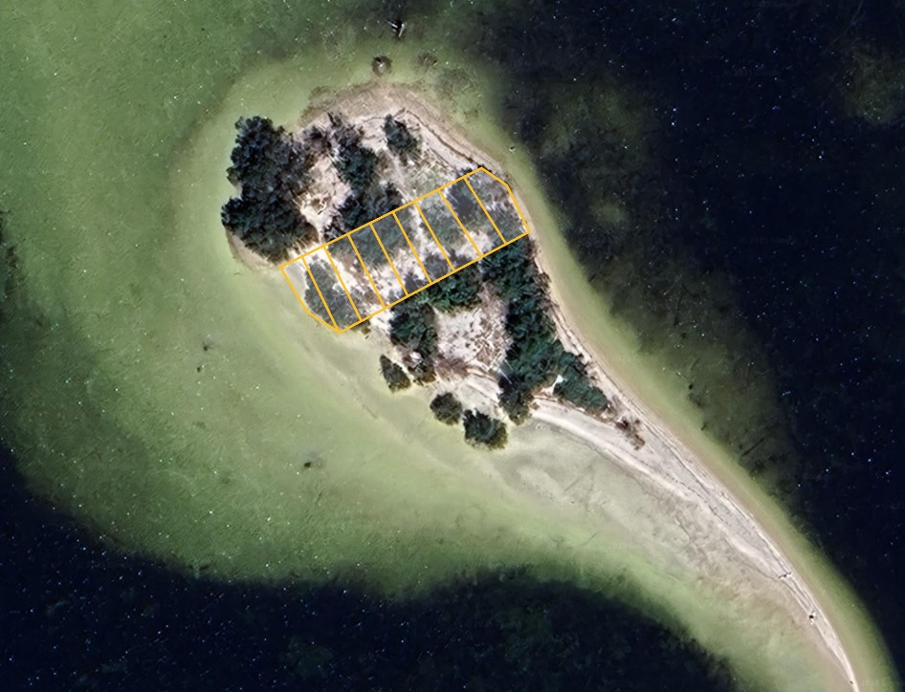
The island is broken into 5 zones. We will be working in zone 2 this year.
ZONE 1 LINE
ZONE 1 LINE
ZONE 2 LINE
ZONE 2 LINE
S
E
W
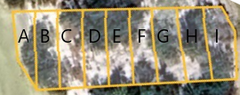
6M

Zone 2 is broken down into 9 sections (A-I). Each section is 6 m wide.
Your team will identify all the plants in the section you are assigned. Mark any invasive species with orange tape and record on them on your plant survey sheet. The invasive species will be removed after we have identified all the invasive species in all the sections of zone 2.
With a tape measure your team will use 4 garden stakes to mark your section boundaries, find the PVC boundary marks. Inside the boundary you will plot all the invasive species on your section map.
Using your transect tape measurer. Pull tape from south to north as close to the center of your section as possible.
Record native and invasive plants species in your section on the graph below
Zone # ___________ Section: ____________
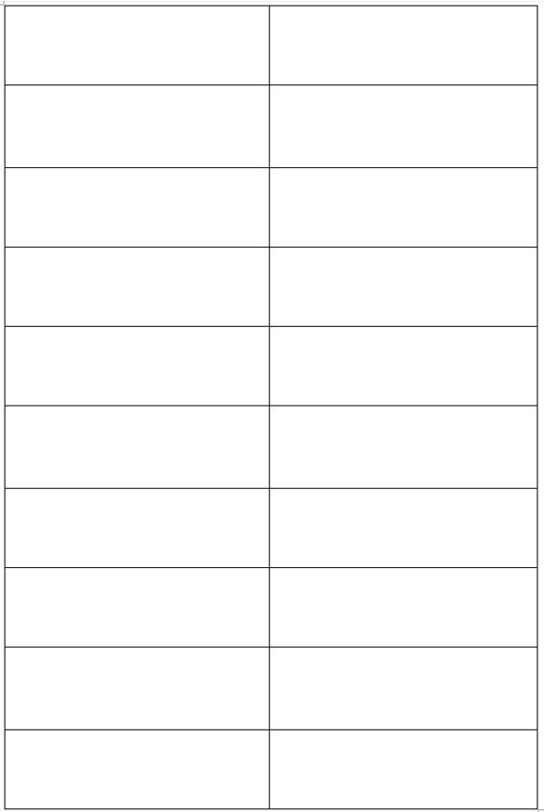
20m

18

16

14

12

10

8

6

4

2

0m

