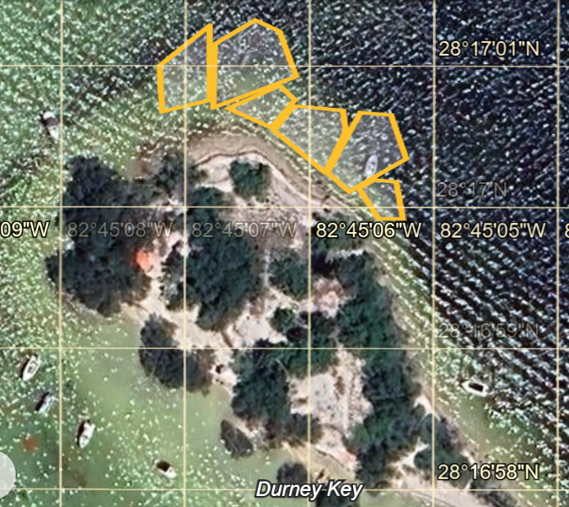

Zone 6

Zone 5

Zone 4

Zone 3

Zone 2

Zone 1

Zone 3

Zone 4

Zone 5

Zone 6

Zone 2

Zone1