**Plant Team Survey**

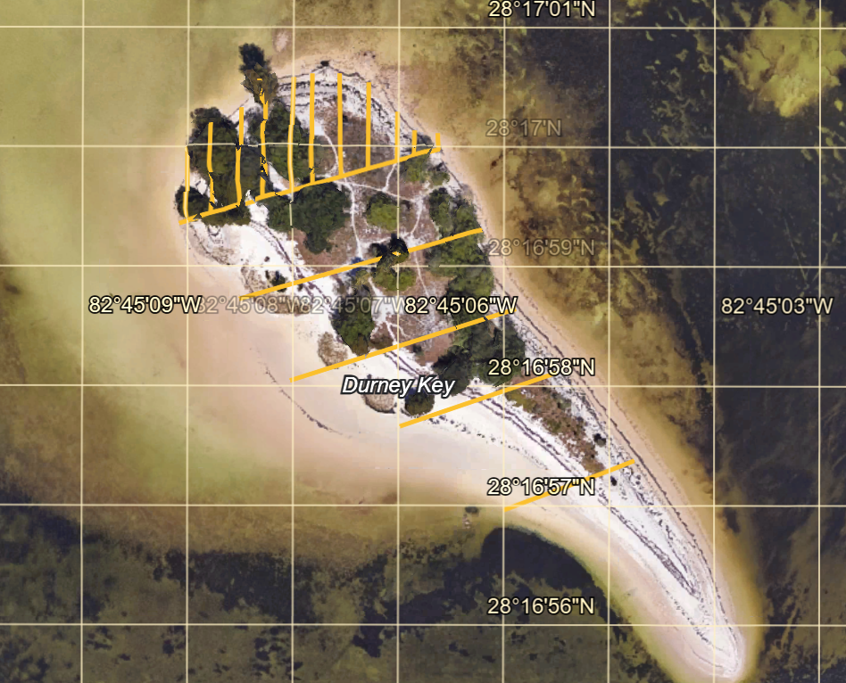

A

ZONE 1 LINE

ZONE 1 LINE

**W**

**E**

**N**

**S**

The island is broken into 5 zones. We will be working in zone 1 the first year.

Zone 1 line is 60 meters long. From north to south, zone 1 is broken down into 10 sections (A-J) from west to east. Each section is 6 meters wide.

Your team will identify all the plants in the section you are assigned. Mark any invasive species with orange tape. The invasive species will be removed after we have identified all the invasive species in all the sections of zone 1.

Using a tape measure your team will use 4 green garden stakes to mark your section boundaries. Inside the boundary you will plot all the invasive species on your section map.

Using your transect tape measurer. Pull tape from south to north as close to the center of your section as possible.

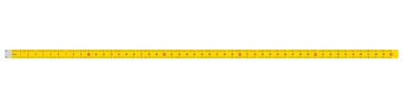

|  |  |
| --- | --- |
|  |  |
|  |  |
|  |  |
|  |  |
|  |  |
|  |  |
|  |  |
|  |  |
|  |  |
|  |  |

100

90

80

70

60

50

40

30

20

10

0

Place an **X** and the name of any invasive species that are found in your sections.

Place an **O** and the name of any mangroves found in your sections.

**Scrub oak Beach Bean Vine Parkinsonia**

**Cabbage palm Scavola Euphorbia Spike grass**

**Smut grass Pineland acacia Ragweed Purslane**

**Cedar Spartina**

**Brazilian Pepper Lead Tree Australian Pine**

